ACCIDENT INVESTIGATION REPORT

INSTRUCTIONS: This Accident Investigation Report is a tool for department supervisors and accident investigation teams to find main causes of illnesses, injuries, and "near misses," and to take corrective actions. Departments are strongly encouraged to use this form as a method of reducing hazards in their areas. Environmental Health and Safety may request departments to supply this information for certain types of accidents.

Statement of Injured Or Ill Employee Concerning Incident: SEE ATTACHMENT #1
Employee Signature: Tom Forklift BGSU ID# P001234567 Date: 6/1/00

Witness Statement (see reverse side)

Equipment Involved: (if applicable)
Name of equipment Forklift
Manufacturer Mule, Inc.
Age of equipment 10 Years
Model and Serial # A123456 RAH Series
Location Production and Warehouse Was there equipment failure? □ Yes x No If so, explain:
Attach equipment history, including maintenance schedules and engineering changes.

Other Factors Involved in the Event (Walking Surfaces, Work Practices, Work Area Design, Weather, Previous Incidents, etc.): SEE ATTACHMENT #1

Corrective Action To Be Taken: (Use separate paper for additional information)
ITEM  NO. | DESCRIPTION | PERSON  ACCOUNTABLE | TARGET  DATE | DATE  COMPLETED
 | SEE ATTACHMENT #2
Examples of corrective actions:
-Re-design work environment -Improve housekeeping -Improve lighting
-Reduce noise/vibration -Improve ventilation -Improve inspection procedure
-Re-train affected workers -Install safety/guard device -Use less hazardous materials
-Use personal protective equipment -Correct building hazards -Repair or replace equipment or tools

Investigation Report Completed by: Steve Miller Date: 6/2/00
Title: Safety Coordinator
Report Reviewed by: Frank Maintenance Date: 6/3/00
Title: Supervisor

BOWLING GREEN STATE UNIVERSITY
ACCIDENT INVESTIGATION REPORT (CONT.)

Witness Statement: I noticed Tom operating the forklift too fast in the vicinity of the doorway. I asked Tom to move some packages and bring more boxes to the material area. Tom told me his forklift brakes were not working properly after he almost hit me.
Witness Signature: Date:

TIPS FOR ACCIDENT INVESTIGATION

- The purpose of accident investigations is to find the underlying causes of an injury, illness, or "near miss" and to take corrective actions. Employees should understand that accident investigations are NOT intended to assign blame.

- Conduct the investigation immediately after the accident. The scene may change and our memories may fade soon after the incident.

- In separate interviews, ask the employee involved in the accident, and the witnesses to the accident, to tell you in their own words exactly what happened.

- Repeat the employee's and witnesses' descriptions of the event to allow them to make corrections or additions.

- Review the completed form with the employees involved to make certain that the report is accurate.

Attachment #1

Statement of Injured or Ill Employee Concerning Incident

Frank instructed me to repair the overhead door in aisle #3.

At about the same time, Alice directed me to remove some boxes of packaged product from her area and to bring more boxing material to the department.

When I was traveling from the warehouse to the production department, I encountered Jim on a stepladder in the middle to the doorway. Unable to stop or avoid the ladder, I struck the ladder with Jim on it. The ladder was knocked out from under Jim. Jim first fell onto the top of the load I was moving from the warehouse; then onto the floor. Jim's left leg broke when it finally struck against the overturned ladder.

Other Factors Involved in the Event

Frank supervises Jim in the maintenance department. Frank instructed Jim to repair the fire door located between the warehouse and production area because it had been reported as not working properly. Although Jim wanted to leave work early for a trout-fishing tournament, he agreed to repair the door. There is no company policy to protect workers when work is being performed in an aisle or doorway. Jim selected the tallest stepladder and set it up so he could inspect the door's mechanical linkage. Jim was on the next to the top step of the ladder when Tom struck the ladder.

Frank is also responsible for the maintenance of the company's forklifts. He admits, that due to lack of personnel, the brakes on Tom's forklift had not received proper maintenance. Frank has not taken forklifts, needing maintenance, out of service.

As a forklift operator, Tom receives directions to move material from all supervisors. Alice supervises the production department. Since there is a shortage of storage space in her department, she instructed Tom to remove some packaged material from the department and to bring more boxing material to the area. Tom acknowledged to Alice that the forklift's brakes were not working properly after narrowly missing Alice with the forklift. Tom had previously reported the bad brakes to maintenance but continued to operate it since repairs were not being done. Alice and at least one other witness reported that Tom operated the forklift too fast in the vicinity of the doorway. Earlier on the day of the incident, Kathy told Alice there was some cooking oil on the floor of the doorway from production to the warehouse. Alice did not inform anyone of the spill nor direct it to be cleaned up.

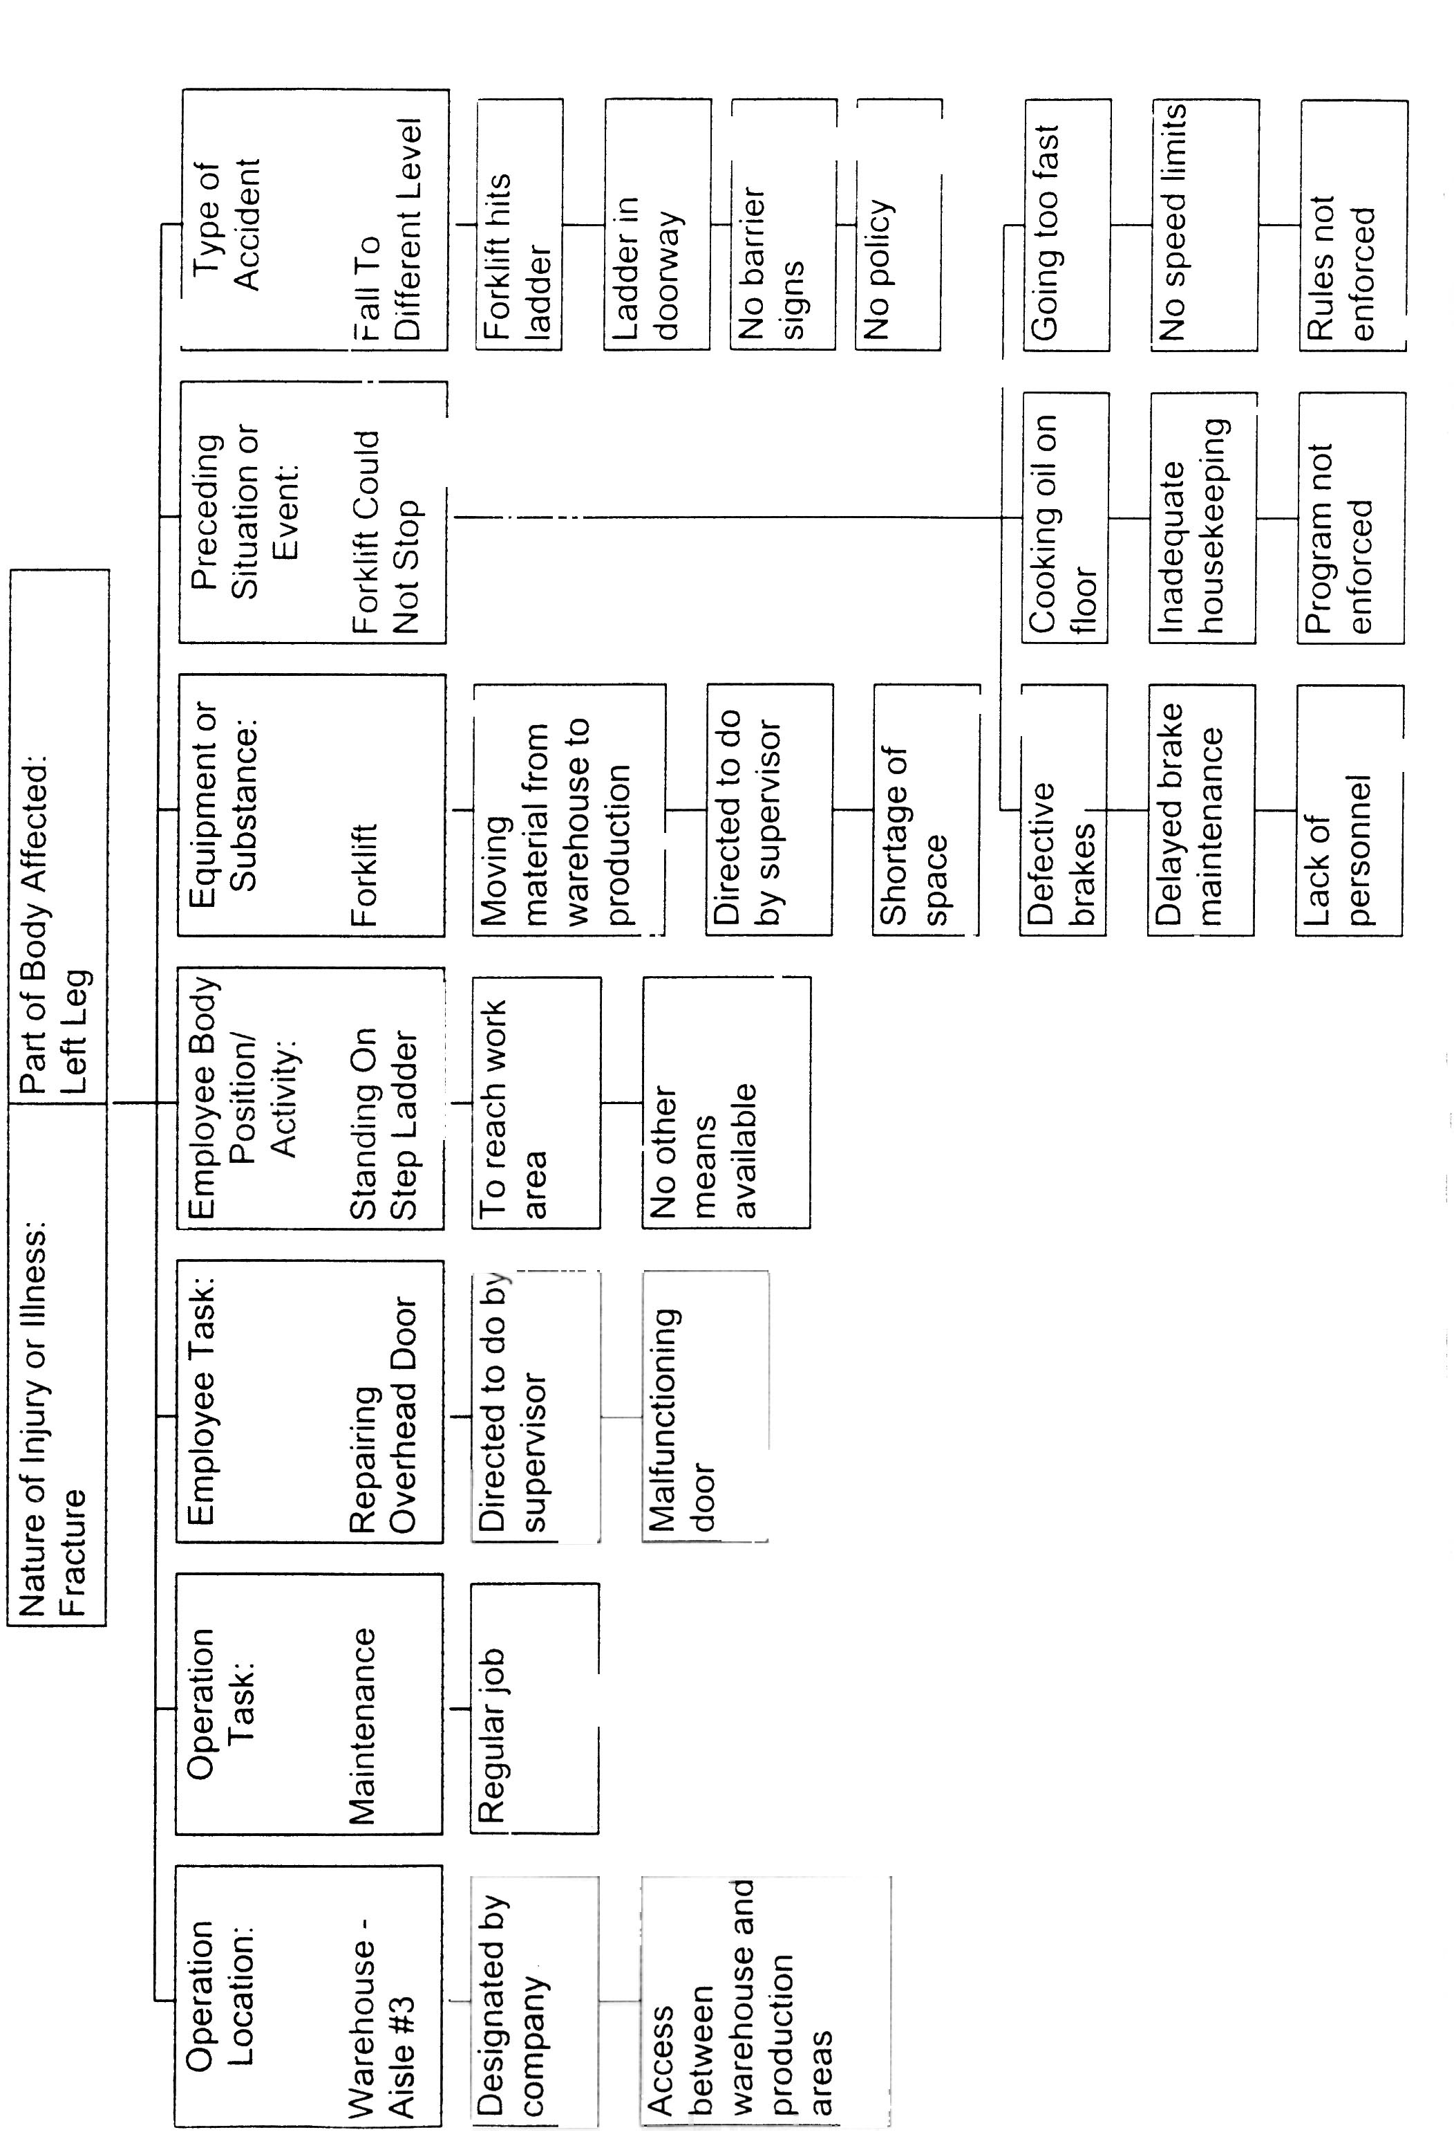
Attachment #2

Preventive Measures for Jim’s Accident

- Repair fire-door (and investigate why it was not working properly)
- Develop and implement LOTO procedure for all fire-doors
- Purchase scissors-lift
- Conduct scissors-lift training
- Hold maintenance man accountable for standing on step-ladder unsafely
- Conduct ladder safety training
- Develop and implement a fall protection program
- Analyze the need for additional production storage space
- Develop and implement a forklift inspection program
- Develop and implement a planned maintenance program for forklifts
- Develop and implement a “deadline” policy for all powered equipment
- Hold supervisor accountable for allowing the forklift with brakes needing repair to be operated
- Clean-up spills immediately (and investigate how the oil was spilled)
- Encourage all employees to practice good housekeeping
- Hold supervisor accountable for not responding to report of spilled oil
- Purchase and install convex mirrors at all blind-corners
- Hold forklift operator accountable for operating the forklift unsafely
- Conduct forklift refresher training
- Hold supervisor accountable for not enforcing safe operation of forklift rules
- Develop and implement a worksite barricade policy
- Purchase worksite barricades

