TRENCHING AND EXCAVATION SAFETY PROGRAM

PURPOSE:

The purpose of this instruction is to ensure compliance with the OSHA Excavation Standard 29 CFR 1926- Subpart "P" and the Safety Program and Training requirements of 29 CFR 1926 - Subpart "C".

GENERAL:

Several hundred people die and ten times that many are injured every year in trenches. Trenching is the most hazardous construction work in America today. Strict adherence to 29 CFR 1926- Subpart "F" is essential to ensure workers safety. A competent person will never allow workers to be exposed to unsafe trench conditions, no matter how short the exposure will be!

DUTIES OF THE COMPETENT PERSON:

1. Will maintain a copy of 29 CFR 1926- Subpart "P" and have a comprehensive knowledge of OSHA’s Excavation Standards. In addition, competent persons shall have a general knowledge of all applicable construction standards.

2. Conduct pre-job site review to develop a job plan that ensures a safe, efficient job process. A competent person will evaluate difficult sloping and shoring problems (i.e. manholes, etc) prior to commencing the work.

3. Perform inspections of equipment and trench conditions at the start of each shift or as needed by changing conditions.

4. Competent person has the duty and responsibility to remove all employees from hazardous condition and effect all changes necessary to ensure safety.

5. Categorize soil conditions and conduct visual and manual tests to determine stability of soil and surrounding trench conditions. NOTE: If visual and manual tests are not performed, soils shall be classified as type “C”.

6. Maintain on-site records of protection systems.

7. Determine the appropriate protection system to be used and oversee installation.

8. Verify that a competent person designs ramps and walkways for employee use in accordance with OSHA standards.

9. Competent person shall verify proper design of structural equipment ramps and walkways, or shall contact an RPE to design structural equipment ramps and walkways.

10. Hold tailgate safety meetings with all crew members prior to trenching and shoring operations. Subsequent meeting shall be held as conditions warrant.

11. A competent person shall be on-site at all times during excavation/trenching operations.

12. Assure that appropriate emergency rescue equipment is available to meet existing or potential conditions.

13. Monitor use of water removal equipment.

14. Test for oxygen presence and air quality in excavations as necessary. Competent persons shall be qualified in identifying confined/hazardous spaces due to the presence of flammable/combustible gases, toxics, oxygen deficiency and oxygen enriched environments.

15. Competent person shall consult with RPE for trenches over 20', specially designed shoring bracing or underpinning or when excavation endangers nearby structures.

NOTE: Competent persons shall ensure that all trenches are properly classified, sloped, or shored in accordance with the appendices of 29 CFR 1926- Subpart "P", or in accordance with manufactures tabulated data. Furthermore, competent persons shall consult with a registered professional engineer (RPE) obtaining written guidance whenever the work exceeds 20 feet in depth, or the work will require control measures not specified in the standard.

STEPS FOR DETERMINING SOILS CLASSIFICATION:

1. Visually inspect spoil pile and trench for indication of cohesive or granular soils. If soil appears to be cohesive, conduct plasticity test. If soils are cohesive classify soils by either thumb penetration, shear vane, or pocket penetrometer. If soils do not pass plasticity test, classify granular soils by sedimentation test. NOTE: Other visual and manual tests are authorized in appendix A to 29 CFR 1926- Subpart "P".

2. Determine if soil is cohesive (plasticity test). The following provides a couple of examples for cohesive soil testing:

A. Roll or Thread test: Mold a moist or wet sample of soil into a ball and attempt to roll it into threads as thin as 1/8" in diameter. Cohesive material can be successfully rolled into threads without crumbling. For example, if at least a two inch length of 1/8" in diameter thread can be held on one end without tearing the soil is cohesive.

NOTE: Only use material passing a No.40 sieve.

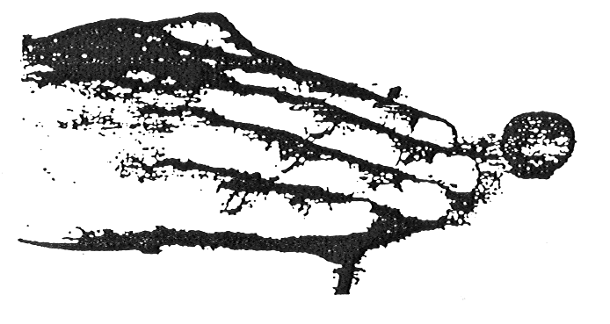
ROLL OR THREAD TEST

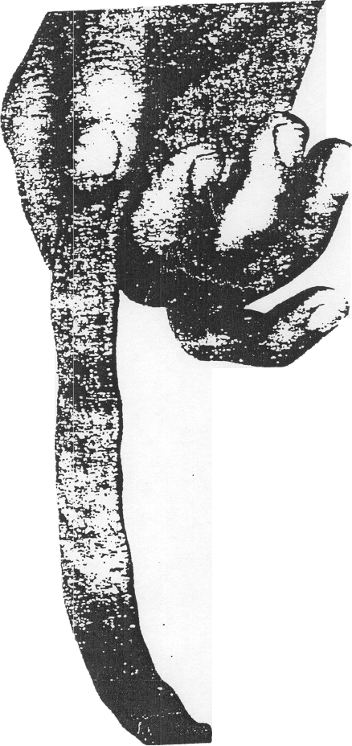
B. Ribbon Test: Form a roll of moist soil about 1/2" to 3/4" in diameter. Cohesive material can be successfully rolled into 1/2" to 3/4" ribbon without crumbling. For example, if at least 3" to 5" in length can be held on one end without tearing the soil is cohesive.
Figure 1 - Ribbon Test

NOTE : Only use material passing a No. 40 sieve.

3. If plasticity test(s) proves that soils have cohesive qualities, determine the type of soil (A,B,C by using the following test methods:

NOTE: Soil testing equipment shall be used in accordance with manufactures specifications.

A. Thumb penetration (cohesive soils only):
Type "A": 1/4" or less
Type "B": 1/4" to 1"
Type "C": 1" or more

B. Determining Shear Strength (cohesive soils only): By using a hand held vane shear device, the soil condition for cohesive soils can be determined. The following provides an example of the application of the vane shear:

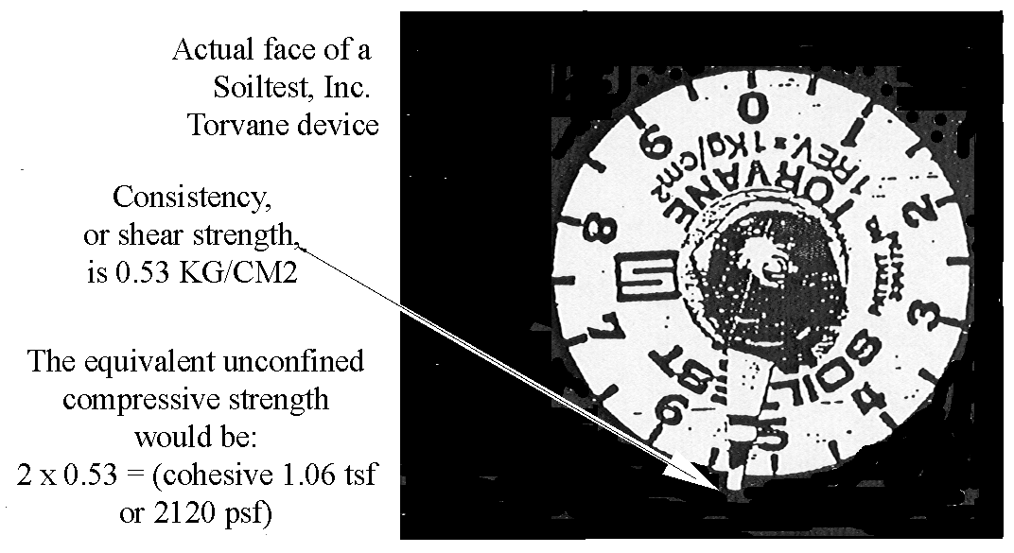

NOTE: This example illustrates a Type "B" soil condition.

C. Determining unconfined compressive strength (cohesive soils only): By using a hand held pocket penetrometer, the soil condition for cohesive soils can be determined. The following provides an example of the application of the pocket penetrometer:

PHOTOGRAPH OF A SOILTEST, INC. POCKET PENETROMETER:

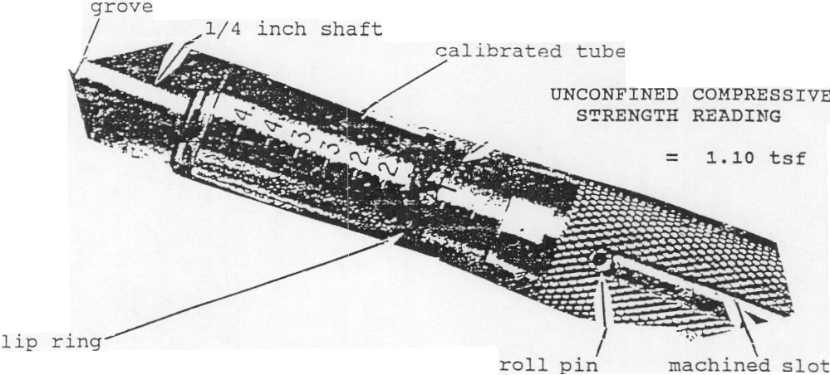

NOTE: Pocket penetrometer is only pushed into the soil until the grove line on the 1/4" shaft penetrates the soil.

4. If soil does not have cohesive qualities (granular soils), use the sedimentation test to determine if soils are a type "B" or "C" soil.

SEDIMENTATION TEST

A. The Sedimentation Test is the hydrometer analysis adapted for field use. Larger particles are the first to settle out of a soil-water suspension. It is used to determine the amount of sand in a sample taken in the field and is used only on soils that are obviously sands or very sandy. To run the sedimentation test, a representative sample of the soil is taken from the spoil pile. Great care must be taken to insure that the sample represents the soil in the trench or excavation; otherwise the test will not be accurate.

B. The soil sample, after the gravel is removed, needs to be large enough to fill a glass jar to a depth of approximately 1-1/2". The soil is placed in a tall straight-sided glass jar so that there is at least 5" of water on top of the soil. The jar should have a flat bottom and must be at least 61/2" inches tall (olive jars work well) .

C. The gravel may be removed by spreading a representative sample of the soil on a flat surface and hand picking the gravel, or by using a number 10 sieve or a piece of 1/8" hardware cloth. The 1/8" hardware cloth will pass some of the smaller gravel particles; they will need to be hand picked. All cohesive aggregations must be broken up so that all particles fall as individuals in the soil water suspension. Use clean water for the test. Place the lid on the jar and thoroughly shake the mixture. After the particles have been completely dispersed and the suspension is uniform, set the jar down and give it slight twist. The larger particles will begin to settle out immediately. The twist levels out the largest particles so that a level surface is generated. All of the sand will have settled out 30 seconds after you set the jar down. Make a mark on the side of the jar. File folder labels work well for marking because they stick well to a damp jar.

D. The particles will continue to settle out of the suspension until nearly clear water remains above the layered soil. Most of the silt will have settled out in an hour. Make a second mark. Seldom is it necessary to wait over an hour. This test is good only for those soils that have a very high percentage of sands. The soil must be thoroughly dispersed because any small clods of silt and clay remaining unbroken up will act like sand.

E. All soil material below the first mark is sand. The material between the lines is silt and most of the clay. Allowing for the thickness of the glass jar bottom, determine the total height of the soil and the height of the sand. Divide the height of the sand by the total height of the soil and multiply by 100; the result will be the percentage of sand in the sample.

F. If the silt-clay mixture settles out rather quickly, mostly silt is indicated. If the suspended solids above the sand settle out slowly, mostly clay is indicated.

G. Recall that if silt is the primary fine material present, the soil can be called a loamy sand, even though it has only 70% sand by this test. If clay is the primary fine material, there must be 85% sand to call the material a loamy sand.

4. Textural Classification -Percentages of sand, silt, and clay. The following chart will aid in soil classification:

TEXTURAL NAME  (SOIL CLASS) | OSHA  SOIL TYPE | RANGE IN PERCENT
TEXTURAL NAME  (SOIL CLASS) | OSHA  SOIL TYPE | SAND | SILT | CLAY
SAND | C | 85-100 | 0-15 | 0-10
LOAMY SAND | C | 70-90 | 0-30 | 0-15
SANDY LOAM | B | 43-80 | 0-50 | 0-20
LOAM | B | 23-52 | 28-50 | 7-27
SILT LOAM | B | 0-50 | 50-80 | 0-27
SILT | B | 0-20 | 80-100 | 0-12
SAND CLA Y LOAM | * | 45-80 | 0-28 | 20-35
CLAY LOAM | * | 20-45 | 15-53 | 27-40
SILTY CLAY LOAM | * | 0-20 | 40-73 | 27-40
SANDY CLAY | * | 45-65 | 0-20 | 35-55
SILTY CLAY | * | 0-20 | 40-60 | 40-60
CLAY | * | 0-45 | 0-40 | 40-100

* DENOTES: A, B, OR C DEPENDING UPON UNCONFINED COMPRESSION STRENGTH AND VISUAL INSPECTION OF TRENCH/EXCAVATION.

The following provides the above information in a graphical geometric form:

CLAY

SAND SILT

NOTE: As a general rule of thumb, you can classify 80% sand or greater as a type "C" soil.

COMPETENT PERSON DOCUMENTATION:

Competent person shall maintain the Daily Inspection Checklist for each trench/excavation. The documentation shall include Job Site Description; Trench/Excavation Inspection Comments; Employee & Public Safety Inspection; Protection System Selected; Soil Conditions; and Construction Design and Comments.

TRAINING:

Competent persons for trenching and excavation work shall be trained in the following objectives:

1. DEFINE SELECTED TERMINOLOGY: Competent persons shall be knowledgeable in the following terms:

- Support system
- Trench
- Excavation
- Registered Professional Engineer (RPE)
- Trench shield/box
- Sloping
- Hydraulic shoring
- Protective system
- Uprights
- Failure

2. IDENTIFY DUTIES OF “COMPETENT PERSON" USING DAILY INSPECTION CHECKLIST: Competent persons shall be knowledgeable in the elements of the Daily Inspection Checklist to identify duties.

3. DOCUMENT TRENCHES/EXCAVATIONS USING THE DAILY INSPECTION CHECKLIST: Competent persons shall be trained to complete the checklist identifying the Job Site Description; Trench/Excavation Inspection Comments; Employee & Public Safety Inspection; Protection System Selected; Soil Conditions; and Construction Design and Comments.

4. DEFINE SELECTED SOIL TERMINOLOGY: Competent person shall be able to identify the following soil conditions:

- Fissures
- Granular
- Saturated
- Clay
- Multiple soil types
- Moist soil
- Caliche
- Cohesive
- Plastic

5. HANDS-ON SOIL TESTING: Competent person training shall include hands on soil classification. Competent person training shall require competent person candidate to classify cohesive (clay) soil (commercial clay or play dough may be used as a substitute), and granular soils.

6. INTERPRET DESCRIPTIONS OF SOIL CONDITIONS AND IDENTIFY TYPES REQUIRING SHORING: Competent persons shall be able to identify conditions that will effect soil classifications, such as: fissures, vibration, previous excavations, blasting, above water table, rock above soil layers, layers tilting in at 4:1 slope or steeper, water freely seeping from side of trench, etc.

7. IDENTIFY CAUSES OF TRENCH CAVE-INS: Competent person shall be able to identify cause of trench cave-in, such as: inadequate support systems, inadequate sloping, surcharge loading, etc.

8. IDENTIFY HYDRAULIC SHORING REQUIREMENTS: Competent person shall be knowledgeable in the manufacturer’s tabulated data, as well as the application of Appendix D to Subpart p (29 CFR 1926). Competent persons shall be able to identify proper installation techniques and limitation of hydraulic shoring, depending upon the depth and soil type. Competent person shall know:

- Maximum horizontal distances between shores,
- Distance from the top cylinder to soil’s top edge,
- Maximum trench width and depth allowed without consulting an RPE,
- Thickness of Finn Form Sheeting for Type "B" soil,
- Number of inches the Finn Form Sheeting should extend above the vertical side of a compound trench and,
- The amount the sheeting may be raised from the bottom of the trench, provided the first cylinder is not higher than 4' from the trench floor to the middle of the first cylinder.

9. IDENTIFY TECHNICAL CHANGES IN SLOPING AND BENCHING SPECIFICATION AND RECOGNIZE SLOPING REQUIREMENTS: Competent person shall be able to identify the slope required for the following soil classifications:

- A - short term - less than 24 hours
- A - long term
- B - long term
- C - long term

In addition, competent persons shall be able to determine when benching is authorized for cohesive soils only.

10. IDENTIFY SAFETY REQUIREMENTS FOR USING A TRENCH SHIELD: Competent person shall be able to identify when end plates are required, how to safely stack shield sections, access and egress requirements, shield construction requirements, material handling requirements (tag line, sling safety, etc.}, and lateral support requirements.

11. IDENTIFY SAFETY REQUIREMENTS FOR A TRENCH WITH SURFACE ENCUMBRANCES: Competent person shall be able to identify appropriate methods in bracing or removing surface encumbrances, including when such bracing should be designed by an RPE.

At the completion of the above training, competent person candidates will demonstrate their proficiency under the supervision of competent company officials prior to being designated as a "competent person" for trenching and excavation work.

TRENCHING/EXCAVATION
DAILY INSPECTION CHECKLIST

COMPETENT PERSON: DATE:

USE ONE OR MORE OF THE FOLLOWING: a " check mark" to indicate yes, comment codes listed below, or fill in blank with applicable information or description.

COMMENT CODES

SOIL TYPE: | ROCK, STABLE ROCK, "A" "B" "C"
HYDROSTATIC  CONDITIONS: | (M} MOIST (D} DRY (R) RAINSTORM  (SA} SATURATED (PS) PARTIAL SATURATION

JOB SITE DESCRIPTION

Location: Area Congested:
Right-Of-Way And Clearance Ok:
Trench/Excavation Depth: Length:
Location Of Underground Utilities Verified: Date:
Location Of Underground Utilities Marked: Date:
Crossing Trench/Excavation: Lines: Road/ Alley:
Parallel To Trench/ Lines: Road / Alley: Building(S):
Excavation:
Pole Bracing: Overhead Lines: Structural Bracing:
Open Date/Time: Job #:
Registered Professional Engineer: Reason:

TRENCH/EXCAVATION INSPECTION COMMENTS

Soil Type: Times Inspected:
Describe Any Changing Conditions, Plans, Or Shoring Equipment Damage In Space Below:

EMPLOYEE & PUBLIC SAFETY INSPECTIONS

Ladders: Ramp For Employees: Ramp For Equipment:
Emergency Equipment: Air Quality Testing: Water Removal :
Lighted Barricades: Barricade Tape: Cones: Fencing:
Flaggers: Weekend Protection: Steel Plating:
Spoil Pile/Other Material Effectively Removed:

PROTECTION SYSTEM SELECTED

Hydraulic Shores (Size): Sheeting Thickness: No.:
Horizontal Walers (Size): Timber Shores:
Slope: ½:1 ¾:1 1:1 1 ½:1
Benching: Unsupported Wall Height:

SOIL CONDITION -SOIL TYPE

NOTE: If one manual & visual test for each is not done, soil must be classified as Type "C".

MANUAL TESTS :

COHESIVE SOILS - RECORD RESULTS:

GRANULAR SOILS - RECORD RESULTS:

VISUAL TESTS:

FISSURES -TRENCH SIDE (CRACKS OR SPALLS):
FISSURES -TOP OF TRENCH (CRACKS OR OPENINGS):
SOIL LAYERS SLOPE INTO TRENCH 4:1 OR STEEPER:
ROCK LAYER ABOVE SOIL LAYER
SEEPAGE INTO TRENCH FROM SIDES , SURFACE , BOTTOM
VIBRATION SOURCES THAT MAY EFFECT TRENCH STABILITY.
PRIOR OF EXISTING EXCAVATION CROSSING TRENCH: PARALLEL

ADDITIONAL COMMENTS/NOTES:

