Machine Guarding

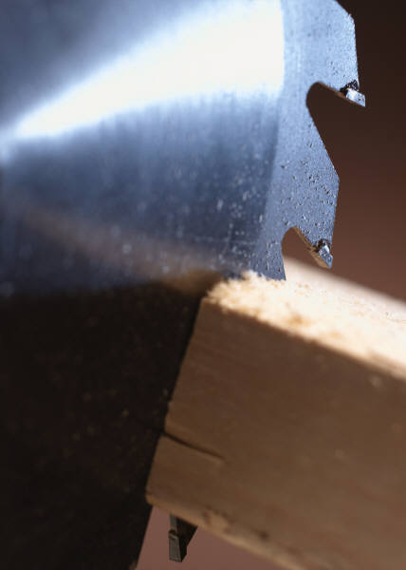
Serious injuries can result from the use of portable and stationary power saws. Accidents may occur if the operator is inexperienced, improperly trained or if the blade is not properly guarded.

According to estimates made by the Consumer Product Safety Commission, more than 310,000 injuries involving workshop power tools required medical attention in the United States in 1995. About one-third (87,000) of these injuries were associated with power saws, both portable and stationary.

The easiest way to avoid injury is to use properly guarded saws and appropriate safety equipment. Avoid loose-fitting clothes and long hair that might become entangled in a power tool and remove rings, watches, neck chains and other jewelry.

This section discusses guidelines and safety measures for the following types of saws:

Table Saws
Band Saws
Chop Saws
Straight Line/Gang Rip Saws
Radial Saws
Miter Saws
Cut-Off Saws
Scroll Saws
Hand Held Saws

Important: Whenever working on or around any piece of machinery or equipment, an effective lockout/tagout program and eye and face protection must be provided for employee protection.

Table Saws
Table Saw

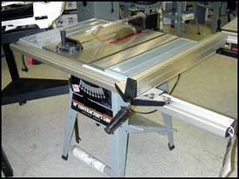
Table Saw with Guide

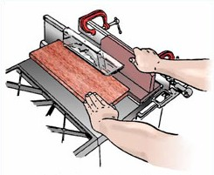
Saw blade with a self-adjusting guard

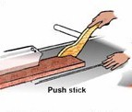
Push Stick

Table saws are used for straight sawing. Depending on the blade, they cut either across (crosscut) or with (ripsaw) the grain of the wood.

Operator Involvement

With hand-fed saws, the operator adjusts the height and angle of the blade. Then, holding the stock, the operator pushes it into the blade. A guide is used to maintain a straight cut at the desired width. At the end of the cutting stroke, the operator either changes positions or pushes the stock past the blade. Self-feed or power table saws are equipped with rollers or a conveyor system to hold the lumber and force-feed it into the saw blade.

POINT OF OPERATION
Potential Hazard: Injuries can occur if an operator’s hands slip while feeding the stock into the saw, or if the operator holds his or her hands too close to the blades while cutting. The operator can also be injured when removing scrap or finished pieces of stock from the table.

Solutions: Enclose the portion of the ripsaw and crosscut saw above the table with a self-adjusting guard as shown. The guard must adjust to the thickness of the material being cut and remain in contact with it [1910.213 (c)(1) and (d)(1)]. Hinge the guard so that the blades can be changed easily.

Use a push stick for small pieces of wood and for pushing stock past the blade. [1910.213(s)(9)]

Additional Safety Measures
- Keep hands out of the line of the cut.

- Attach a brake to the motor’s arbor to stop the saw from coasting after the power has been cut off, or have the operator remain at the saw station after the motor is shut off, until the blade stops turning.

OTHER MOVING PARTS

ACCIDENT REPORT
Finger Amputation from Rip Saw Accident
A worker was ripping a wooden workpiece with a dado on a manual-feed table ripsaw. When the workpiece began to bind, the worker attempted to move the workpiece through by pushing hard on it in the normal direction of operation. The workpiece subsequently broke free, exposing the circular saw blade underneath which caught the worker's fingers on his right hand. The worker suffered amputations of his index and little finger at the first knuckle, and middle and ring fingers at the second knuckle. The worker should have used a push stick to free the binding workpiece instead of his right hand.
Potential Hazard: Injuries can occur if the operator makes contact with the blade under the table or with the power transmission apparatus (if not enclosed).

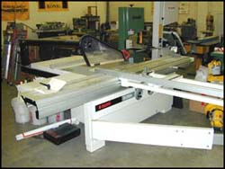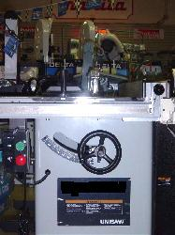
Table Saw Table Saw with enclosed

ACCIDENT REPORT

Unguarded Table Saw Results in Amputation
A worker was assembling parts of a cabinet when he noticed one of the parts needed another cut to fit. When he walked over to the operating side of the table saw, he noticed that the blade guard was lying on the floor under the saw. Without installing the guard, the worker proceeded to make the cut and then reach across behind the blade to remove the scrap piece. While dragging the scrap piece towards himself, the scrap caught on the blade and pulled his hand right into the unguarded rotating blade. This resulted in multiple finger amputations on his left hand.
saw and power transmission
apparatus below the table

Solution: Always guard the portion of the blade below the table. Protect operators from possible contact when reaching under the table. [1910.213(a)(12)]

Always guard the power transmission apparatus (belts, pulleys, chains, sprockets, etc.). [1910.213(a)(9)]

KICKBACKS
Potential Hazard: Kickbacks occur when the blade catches the stock and throws it back toward the operator. Kickbacks can result if the blade height is not correct or if the blade is not maintained properly. Kickbacks are more likely to occur when ripping, rather than crosscutting. Kickbacks also can occur if safeguards are not used or if poor-quality lumber is cut.

Solutions: For ripsaws, use a spreader to prevent material from squeezing the saw or kicking back during ripping. [1910.213(c)(2)]

Use anti-kickback fingers to hold the stock down in the event that the saw kicks back the material. [1910.213(c)(3)]

Maintain and sharpen blade. [1910.213(s)(2)]

Additional Safety Measures
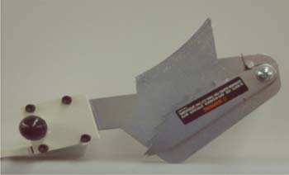
Anti-kickback fingers

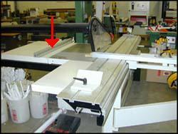
Table saw with rip fence

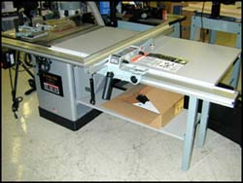
Table Saw

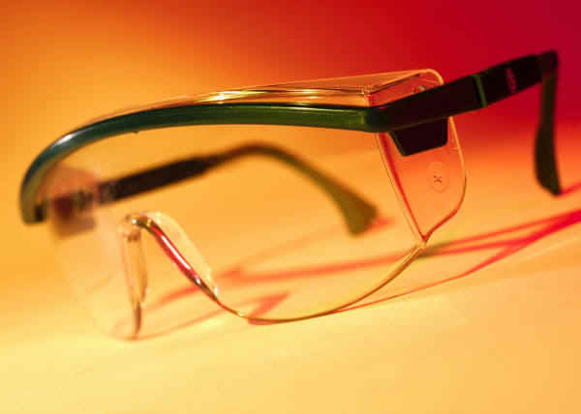
Protective eyewear is important!

- Operate the saw at the speed specified by the manufacturer.
- Leave sufficient clearance for stock.
- Stand to the side of the saw blade to avoid injury due to kickback.
- Use the proper blade for the cutting action. For example, do not use a crosscut blade for ripping.
- Guide the wood to be cut parallel to the rip fence to minimize the potential for kickback.
- Avoid crosscutting long boards on table saws. Considerable hand pressure is required close to the saw blade, and the boards create a safety hazard to other people.
- Use a filler piece between the fence and the saw blade when necessary such as when there is little clearance on the fence side.
- Properly support all pieces of stock, including the cut and uncut ends, scrap, and finished product.

FLYING PARTICLES
Potential Hazard: The cutting action of the blade may throw wood chips, splinters, and broken saw teeth.

Solution: Remove cracked saw blades from service. [1910.213(s)(7)]

Additional Safety Measures
- Maintain sharp blades.
- Always wear eye and face protection.

Straight Line/Gang Rip Saws

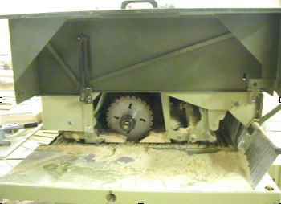
Gang Rip Saw

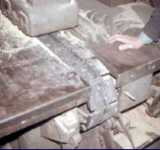
Gang Rip Saw

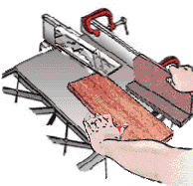
Kickback demonstration

A straight line or gang rip saw is a circular blade machine, usually of the radial design, used for cutting wood across and above the stock. The blade is mounted directly to the motor, which is contained in the moveable ram. The stroke may be manual or powered. The saw blade generally rotates at 3,600 rotations per minute (RPM). Stock is fed in front of the machine on a feed table with rolls and guides and pulled across the stock. After the cut is complete, the blade must return to its original position behind the stock and the stock is repositioned for the next cut.

Operator Involvement

This type of saw requires the operator to position the stock, hold it stationary, and grasp the sawing mechanism.

POINT OF OPERATION
Potential Hazard: Contact with the blade may occur during operation, when the saw is idling, if the return device fails, or if the saw bounces forward from a retracted position. Also, if the saw blade is able to go past the edge of the table, the blade could come in contact with the operator's body.

Solutions: Enclose upper half of saw and arbor end with a self-adjusting hood. The hood must drop on top of and remain in contact with the table or stock. When the saw returns to the back of the table, the hood must cover the lower portion of the blade. [1910.213(g)(1)]

Ensure that the saw contains an automatic device (such as a counterweight) to return the saw to the back of the table after the cut has been made. [1910.213(g)(2)]

Use limit chains or other effective means (for example, extend the table edge) to keep saw from moving beyond the front or back edge of the table. [1910.213(g)(3)]

Enclose overhead drive with a fixed guard. [1910.219]

The direction of the saw rotation must be clearly marked on the hood and a warning label placed that reads "Danger: Do Not Rip or Plough From This End". [1910.213(h)(5)]

Additional Safety Measures
- Position the piece to be cut before starting the saw.
- Stand at the side of the saw blade when the saw is running, and use the hand nearest the handle to operate the saw. (This keeps the operator's body out of the line of the saw.)
- Keep hands out of the line of the cut.
- Install a latch with a ratchet release on the handle, non-recoil spring, bumper, or other device to keep the saw from rebounding from its idle position.

NIP POINTS
Potential Hazard: Clothing, hair, or hands may be caught by and pulled into the in-running rolls of the automatic feed.

Solutions: Guard feed rolls with a hood or suitable guard. [1910.213(n)(3)] & [1910.213(n)]

Additional Safety Measures
- Stand at the side of the saw blade when the saw is running and use the hand nearest the handle to operate the saw. (This keeps the operator's body out of the line of the saw.)

KICKBACKS
Potential Hazards: Stock caught by the blade may be thrown back at the operator.

Additional Safety Measures
- Position the piece to be cut before starting the saw.
- Stand at the side of the machine and use the hand nearest the handle to operate the saw. (This keeps the operator's body out of the line of the saw.)

FLYING PARTICLES
Potential Hazards: The cutting action of the blade may throw wood chips, splinters, and broken saw teeth.

Solutions: Enclose overhead drive with a fixed guard. [1910.219]

Make sure guards and counterweights are properly adjusted at all times. Take improperly adjusted saws out of service. [1910.213(s)(1)]

Remove cracked and defective saw blades. [1910.213(s)(7)]

Supply hand-fed circular ripsaws with a spreader or non-kickback fingers to prevent material from being thrown back on the operator. [1910.213(c)(2)] and [1910.213(f)(2)]

Additional Safety Measures
- Maintain sharp blades.
- Position the piece to be cut before starting the saw.
- Stand at the side of the machine and use the hand nearest the handle to operate the saw. (This keeps the operator's body out of the line of the saw.)
- Always wear eye and face protection.

Cut-Off Saws

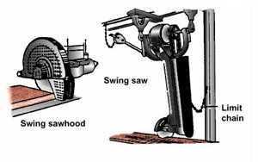
Guarded swing cutoff saw

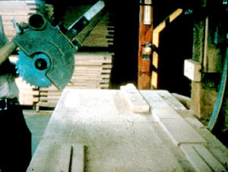
Large swing cut-off saw

Overhead Swing Cut-off Saws
A woodworking cut-off saw is a circular blade machine, usually of the radial design, used for cutting stock across and above the stock. The blade is mounted directly to the motor, which is contained in the moveable ram. The stroke may be manual or powered. The saw blade generally rotates at 3,600 rotations per minute (RPM). Stock is fed in front of the machine on a feed table with rolls and guides.

Operator Involvement

The most commonly found cut-off saw has a manual stroke. This requires the operator to position the stock, hold it stationary, and grasp the sawing mechanism and pull it across the stock. After the cut is complete, the blade must return to its original position and the stock is repositioned for the next cut.

POINT OF OPERATION
Potential Hazard: Contact with the blade may occur during operation, when the saw is idling, if the return device fails, or if the saw bounces forward from a retracted position. If the saw blade is able to go past the edge of the table, the blade could come in contact with the operator's body.

Solutions: Enclose upper half of saw and arbor end with a self-adjusting hood. The hood must drop on top of and remain in contact with the table or stock. When the saw returns to the back of the table, the hood must cover the lower portion of the blade. [1910.213(g)(1)]

Ensure that the saw contains an automatic device (for example, a counterweight) to return the saw to the back of the table after the cut has been made. [1910.213(g)(2)]

Use limit chains or other effective means (for example, extend the table edge) to keep saw from moving beyond the front or back edge of the table. [1910.213(g)(3)]

Enclose the overhead drive with a fixed guard. [1910.219]

Additional Safety Measures
- Position the piece to be cut before starting the saw.
- Stand at the side of the saw blade when the saw is running and use the hand nearest the handle to operate the saw. (This keeps the operator's body out of the line of the saw).
- Install a latch with a ratchet release on the handle, non-recoil spring, bumper, or other device to keep the saw from rebounding from its idle position.
- Keep hands out of the line of the cut.

KICKBACKS
Potential Hazards: Stock caught by the blade may be thrown back at the operator.

Solutions: Enclose the overhead drive with a fixed guard. [1910.219]

Make sure guards and counterweights are properly adjusted at all times. Remove improperly adjusted saws. [1910.213(s)(1)]

Remove cracked and defective saw blades. [1910.213(s)(7)]

Additional Safety Measures
- Maintain sharp blades.
- Position the piece to be cut before starting the saw.
- Stand at the side of the saw blade when the saw is running, and use the hand nearest the handle to operate the saw. (This keeps the operator's body out of the line of the saw.)
- Always use eye and face protection.

FLYING PARTICLES
Potential Hazards: The cutting action of the blade may throw wood chips, splinters, and broken saw teeth.

Solutions: Enclose the overhead drive with a fixed guard. [1910.219]

Make sure guards and counterweights are properly adjusted at all times. Remove improperly adjusted saws. [1910.213(s)(1)]

Remove cracked and defective saw blades. [1910.213(s)(7)]

Additional Safety Measures
- Maintain sharp blades.
- Position the piece to be cut before starting the saw.
- Stand at the side of the saw blade when the saw is running, and use the hand nearest the handle to operate the saw. (This keeps the operator's body out of the line of the saw.)
- Always use eye and face protection.

Band Saws
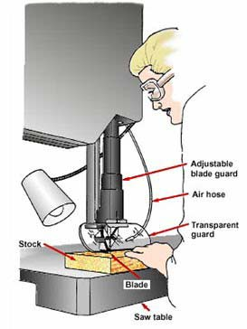
Vertical band saw in operation

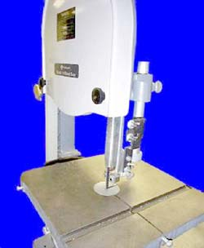
Vertical Band Saw

Band saws use thin, flexible, continuous steel strips with cutting teeth on one edge. They are used primarily for cutting curves in stock or in food processing plants to cut and trim meat, poultry, and fish. The blade runs on two pulleys, driver and idler, and through a work table where material is manually fed. Automatic feeds can be used for production cutting. However, this machine is usually considered a manual-feed tool. The two types of band saws, horizontal and vertical, are named for their respective cutting blade positions.

Operator Involvement

The operator is required to hand-feed and manipulate the stock against the blade to saw along a predetermined line. The user must also keep the stock flat on the work table and exert the proper cutting force.

POINT OF OPERATION
Potential Hazard: Contact with the blade is the most common cause of injury. Extreme caution is necessary because the operator's hands may come close to the saw blade, and a band saw cannot be completely guarded.

Solutions: Guard the entire blade except at the point of operation (the working portion of the blade between the bottom of the guide rolls and the table). [1910.213(i)(1)]

Use a self-adjusting guard for the portion of the blade between the sliding guide and the upper saw so that it raises and lowers with the guide. [1910.213(i)(1)]

Fully enclose the pulley mechanism. [1910.219(d)]

Guard feed rolls. [1910.213(i)(3)]

Make sure the saw includes a tension control device to indicate proper blade tension. [1910.213(i)(2)]

Additional Safety Measures
- Maintain appropriately sharpened blades.
- Use a blade of an appropriate size and type. For example do not force a wide saw to cut a small radius.
- Properly adjust the blade guidepost to fit the thickness of the stock and provide additional guarding.
- Set the guard as close as possible to the stock when it is near the blade.
- Use a push stick or manual feed arm to control the stock when it is near the blade.
- Install a brake on one or both wheels to minimize the potential for coasting after the saw has been shut off and do not retrieve material until the blade has stopped.
- Use a special jig or fixture when cutting small pieces of stock.

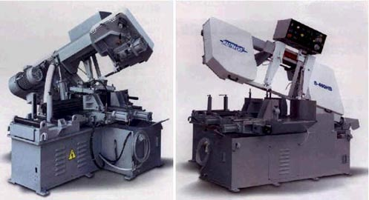
Front and rear view of horizontal band saw

Radial Saws
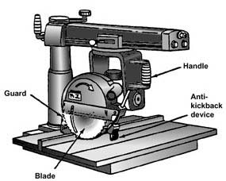
Guarded radial saw

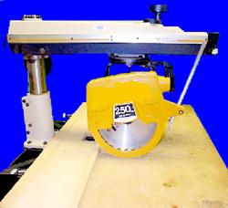
Guarded radial saw

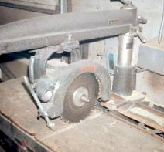
Unguarded lower blade and
arbor end of radial saw

Radial saws are circular saws that cut downward, either with or against the wood grain (rip or crosscut). Radial saws have features that make them more versatile than table saws. The saw arm can be raised and lowered and swung from side to side to adjust the depth and horizontal angle of the cut. The blade can also be replaced with shaping cutters, disks, or drum sanders and other accessories.

Operator Involvement

For crosscutting, the operator pushes the wood away from himself or herself against a fence. For rip cuts, the blade is set parallel to the fence, and the stock is pushed through. The saw blade rotates upward toward the operator, who feeds the stock in the opposite direction of the blade movement.

POINT OF OPERATION
Potential Hazard: Contact with the turning blade may occur. If the saw blade is able to go past the edge of the table, the blade could come in contact with the operator's body. Material may move during cuts.

Solutions: Enclose the upper half of the saw (from the blade down to the end of the saw arbor) with a fixed hood. Guard the lower half with a self-adjusting, floating guard that rises and falls and automatically adjusts to the thickness of the stock. [1910.213(h)(1)]

Make sure the saw has a return device. The front end of the unit must be slightly higher than the rear, so that the cutting head will return to its original position when released by the operator. This must also prevent the cutting head from rolling or moving the arm due to gravity or vibration. [1910.213(h)(4)]

Install an adjustable stop to limit forward travel distance of the blade during repeat cuts. [1910.213(h)(3)]
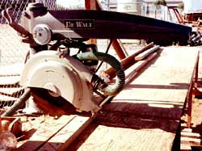
Guarded radial saw

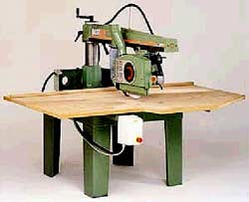
Guarded radial saw

Use limit chains or other effective means (for example, extend the table edge) to keep saw from moving beyond the front or back edge of the table. [1910.213(g)(3)]

Additional Safety Measures
- Securely fasten material to avoid unwanted movement during cuts.
- Measure boards against a stop gauge or turn off the saw if measuring by rule. Wait for the blade to stop before moving materials or making measurements.

KICKBACKS
Potential Hazard: Stock caught in the blade or fed in the wrong direction may be thrown back at the operator.

Solutions:
For ripping, install non-kickback fingers on both sides of the saw blade. [1910.213(h)(2)]

Use a spreader in ripping operations to prevent the cut in the wood from immediately closing and binding the blade. [1910.213(h)(2)]

Make sure that stock is in the correct direction. Post a warning label on the hood showing the direction of saw rotation. [1910.213(h)(5)]

Additional Safety Measures
- During crosscutting, operate the saw from the side of the table with the handle.

FLYING PARTICLES
Potential Hazard: The cutting action of the blade may throw wood chips, splinters, and broken saw teeth.

Solutions:

Additional Safety Measures
- During crosscutting, operate the saw from the side of the table with the handle.
- Always wear eye and face protection.

Scroll Saws
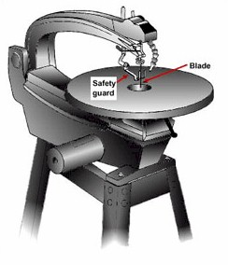
Scroll saw with safety guard

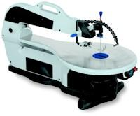
Scroll Saw with safety guard

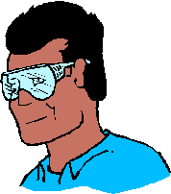
Protective eyewear

Scroll saws are useful for precision-cutting intricate curves and patterns on thin stock. They have thin blades that move rapidly up and down through the opening in the saw table. The blade is held in upper and lower chucks that pull it tight and keep it from bending. A hold-down adjusts to the thickness of the wood being cut. Scroll saws are generally not considered to be as dangerous as other saws; however, contact at the point of operation can cause hand and finger injuries. Contact with the blade can also occur below the table. All portions of the blade must be guarded.

Operator Involvement
The machine is turned on/off by a switch or knob and the material is pushed through the moving blade. The cutting motion should always be away from the operator.

POINT OF OPERATION
Potential Hazard: Contact with the moving blade.

Solution: Guard the blade, above and below the table, with an adjustable or self-adjusting guard. Provide aids to push material through the blade.

FLYING CHIPS
Potential Hazard: Wood chips and splinters may be thrown by the cutting action.

Solution: Guard the blade with an adjustable or self-adjusting guard. Maintain sharp blades.

Additional Safety Measures
- Make turns slowly; do not make sharp turns with a wide blade; use a narrow blade for sharp turns. Make sure the blade being used is suitable for the work being done.
- Always wear eye and face protection.
- Keep loose clothing and long hair away from cutting area.

Chop Saws
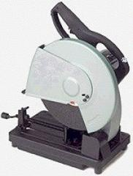
Chop saw

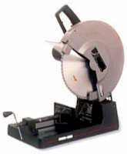
Chop Saw

A chop saw is essentially a lightweight circular saw mounted on a spring-loaded pivoting arm, and supported by a metal base. Chop saws are considered the best saw to get very exact, square cuts. Compound miter saws have been developed due to the limited cutting capacity of the chop saw. These are basically chop saws that can make bevel cuts as well as miter cuts.

Operator Involvement

The chop saw is operated by the user lining the saw blade with the user's mark. The user then positions the hands properly, clamping the wood to the fence with one hand and working the saw with the other. A trigger is depressed to activate the blade and the blade is pulled through the work piece. The left hand secures the material and the right hand stays firmly on the handle. Once the blade has been guided through the cut, the user guides the saw back to the upright position.

POINT OF OPERATION
Potential Hazard: Contact with the turning blade.

Solution: Ensure that all guards are in place and working. If a guard seems slow to return to its normal position, adjust or repair it immediately.

Additional Safety Measures
- Use only recommended size and RPM rated blades.
- Maintain sharp blades.
- Always wear eye and face protection

Miter Saws

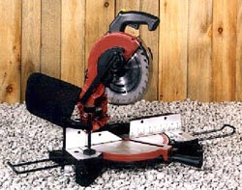
Miter saw

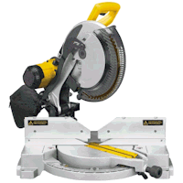
Miter saw

A miter saw is a circular power saw that is mounted on a frame and designed to make accurate angle cuts. The saw blade and motor are mounted on an elbow hinged arm, which is fixed at the rear of the saw. When the blade is lowered in a chopping motion, the blade cuts through the work piece, passing through a slot in the base. The miter saw is sometimes referred to as a chop box.

Operator Involvement

The operator of a miter saw slides the head out over the work, then lowers the blade into the wood, and makes the cut while pushing the head back toward the fence. Most workers find that this feels safer than pulling the blade toward them during a cut, as is done with a radial arm saw. (Buildscape, article 105)

POINT OF OPERATION
Potential Hazards: The operator's hands may slip off the stock while pushing into the saw blade. This may result in severe cuts and amputations.

Severe cuts and amputations may also occur if the operator's hand are too close to the blade during cutting operations.

Solution: Miter saws must be equipped with a guard that protects the portion of the saw above the table. The guard must automatically adjust itself to the thickness of the material being cut in order to provide continuous protection from the blade. [1910.213(h)(1)]

Additional Safety Measures
- Maintain sharp blades.
- Make sure hands are kept at a safe distance from the blade during cutting operations.
- Always wear eye and face protection.

Handheld Saws
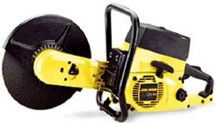
Powered handheld saw

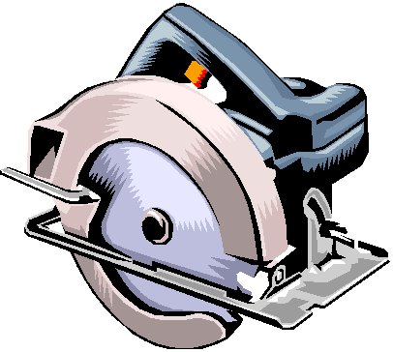
Portable circular saw

A hand-held saw is portable and requires only the users hands to operate. Hand-held saws can be powered or manual. Powered hand-held saws have a greater potential to be dangerous.

Operator Involvement

When using powered saws, the operator is responsible for holding the saw correctly and depressing the pressure control (trigger). The operator then maneuvers the saw according to how the stock is to be cut. Once the task is completed, the operator's finger is removed from the trigger to stop the motor.

Regulations for basic powered handheld saws fall into two categories:

Circular Saws
Handheld Circular Saws

Circular saws are used for straight sawing. Depending on the blade, they cut either across (crosscut) or with (rip) the grain of the wood.

Operator Involvement

The operator adjusts the height of the blade and, while holding the stock, pushes the blade through the work piece to perform the cut.

Potential Hazard: Contact with the turning blade.

Solutions: Portable circular saws must have an upper guard that covers the entire blade of the saw and a retractable lower guard. [1926.304(d)]

Hand-held circular, reciprocating, saber, scroll, and jig saws with blades greater than one-fourth inch must be equipped with a constant-pressure control. [1926.304(f)]

Additional Safety Measures
- When using a hand-held saw, the blade should be directed away from the aisle and any people who are in close proximity to the saw.
- Use the proper blade for the material being cut.
- Maintain sharp blades.
- Always wear eye and face protection.
Handheld Jig Saws

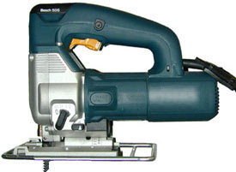
Handheld jig saw

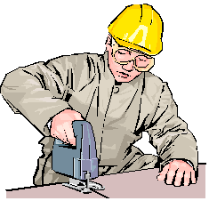
Jigsaw in use

Handheld jig saws are useful for precision-cutting, intricate curves and patterns in thin stock. They have thin blades that move rapidly up and down. The blade is held in upper and lower chucks that pull it tight and keep it from bending.

Handheld jig saws are generally not considered to be as dangerous as other saws, however, contact at the point of operation can cause hand and finger injuries. Contact with the blade can also occur below the stock being cut. All portions of the blade must be guarded.

Operator Involvement

The operator is responsible for holding the jig saw with one hand while the other hand is used to secure the stock. A trigger is depressed and the saw is moved over the stock as the blade cuts through the material. The trigger must be held throughout the entire cutting process.

POINT OF OPERATION
Potential Hazard: Contact with the moving blade may occur.

Solution: Guard the blade with an adjustable or self-adjusting guard both above and below the stock being cut. [1910.213(r)(4)]

FLYING PARTICLES
Potential Hazard: Wood chips and splinters may be thrown by the cutting action.

Solution: Guard the blade with an adjustable or self-adjusting guard as necessary. [1910.213(r)(4)]

Additional Safety Measures
- Use the proper size of blade for the work being done.
- Maintain sharp blades.
- Make turns slowly. Do not make sharp turns with a wide blade; use a narrow blade for sharp turns.
- Always wear eye and face protection.
- Wear guard (for example, mesh gloves, metal guards) on the free hand to protect it from flying particles.

