Falls:

Misuse of Portable Ladders

Am I In Danger?  You risk falling if portable ladders are not safely positioned each time they are used. While you are on a ladder, it may move and slip from its supports. You can also lose your balance while getting on or off an unsteady ladder. Falls from ladders can cause injuries ranging from sprains to death.  How Do I Avoid Hazards?  - Position portable ladders so the side rails extend at least 3 feet above the landing.  - Secure side rails at the top to a rigid support and use a grab device when 3 foot extension is not possible.  - Make sure that the weight on the ladder will not cause it to slip off its support.  - Before each use inspect ladders for cracked or broken parts such as rungs, steps, side rails, feet and locking components.  - Do not apply more weight on the ladder than it is designed to support [For more, see Ladder Safety below].  - Use only ladders that comply with OSHA design standards [1926.1053(a)(1)]. | Figure 1 - This ladder is being used at the proper angle, and appears to be stable and secure
Additional Information:
- OSHA Standard: 1926.1053(b)(1)
- Worker Deaths by Falls: A Summary of Surveillance Findings and Investigative Case Reports. NIOSH Publication 2000-116 (2000, November). See listing on NIOSH website

Ladder Safety

The OSHA Standard for portable ladders contains specific requirements designed to ensure worker safety:

 | Loads  Angle  Rungs | Slipping  Other Requirements
Loads  - Self-supporting (foldout) and non-self-supporting (leaning) portable ladders must be able to support at least four times the maximum intended load, except extra-heavy-duty metal or plastic ladders, which must be able to sustain 3.3 times the maximum intended load. (See Figure 2.) |  |  | 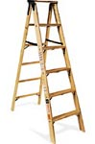  Figure 2
Angle  - Non-self-supporting ladders, which must lean against a wall or other support, are to be positioned at such an angle that the horizontal distance from the top support to the foot of the ladder is about 1/4 the working length of the ladder. (See Figure 3.)  - In the case of job-made wooden ladders, that angle should equal about 1/8 the working length. This minimizes the strain of the load on ladder joints that may not be as strong as on commercially manufactured ladders. |  |  | 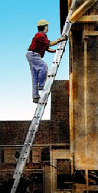  Figure 3
Rungs  - Ladder rungs, cleats, or steps must be parallel, level, and uniformly spaced when the ladder is in position for use. Rungs must be spaced between 10 and 14 inches apart.  - For extension trestle ladders, the spacing must be 8-18 inches for the base, and 6-12 inches on the extension section.  - Rungs must be so shaped that an employee's foot cannot slide off, and must be skid-resistant. (See Figure 4.) |  |  | 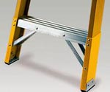  Figure 4
Slipping
- Ladders are to be kept free of oil, grease, wet paint, and other slipping hazards.
- Wood ladders must not be coated with any opaque covering, except identification or warning labels on one face only of a side rail.
Other Requirements  - Foldout or stepladders must have a metal spreader or locking device to hold the front and back sections in an open position when in use. (See Figure 5.)  - When two or more ladders are used to reach a work area, they must be offset with a landing or platform between the ladders.  - The area around the top and bottom of ladder must be kept clear.  - Ladders must not be tied or fastened together to provide longer sections, unless they are specifically designed for such use. (See Figure 6.)  - Never use a ladder for any purpose other than the one for which it was designed. |  |  | 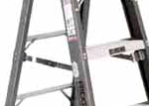  Figure 5
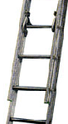

Figure 6
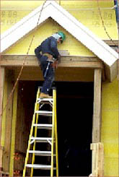

Additional Examples

Figure 7 - This is improperly using the top rung of this stepladder to work from.

