Powered Industrial Trucks
(Forklifts)

29 CFR 1910.178

Table of Contents

Executive Summary 1
Powered Industrial Trucks 3
Appendices
A - Powered Industrial Truck Operator Training 13
B - Sample Daily Checklist For Powered Industrial Trucks 18
C - Developing a Training Program for Powered Industrial Trucks 31
D - Sample Powered Industrial Truck Operator Training Program Outline 35
E - Training Questionnaire 37
F - Sample Performance Test for Forklift Operators 40
G - Certification of Training 41
H - Frequently Asked Questions About Powered Industrial Truck Operator Training 43
I - Forklift Designation 48
J - Designated Locations 51
Table
Summary Table on Use of Industrial Trucks in Various Locations 53

Powered Industrial Truck (Forklift) Training

Executive Summary

29 CFR 1910.178 Change Highlights (effective March 1, 1999)

The Powered Industrial Truck (forklift) section of the standard was changed to incorporate more training requirements. An employer is now required to “certify” forklift operators before they are allowed to operate the equipment. The training should be based on the:

- operator's prior knowledge and skill;
- types of powered industrial trucks (forklift, motor hand, hand/rider, rider reach, order picker trucks, etc.);
- hazards present in the workplace; and
- operator's demonstrated ability to operate a powered industrial truck safety.

Forklift operators shall receive initial training in the following topics, except in topics which the employer can demonstrate are not applicable to safe operation of the forklift in the employer's workplace.

Forklift-related topics:

- operating instructions, warnings, and precautions for the types of forklifts the operator will be authorized to operate;
- differences between a forklift and an automobile;
- forklift controls and instrumentation (where they are located, what they do, and how they work);
- engine or motor operation;
- steering and maneuvering;
- visibility (including restrictions due to loading);
- fork and attachment adaptation, operation, and use limitations;
- vehicle capability;
- any vehicle inspection and maintenance that the operator will be required to perform;
- refueling and/or charging and recharging of batteries;
- operating limitations; and
- any other operating instructions, warnings, or precautions listed in the operator's manual for the types of vehicle that the employee is being trained to operate.

Workplace-related topics:

- surface conditions where the vehicle will be operated;
- composition of loads to be carried and load stability;
- load manipulation, stacking, and unstacking;
- pedestrian traffic in areas where the vehicle will be operated;
- narrow aisles and other restricted places where the vehicle will be operated;
- hazardous (classified) locations where the vehicle will be operated;
- ramps and other sloped surfaces that could affect the vehicle's stability;
- closed environments and other areas where insufficient ventilation or poor vehicle maintenance could cause a buildup of carbon monoxide or diesel exhaust; and
- other unique or potentially hazardous environmental conditions in the workplace that could affect the safe operation.

Refresher training is required if the:

- operator is involved in an accident or a near-miss accident;
- operator has been observed operating the vehicle in an unsafe manner;
- operator has been determined during an evaluation to need additional training; or
- operator is assigned to operate a different type of forklift.

Evaluations of each operator's performance are required as part of the initial and refresher training, and at least once every three years.

The employer shall certify that each employee has been trained and evaluated. The certification shall include the name of the operator, the date of training, the date of the evaluation, and the identity of the person(s) performing the training or evaluation.

Powered Industrial Trucks
(Forklifts)

This program is written to comply with the requirements of 29 CFR 1910.178 Powered Industrial Trucks (Forklifts) for general industry and 29 CFR 1926.602 for the construction industry. The purpose of this program is to outline the safety requirements relating to fire protection, design, maintenance, and use of forklift trucks, tractors, platform lift trucks, motorized hand trucks, and other specialized industrial trucks powered by electric motors or internal combustion engines. The requirements outlined in the procedure do not pertain to the operation of automobile or truck type vehicles not operated within work areas.

The use of forklift trucks is subject to certain hazards that cannot be completely eliminated by mechanical means, but the risks can be minimized by the exercise of intelligence, care, and common sense. It is therefore essential to have competent and careful operators, physically and mentally fit, and thoroughly trained in the safe operation of the equipment and the handling of the loads. Serious hazards are overloading, instability of the load, obstruction to the free passage of the load, collision with objects or pedestrians, poor maintenance, and use of equipment for a purpose for which it was not intended or designed.

Only trained and certified operators shall be permitted to operate a forklift truck. Methods shall be devised to train and certify operators in the safe operation of forklift trucks. To obtain an operators license, each employee to be licensed must demonstrate to the employer, the safe driving skills necessary to operate each specific type of equipment for which the employee is to be licensed.

The Occupational Safety and Health Administration (OSHA) requires that a training program be devised that bases the amount and type of training required on: the operator’s prior knowledge and skill; the types of powered industrial trucks the operator will operate in the workplace; the hazards present in the workplace; and the operator's demonstrated ability to operate a powered industrial truck safely.

At a minimum, training should include the following:

- forklift stability (Appendix A);
- procedure(s) for inspecting forklift (Appendix B);
- procedure(s) when defects are found;
- general loading practices;
- forklift operating rules within the workplace to include control operation, traveling speeds, cornering speeds, driving near pedestrians, the importance of adequate clearances and of looking in the direction of travel;
- determining whether the load is safe to handle;
- correct piling/stacking of materials in stock;
- precautions when leaving a forklift unattended;
- working in hazardous environments or with hazardous materials;
- refueling or recharging operations; and
- specific hazards of the truck operators' prospective tasks.

Employees who violate safe operating rules for forklift trucks, or who drive forklift trucks without authorization, or supervisors who allow unauthorized employees to drive forklift trucks should be subject to disciplinary action up to and including termination.

Specific information regarding developing of a training program for powered industrial truck operators can be found in Appendix C. This attachment discusses basic issues to developing an “in-house” training capability that includes operator identification, types of forklifts, methods of training, training program content, employee evaluation, and refresher training. Additionally included are a sample powered industrial truck operator training program outline (Appendix D), a sample training questionnaire (Appendix E), and a sample performance test for forklift operators (Appendix F).

The new forklift standard is intended to reduce the number of injuries and deaths that occur as a result of inadequate operator training. The standard will apply to all industries where forklifts are being used, except agricultural operations. Appendix G is provided to help address frequently asked questions about powered industrial truck operator training.

Inspecting the Forklift

Forklifts shall be inspected before being placed in service and shall not be placed in service if the examination shows any condition adversely affecting the safety of the vehicle.

- Such examination shall be made at least daily before each shift.
- Industrial trucks used on a round-the-clock basis shall be examined before each shift.
- Defects, when found, shall be immediately reported and corrected.

Establish and implement an inspection program.

- At the start of each shift, the operator should check the forklift assigned to assure that it is in safe working order.
- If for any reason the operator believes that the forklift is unsafe to drive or operate, it should be immediately reported to the supervisor.
- Appendix B provides examples of items to inspect both by forklift type and generic.

Unless qualified, the operator should not attempt to make any repairs. Only qualified and authorized personnel should be permitted to maintain, repair and adjust forklifts. The employer shall not perform modifications and additions that affect capacity and safe operation without manufacturers prior written approval. Capacity, operation, and maintenance instruction plates, tags, or decals shall be changed accordingly.

If the forklift is equipped with front-end attachments, other than factory installed attachments, the employer shall request that the forklift be marked to identify the attachments and show the approximate weight of the forklift and attachment combination at maximum elevation with load laterally centered.

The operator shall see that all nameplates and markings are in place and are maintained in a legible condition.

When a Defect is Found

Any forklift in an unsafe operating condition shall be removed from service.

- All repairs shall be made by authorized personnel.
- Remove the forklift from service and tag it out of service until the defect can be repaired or the forklift can be replaced.

Establish and implement an inspection and preventive maintenance program to minimize the possibility of employees using unsafe forklift.

- Operating and safety instruction outlined in manufacturers manuals must be followed.
- Forklift dealers also can provide sound advice on proper lubricants, parts, tools and procedures, and may also perform truck maintenance under contract.

No repairs shall be made in Class I, II, and III locations. (Appendix H & I.)

No forklift truck shall be operated with a leak in the fuel system until the leak has been corrected.

- Those repairs to the fuel and ignition systems of forklift that involve fire hazards shall be conducted only in locations designated for such repairs.
- Fuel tanks shall not be filled while the engine is running.
- Spillage of oil or fuel shall be avoided and shall be carefully removed and the fuel tank cap replaced before restarting the engine.
- Open flames shall not be used for checking gasoline level in fuel tanks or for checking electrolyte levels in storage batteries.

Forklifts in need of repairs to the electrical system shall have the battery disconnected prior to such repairs.

All parts of any such forklift requiring replacement shall be replaced only by parts equivalent as to safety with those used in the original design.

Forklift shall not be altered so that the relative positions of the various parts are different from what they were when originally received from the manufacturer.

- Forklift shall not be altered either by the addition of extra parts not provided by the manufacturer or by the elimination of any parts without manufacturers written authorization.
- Additional counter-weighing of forklifts shall not be done unless approved by the forklift manufacturer.

Any vehicle that emits hazardous sparks or flames from the exhaust system shall immediately be removed from service and not returned to service until the cause for the emission of such sparks and flames has been eliminated.

- Water mufflers shall be filled daily or as frequently as is necessary to prevent depletion of the supply of water below 75% of the filled capacity.
- Vehicles with mufflers having screens or other parts that may become clogged shall not be operated while such screens or parts are clogged.

When the temperature of any part of any forklift is found to be in excess of its normal operating temperature, thus creating a hazardous condition, the vehicle shall be removed from service. The forklift shall not be returned to service until the cause for such overheating has been eliminated.

Powered industrial trucks shall be kept in a clean condition, free of lint, excess oil, and grease. Noncombustible agents should be used for cleaning trucks. Low flash point (below 100 degrees F) solvents shall not be used. High flash point (at or above 100 degrees F) solvents may be used. Precautions regarding toxicity, ventilation, and fire hazard shall be consonant with the agent or solvent used.

Powered industrial trucks originally approved for the use of gasoline for fuel may be converted to liquefied petroleum gas fuel provided the complete conversion results in a truck which embodies the features specified for LP or LPS designated trucks. The conversion equipment shall be approved in writing by the manufacturer.

General Loading Practices

Portable and powered dockboards shall be strong enough to carry the load imposed on them.

Portable dockboards shall be secured in position, either by being anchored or equipped with devices that will prevent slippage.

Powered dockboards shall be designed and constructed in accordance with Commercial Standard CS202-56 (1961) “Industrial Lifts and Hinged Loading Ramps” published by the U.S. Department of Commerce.

Handholds, or other effective means, shall be provided on portable dockboards to permit safe handling.

Positive protection shall be provided to prevent railroad cars from being moved while dockboards or bridge plates are in position.

Wheel stops or other recognized positive protection shall be provided to prevent railroad cars from moving during loading or unloading operations.

The brakes of highway trucks shall be set and wheel chocks placed under the rear wheels to prevent the trucks from rolling while they are boarded with powered industrial trucks.

Fixed jacks may be necessary to support a semi trailer and prevent upending during the loading or unloading when the trailer is not coupled to a tractor.

Brakes shall be set and wheel blocks shall be in place to prevent movement of trucks, trailers, or railroad cars while loading or unloading.

- Fixed jacks may be necessary to support a semi trailer during loading or unloading when the trailer is not coupled to a tractor.
- The flooring of trucks, trailers, and railroad cars shall be checked for breaks and weakness before they are driven onto.

Only stable or safely arranged loads shall be handled. Caution shall be exercised when handling off-center loads that cannot be centered.

Only loads within the rated capacity of the forklift truck shall be handled.

The long or high (including multiple-tiered) loads that may affect capacity shall be adjusted.

Forklift equipped with attachments shall be operated as partially loaded trucks when not handling a load.

A load engaging means (forks) shall be placed under the load as far as possible; the mast shall be carefully tilted backward to stabilize the load.

Extreme care shall be used when tilting the load forward or backward, particularly when high tiering.

- Tilting forward with load engaging means elevated shall be prohibited except to pick up a load.
- An elevated load shall not be tilted forward except when the load is in a deposit position over a rack or stack.
- When stacking or tiering, only enough backward tilt to stabilize the load shall be used.

General Forklift Operating Rules

The operator shall:
- maintain a safe distance (recommended 3'-5') from the edge of ramps or platforms while on any elevated dock, or platform or freight car;
- assure sufficient headroom under overhead installations, lights, pipes, sprinkler system, etc.;
- observe all traffic safety rules, including authorized plant speed limits;
- maintain a safe distance, approximately three truck lengths from the forklift ahead, and the forklift shall be kept under control at all times;
- yield the right-of-way to pedestrians;
- yield the right-of-way to ambulances, fire trucks, or other vehicles in emergency situations;
- slow down and sound the horn at cross aisles and other locations where vision is obstructed;
- look in the direction of, and keep a clear view of, the path of travel;
- travel with the load trailing if the load being carried obstructs forward view;
- cross railroad tracks diagonally wherever possible; and
- ascended or descended grades slowly.

- When ascending or descending grades in excess of 10%, loaded trucks shall be driven with the load upgrade.
- On all grades the load and load engaging means shall be tilted back if applicable, and raised only as far as necessary to clear the road surface.

- Operate at a speed, under all travel conditions, that will permit the forklift to be brought to a stop in a safe manner;
- slow down for wet and slippery floors;
- properly secure dock board or bridge plates before they are driven over. Dock board or bridge plates shall be driven over carefully and slowly and their rated capacity never exceeded; and
- approach elevators slowly, and then enter squarely after the elevator car is properly leveled.

- On the elevator, the controls shall be neutralized, power shut off, and the brakes set.
- Motorized hand trucks must enter elevator or other confined areas with load end forward.
- Note any oil or fuel leakage from any forklift and report the deficiency to supervisors immediately.

The operator shall not:
- operate a forklift under the influence of prescription or over-the-counter medications that may interfere with safe operation of the forklift in any manner (i.e., drowsy, dizzy, loss of attention);
- drive forklifts up to anyone standing in front of a bench or other fixed object;
- run over loose objects on the roadway surface;
- allow persons to stand or pass under the elevated portion of any forklift, whether loaded or empty;
- park closer than eight feet from the center of railroad tracks;
- allow any person to ride on forklift except the operator, unless the forklift has provisions (additional seating authorized by the manufacturer) for passengers;
- place arms or legs between the uprights of the mast or outside the running lines of the forklift;
- use forklift for opening or closing freight doors;
- block fire aisles, access to stairways, or fire equipment with the forklift or the load being handled;
- pass other forklifts traveling in the same direction at intersections, blind spots, or other dangerous locations;
- participate in stunt driving or horseplay; or
- push or tow other forklifts.

An overhead guard shall be used as protection against falling objects.

Note: Overhead guards are intended to offer protection from the impact of small packages, boxes, bagged material, etc., representative of the job application, but not to withstand the impact of a falling capacity load.

A load backrest extension shall be used whenever necessary to minimize the possibility of the load or part of it from falling to the rear.

Only approved powered industrial trucks shall be used in hazardous locations.

When lifting personnel with a forklift equipped with vertical only, or vertical and horizontal controls capable of being elevated with the lifting carriage or forks, the following additional precautions shall be taken for the protection of the personnel being elevated.

- Use of a safety platform firmly secured to the lifting carriage and/or forks.
- Personnel on the platform shall have access to the power shut off to the forklift.
- Protection from falling objects, as indicated, necessary by the operating conditions shall be provided.

Determining Load Safety

Forklift operators should know the weight of the load prior to moving the load.

Standing on a forklift or adding counterweights to compensate for an overload will not be permitted.

Operators should never attempt to operate a forklift with an overload. Such a load is dangerous because it removes weight from the steering wheels, which affects the steering.

Correct Material Piling/Stacking

Approach to within a foot or so of stack or tier with load held low.

- Stop forklift and raise load slowly while inching forward.
- When load reaches desired height, tilt upright forward until it is vertical.
- Position load over stack so it lines up squarely.

Lower the load slowly. When it is resting solidly on the stack and forks are free, back machine away slowly.

Extreme care must be taken when mast and load are raised high (see Appendix A for more information).

- The heavier the load and the higher it is raised, the higher the forklift's center of gravity is forced, reducing stability.
- When lifting a load, always check for any overhead obstructions that might be damaged or cause the load to spill or topple the forklift.

Always heed instructions about stacking height.

- Stacking right to the ceiling will block the sprinkler system and may overload the floor.
- Allow 18" clearance below sprinkler heads or piping.
- Allow 24" clearance below roof if not equipped with sprinklers.
- Never allow other workers to stand nearby when you stack materials.

Do not stack material in aisles or roadways.

Unattended Forklift Precautions

When a powered industrial truck is left unattended:

- fully lower load engaging means;
- neutralize controls;
- shut off power;
- set brakes; and
- block wheels if the forklift is parked on an incline.

A powered industrial truck is unattended when:

- the operator is 25' or more away from the vehicle which remains in his view; or
- the operator leaves the vehicle and it is not in his view.

When the operator of a powered industrial truck is dismounted and within 25' of the forklift still in his view:

- the load engaging means shall be fully lowered;
- controls neutralized; and
- brakes set to prevent movement.

If the load must remain elevated, the operator must remain on the forklift truck at the controls.

Hazardous Environments and Materials

Concentration levels of carbon monoxide gas created by powered industrial truck operations shall not exceed the levels specified in 29 CFR 1910.1000.

Where general lighting is less than 2 lumens per square foot, auxiliary directional lighting shall be provided on the forklift.

Refueling or Recharging Operations

Battery charging installations shall be located in areas designated for that purpose.

Facilities shall be provided for flushing and neutralizing spilled electrolyte, for fire protection, for protecting charging apparatus from damage by forklifts, and for adequate ventilation for dispersal of fumes from gassing batteries.

A conveyor, overhead hoist, or equivalent material handling equipment shall be provided for handling batteries.

Reinstalled batteries shall be properly positioned and secured in the forklift.

- A carboy tilter or siphon shall be provided for handling electrolyte.
- When charging batteries, acid shall be poured into water; water shall not be poured into acid.

Forklifts shall be properly positioned and brake applied before attempting to change or charge batteries.

Care shall be taken to assure that vent caps are functioning. The battery (or compartment) cover(s) shall be open to dissipate heat.

Smoking shall be prohibited in charging and refueling areas and "No Smoking" signs posted in these areas.

Precautions shall be taken to prevent open flames, sparks, or electric arcs in battery charging areas.

Tools and other metallic objects shall be kept away from the top of uncovered batteries

POWERED INDUSTRIAL TRUCK OPERATOR TRAINING

STABILITY OF POWERED INDUSTRIAL TRUCKS

SUMMARY OF APPENDIX A

A-1. Definitions

The following definitions help to explain the principle of stability:

 Center of Gravity is a point on an object at which all of the object's weight can be considered to be concentrated.

 Counterweight is the weight that is a part of the truck's basic structure that is used to offset the load's weight and to maximize the vehicle's resistance to tipping over.

 Fulcrum is the truck's axis of rotation when it tips over.

 Grade is a surface's slope that is usually measured as the number of feet of rise or fall over a hundred foot horizontal distance (measured as a per cent).

 Lateral stability is a truck's resistance to tipping over sideways.

 Line of action is an imaginary line through an object's center of gravity.

 Load center is the horizontal distance from the load's edge (or the fork's or other attachment's vertical face) to the line of action through the load's center of gravity.

 Longitudinal stability is the truck's resistance to overturning forward or rearward.

 Moment is the product of the object's weight times the distance form a fixed point. In the case of a powered industrial truck, the distance is measured from the point that the truck will tip over to the object's line of action. The distance is always measured perpendicular to the line of action.

 Track is the distance between wheels on the vehicle's same axle.

 Wheelbase is the distance between the centerline of the vehicle's front and rear wheels.

A-2. General

Stability determination for a powered industrial depends on a few basic principles. There are many factors that contribute to a vehicle's stability:

 vehicle wheelbase;
 track;
 height;
 the load's weight distribution; and,
 the vehicle's counterweight location (if so equipped).

The "stability triangle," used in most stability discussions, demonstrates stability simply.

A-3. Basic Principles

Determining whether an object is stable is dependent on the object's moment at one end of a system being greater than, equal to, or smaller than the object's moment at the system's other end. This is the same principle on which a see-saw works. If the product of the load and distance from the fulcrum (moment) is equal to the moment at the device's other end, the device is balanced and will not move. However, if there is a greater moment at the device's one end, the device will try to move downward at the end with the greater moment.

Longitudinal stability of a counterbalanced powered industrial truck depends on the vehicle's moment and the load's moment. In other words, if the mathematic product of the load moment (the distance from the front wheels, the point about which the vehicle would tip over) to the load's center of gravity times the load's weight is less than the vehicle's moment, the system is balanced and will not tip forward. However, if the load-moment is greater than the vehicle-moment, the greater load-moment will force the truck to tip forward.

A-4. The Stability Triangle

Almost all counterbalanced powered industrial trucks have a three point suspension system, that is, the vehicle is supported at three points. The truck's steer axle is attached to the truck by a pivot pin in the axle's center. When the points are connected with imaginary lines, this three-point support forms a triangle called the stability triangle (Figure 1).

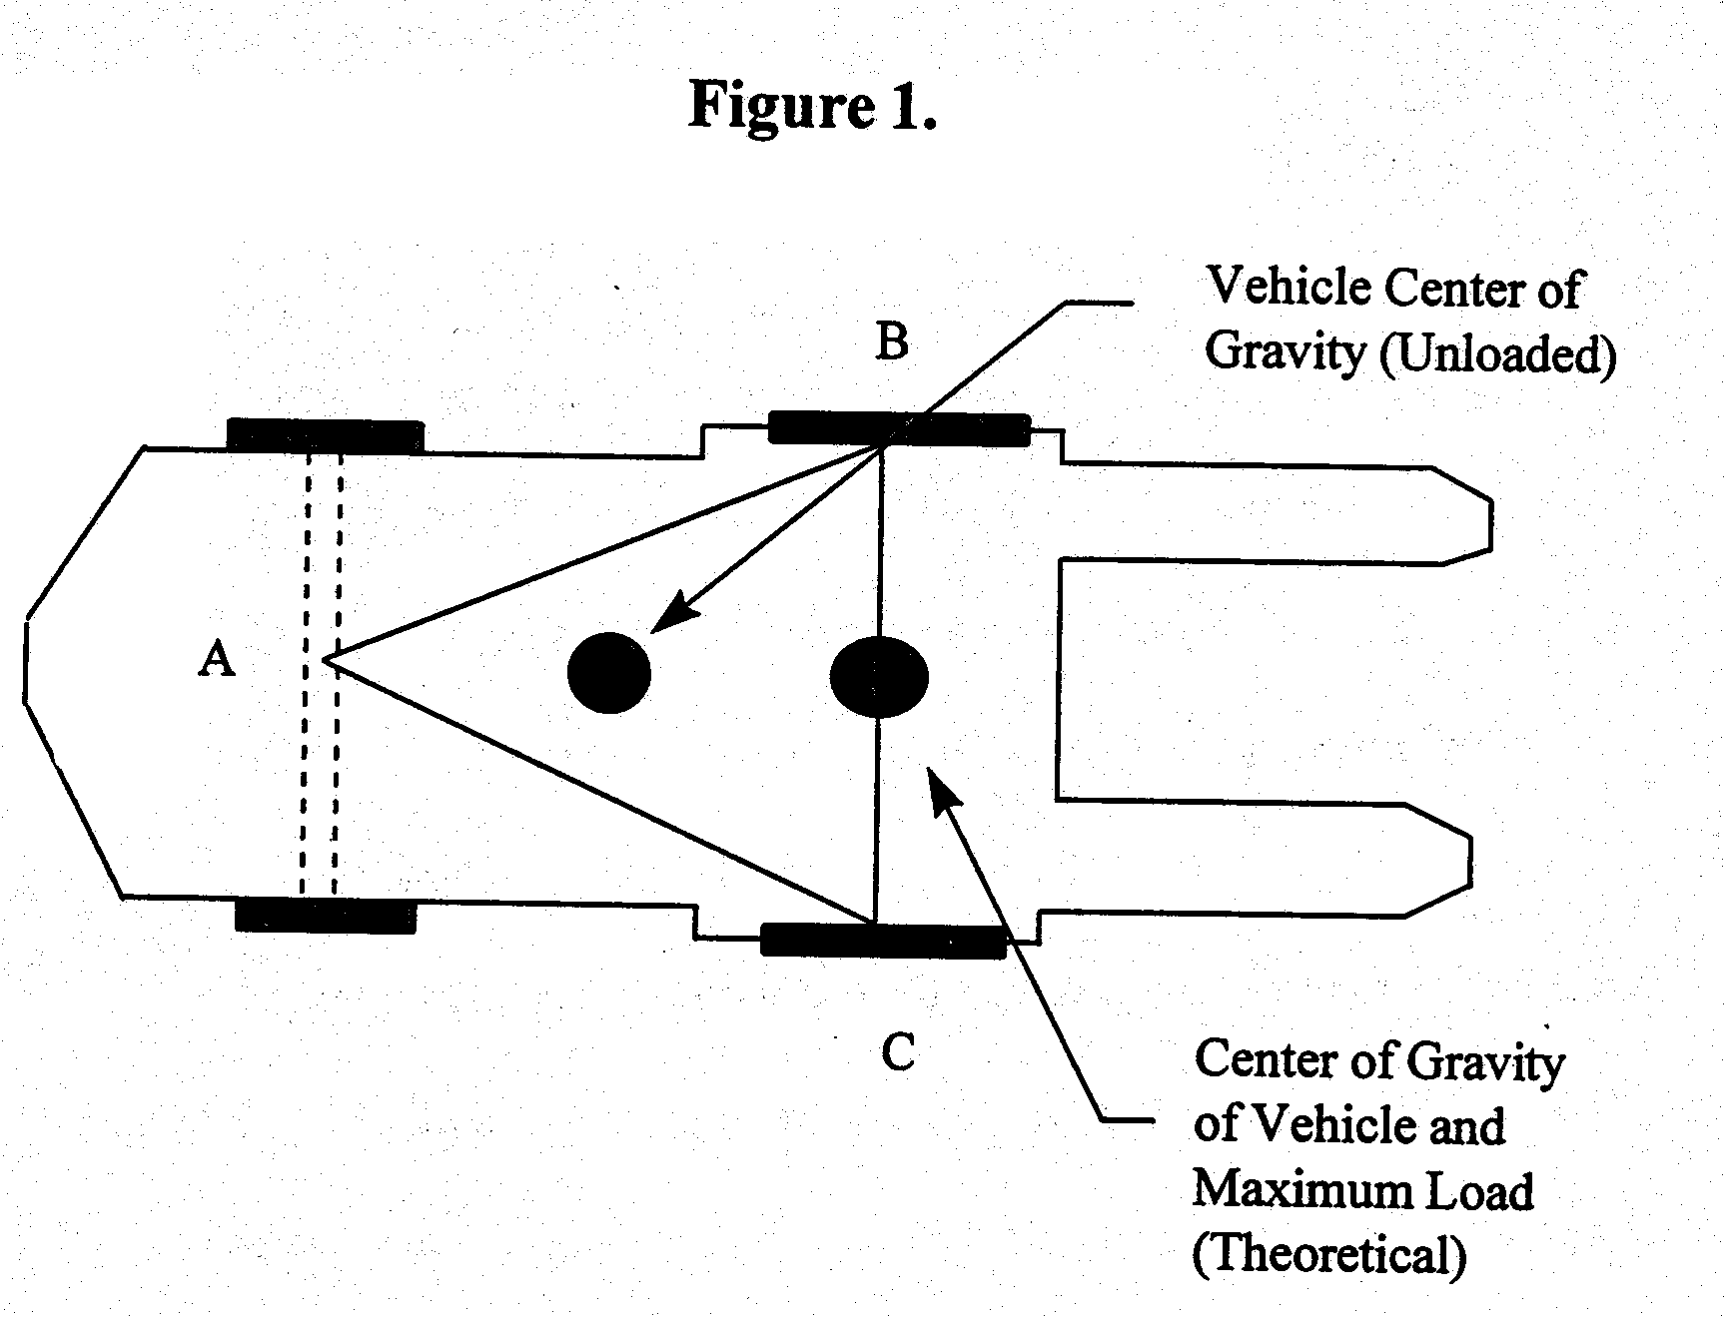

Notes:

- When the vehicle is loaded, the combined center of gravity (CG) shifts toward line B-C. Theoretically, the maximum load will result in the CG at the line B-C. In actual practice, the combined CG should never be at line B-C.

2. The addition of additional counterweight will cause the truck CG to shift toward point A and result in a truck that is less stable laterally.

When the vehicle's line of action, or load center, falls within the stability triangle, the vehicle is stable and will not tip over. However, when the vehicle's line of action or the vehicle/load combination falls outside the stability triangle, the vehicle is unstable and may tip over. See Figure 2.

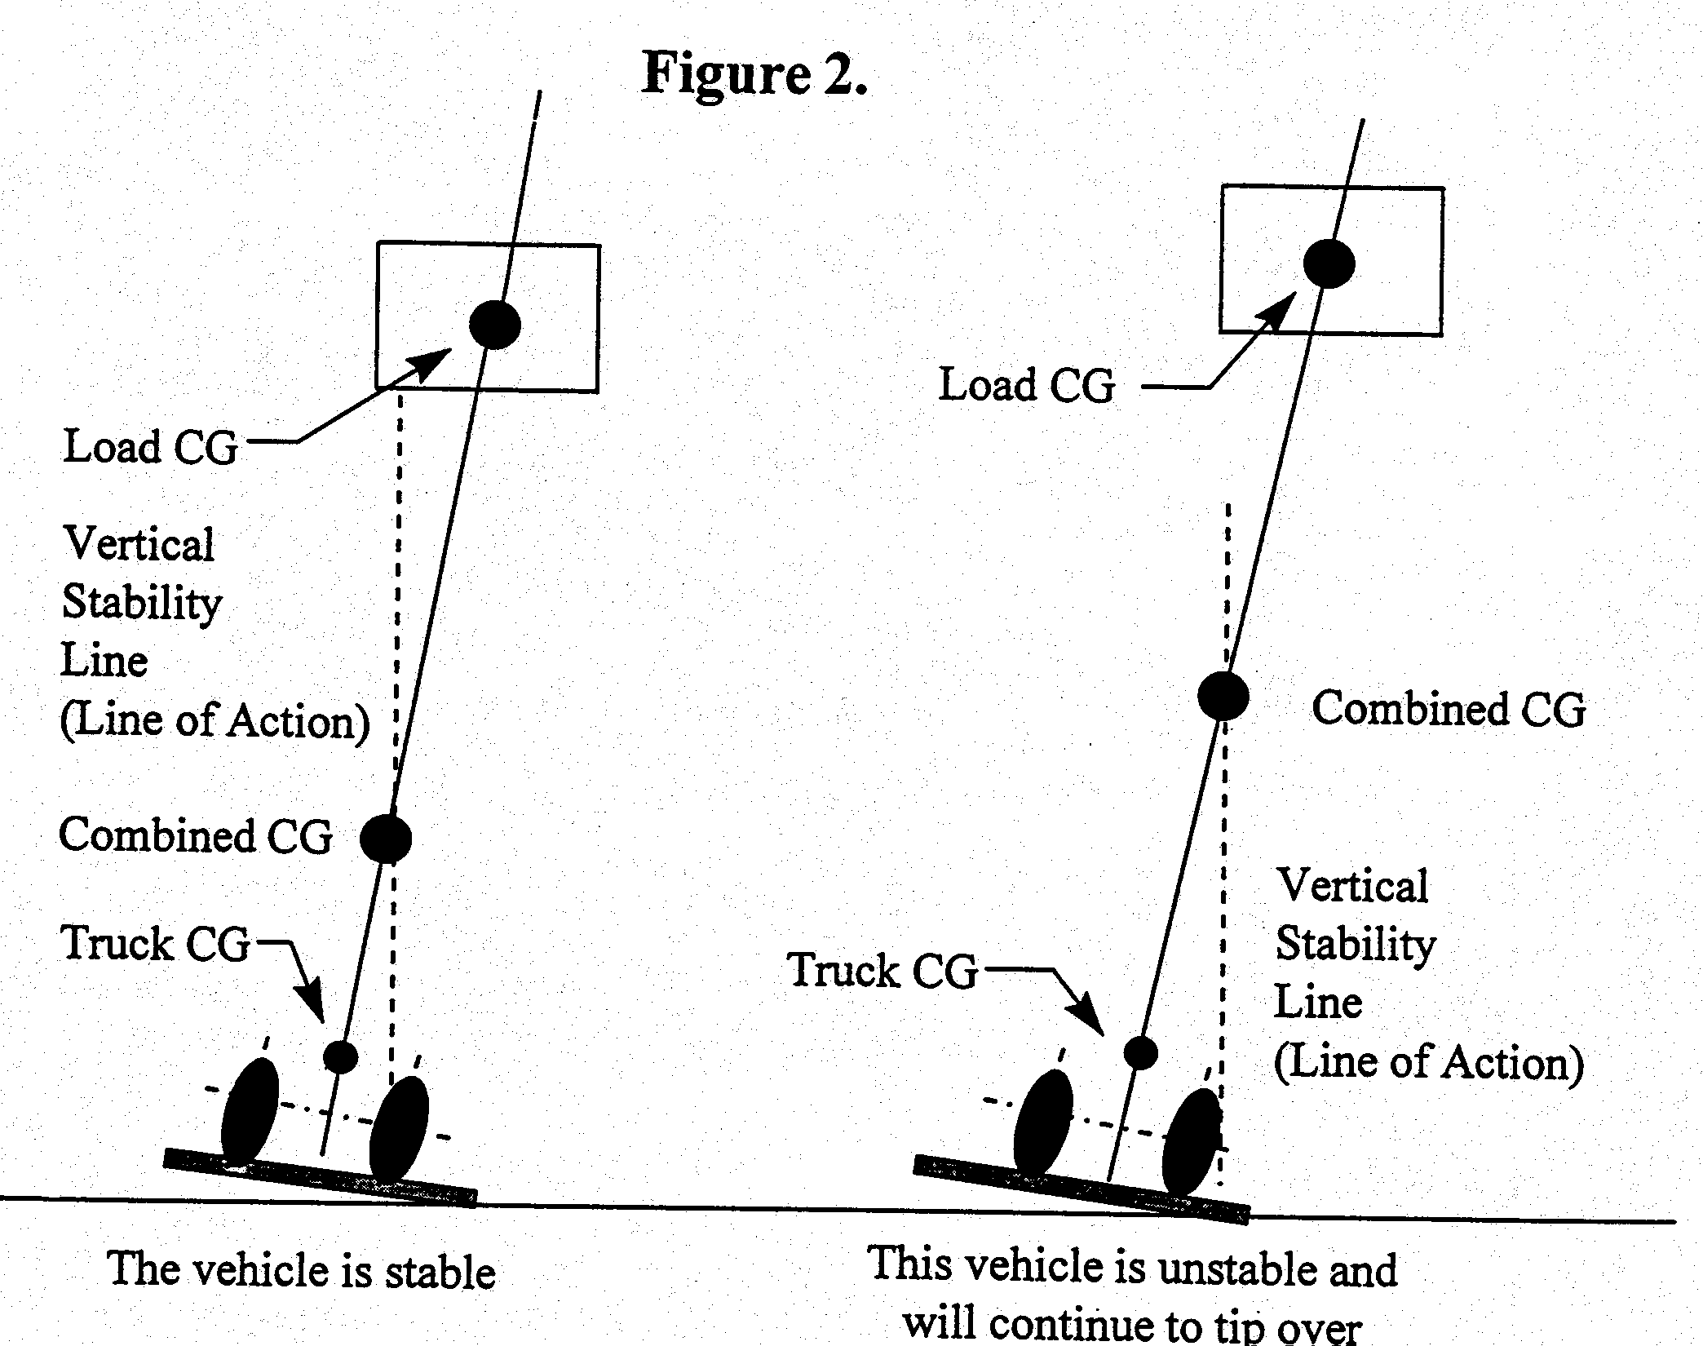

A-5. Longitudinal Stability

The axis of rotation when a truck tips forward is the front wheels' points of contact with the pavement. When a powered industrial truck tips forward, the truck will rotate about this line. When a truck is stable, the vehicle-moment must exceed the load-moment. As long as the vehicle-moment is equal to or exceeds the load-moment, the vehicle will not tip over. On the other hand, if the load moment slightly exceeds the vehicle-moment, the truck will begin to tip forward, thereby causing loss of steering control. If the load-moment greatly exceeds the vehicle moment, the truck will tip forward.

To determine the maximum safer load-moment, the truck manufacturer normally rates the truck at a maximum load at a given distance from the front face of the forks. The specified distance from the front face of the forks to the line of action of the load is commonly called a load center. Trucks with a 30,000 pounds or less capacity are normally rated at a given load weight at a 24-inch load center. For trucks of greater than 30,000 pounds capacity, the load center is normally rated at 36- or 48-inch load center distance. To safely operate the vehicle, the operator should always check the data plate to determine the maximum allowable weight at the rated load center.

Although the true load-moment distance is measured from the front wheels, this distance is greater than the distance from the front face of the forks. Calculation of the maximum allowable load-moment using the load-center distance always provides a lower load-moment than the truck was designed to handle. When handling unusual loads, such as those that are larger than 48 inches long (the center of gravity is greater than 24 inches) or an offset center of gravity, etc., a maximum allowable load moment should be calculated and used to determine whether a load can be safely handled.

 For example, if an operator is operating a 3000 pound capacity truck (with a 24 inch load center), the maximum allowable load moment is 72,000 inch pounds (3,000 times 24). If a probable load is 60 inches long (30 inch load center), than the maximum that this load can weigh is 2,400 pounds (72,000 divided by 30).

A-6. Lateral Stability

The vehicle's lateral stability is determined by the lines of action's position (a vertical line that passes through the combined vehicle's and load's center of gravity) relative to the stability triangle. When the vehicle is not loaded, the truck's center of gravity location is the only factor to be considered in determining the truck's stability. As long as the line of action of the combined vehicle's and load's center of gravity falls within the stability triangle, the truck is stable and will not tip over. However, is the line of action falls outside the stability triangle, the truck is not stable and may tip over. Factors that affect the vehicle's lateral stability include the load's placement on the truck, the height of the load above the surface on which the vehicle is operating, and the vehicle's degree of lean.

A-7 Dynamic Stability

The dynamic forces that result when the vehicle and load are put into motion must also be considered. The weight's transfer and the resultant shift in the center of gravity due to the dynamic forces created when the machine is moving, braking, cornering, lifting, tilting, and lowering loads, etc., are important stability considerations.

When determining whether a load can be safely handled, the operator should exercise extra caution when handling loads that cause the vehicle to approach its maximum design characteristics. For example, if an operator must handle a maximum weight load, the load should be carried at the lowest practical height, the truck should be accelerated slowly and evenly, and forks should be tilted forward cautiously. However, no precise rules can be formulated to cover all of these eventualities.

Sample Daily Checklists
For Powered Industrial Trucks

The following checklist are intended to assist in providing training on OSHA's revised powered industrial truck operator standards. They are not a substitute for any of the provisions of the Occupational Safety and Health Act of 1970, or for any standards issued by the U.S. Department of Labor's Occupational Safety and Health Administration (OSHA). OSHA wishes to acknowledge the UAW-Ford National Joint Committee on Health and Safety for granting permission to use the checklists and related graphics.

The revised OSHA standard for powered industrial truck training requires that an employer provide training to truck operators on a variety of topics. Among these topics are vehicle inspection and maintenance that the operator will be required to perform. The following checklists are being provided as part of OSHA's ongoing effort to assist employers and employees in ensuring that a safe and healthful workplace is provided. The lists serve as a guide only and may not be totally inclusive. Each type of powered industrial truck is unique and checklist pertinent to each type of vehicle should be modified accordingly. It is recommended that the manufacturer's instructions on vehicle maintenance and owner's and operator's responsibilities also be consulted. The OSHA standards for powered industrial trucks should be evaluated to ensure compliance.

Your workplace may have a variety of trucks that are being operated. They may include the following types of vehicles:

Electric forklift trucks
- Propane forklift trucks
- Yard forklift trucks
- Electric transtacker
- Riding grip tow
- Stand-up riding tow tractor
- Walking pallet truck
- Walking transtacker
- Tow tractors
- Industrial tractors
- Reach trucks
- Order pickers

You may choose to use a checklist for each type of industrial truck you have in your workplace or compile one that can be used for any type of truck. Attached are some sample checklists for various types of trucks, as well as a generic list that can be modified to suit your workplace needs.

Daily Inspection Checklist  Electric Forklift Truck | 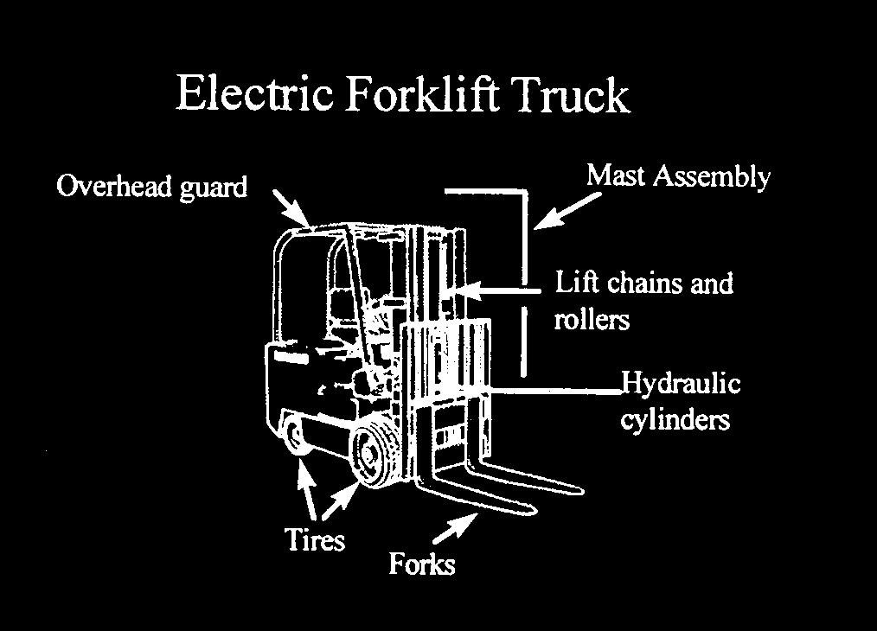
KEY OFF Procedures

- Vehicle inspection
- Overhead guard
- Hydraulic cylinders
- Mast assembly
- Lift chains and rollers
- Forks
- Tires
- Examine the battery
- Check the hydraulic fluid level

KEY ON Procedures

- Check the gauges
- Hour meter
- Battery discharge indicator
- Test the standard equipment
- Steering
- Brakes
- Front, tail, and brake lights
- Horn
- Safety seat (if equipped)
- Check the operation of load-handling attachments

Daily Inspection Checklist  Propane Forklift Truck | 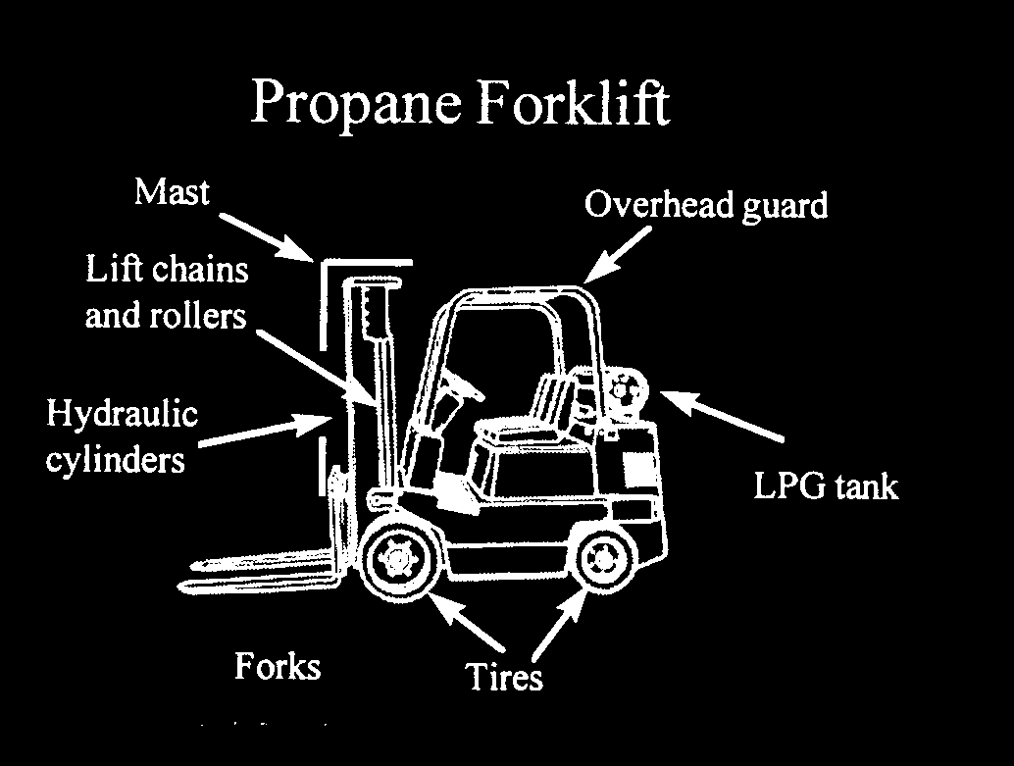
KEY OFF Procedures

- Vehicle inspection
- Overhead guard
- Hydraulic cylinders
- Mast assembly
- Lift chains and rollers
- Forks
- Tires
- LPG tank and locator pin
- LPG tank hose
- Gas gauge
- Check the engine oil level
- Examine the battery
- Check the hydraulic fluid level
- Check the engine coolant level

KEY ON Procedures

- Test the front, tail, and brake lights

ENGINE RUNNING Procedures

- Check the gauges
- Oil pressure indicator lamp
- Ammeter indicator lamp
- Hour meter
- Water temperature gauge
- Test the standard equipment
- Steering
- Brakes
- Front, tail, and brake lights
- Horn
- Safety seat (if equipped)
- Check the operation of load-handling attachments
- Check the transmission fluid level

Daily Inspection Checklist  Yard Forklift Truck | 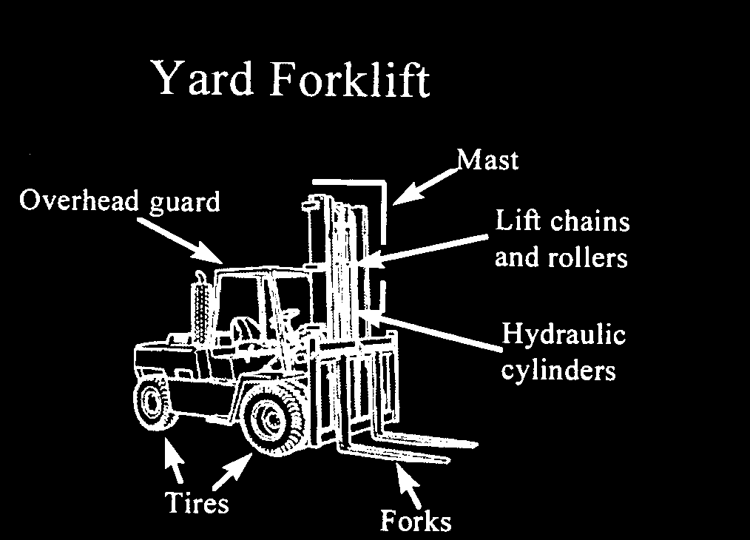
KEY OFF Procedures
- Vehicle inspection
- Overhead guard
- Hydraulic cylinders
- Mast assembly
- Lift chains and rollers
- Forks
- Tires
- LPG tank and locator pin
- LPG tank hose
- Gas gauge
- Check the engine oil level
- Examine the battery
- Check the hydraulic fluid level
- Check the engine coolant level

KEY ON Procedures
- Test the standard equipment
- Front, tail, and brake lights
- Fuel gauge (if diesel)
- Windshield wiper
- Heater

ENGINE RUNNING Procedures
- Check the gauges
- Oil pressure indicator lamp
- Ammeter indicator lamp
- Ammeter
- Hour meter
- Water temperature gauge
- Test the standard equipment
- Steering
- Brakes
- Front, tail, and brake lights
- Horn
- Safety seat (if equipped)
- Check the operation of load-handling attachments
- Check the transmission fluid level

Daily Inspection Checklist  Electric Transtacker | 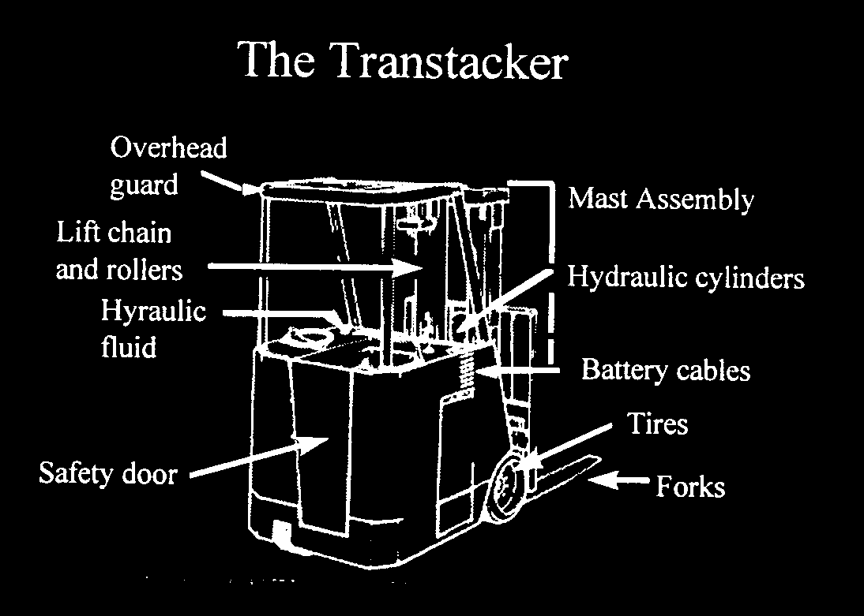
KEY OFF Procedures

- Vehicle inspection
- Overhead guard
- Hydraulic cylinders
- Mast assembly
- Lift chains and rollers
- Forks
- Tires
- Battery cables
- Safety door

KEY ON Procedures

- Check gauges
- Battery discharge indicator
- Hour meter
- Test the standard equipment
- Steering brakes
- Lights
- Horn
- Test control lever
- Check the operation of load-handling attachments

Daily Inspection Checklist  Riding Grip Tow | 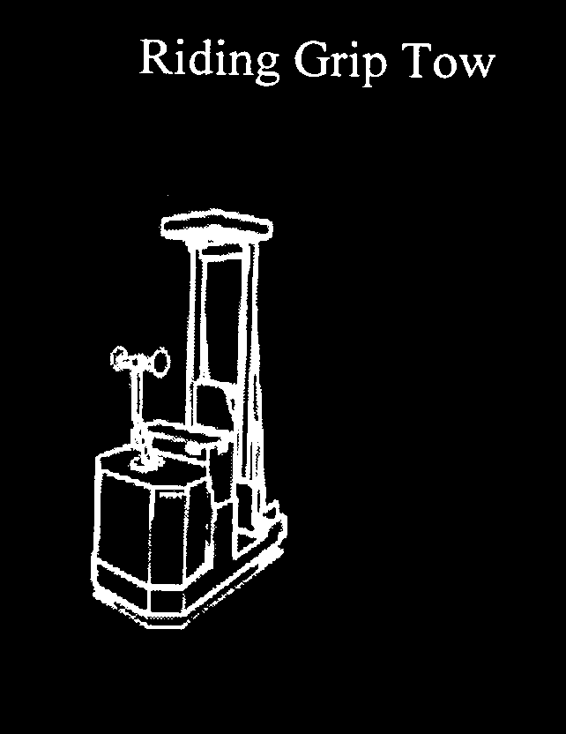
- Vehicle inspection
- Lines and hoses
- Battery
- Safety switch
- Hand guards
- Operations inspection
- Test brakes
- Check drive operations
- Test horn
- Check grip coupling

Daily Inspection Checklist  Stand-up Riding Tow Tractor | 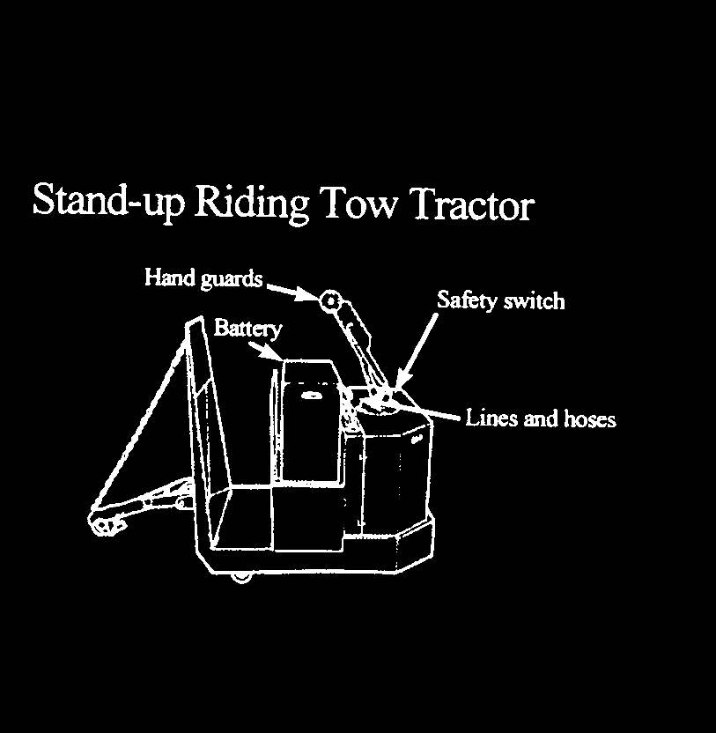
- Vehicle inspection
- Lines and hoses
- Battery
- Safety switch
- Hand guards
- Operations inspection
- Test brakes
- Check drive operations
- Test horn
- Check grip coupling

Daily Inspection Checklist  Indoor Propane Tow Tractor | 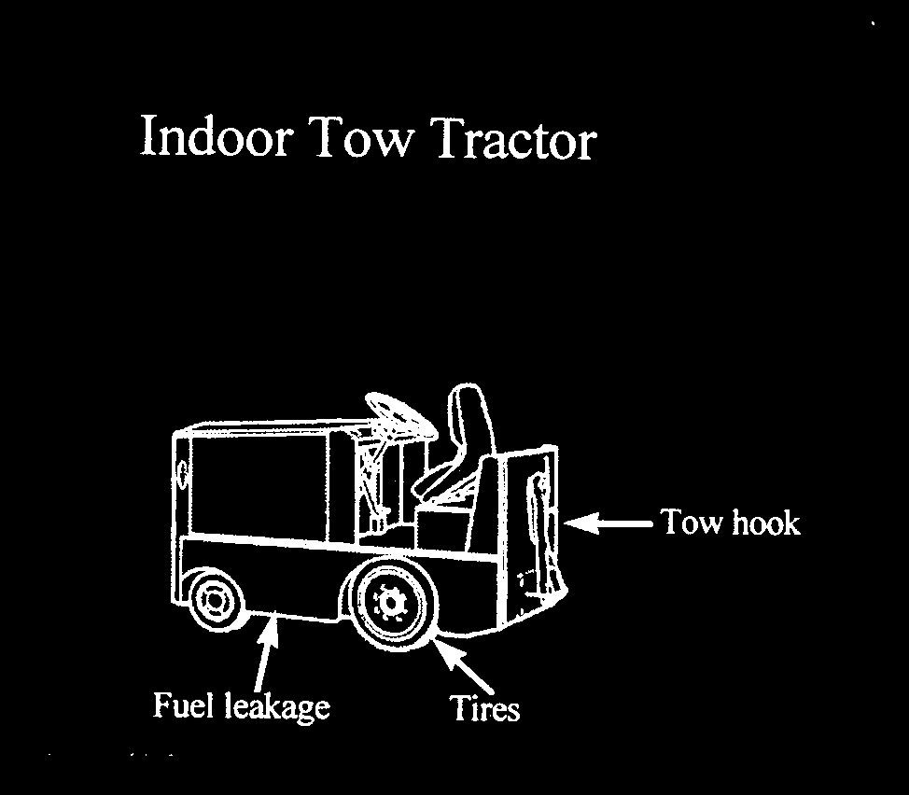
KEY OFF Procedures

- Vehicle inspection
- Fluid leakage
- Tires
- Tow hook
- Windshield (if equipped)
- Overhead guard (if equipped)
- LPG tank and locator pin
- LPG tank hose
- Gas gauge
- Check the engine oil level
- Check the engine coolant level
- Examine the battery

KEY ON Procedures

- Test the standard equipment
- Check gauges
- Oil pressure gauge
- Ammeter
- Water temperature gauge
- Hour meter

ENGINE RUNNING Procedures

- Inspect standard equipment
- Steering
- Brakes
- Horn
- Safety seat (if equipped)
- Check transmission fluid level

Daily Inspection Checklist  Industrial Tractors | 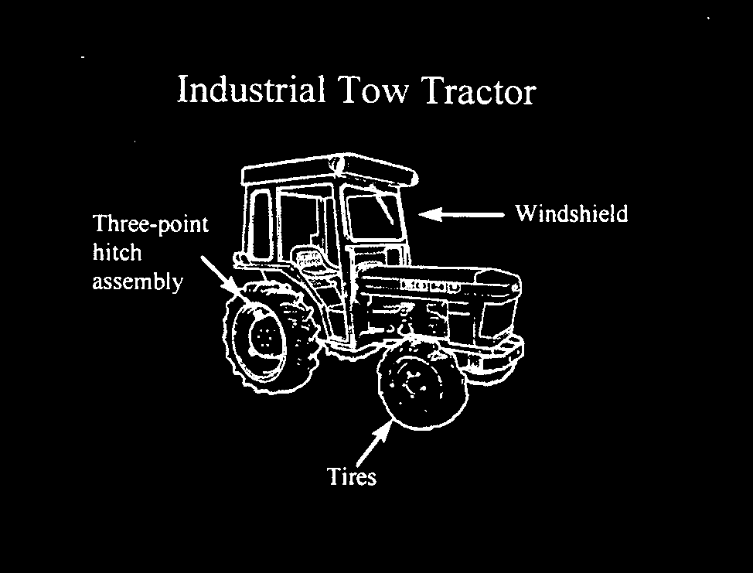
KEY OFF Procedures

- Vehicle inspection
- Windshield
- Tires
- Three-point hitch assembly
- Check the engine oil level
- Check the engine coolant level

KEY ON Procedures

- Check gauges
- Oil and battery lights
- Temperature
- Hour meter
- Test the standard equipment
- Steering
- Front, tail, and brake lights
- Horn

ENGINE RUNNING Procedures

- Inspect standard equipment
- Windshield wiper
- Brakes
- Hoist operation
- Safety seat (if equipped)
- Check transmission fluid level

Daily Inspection Checklist  Reach Truck | 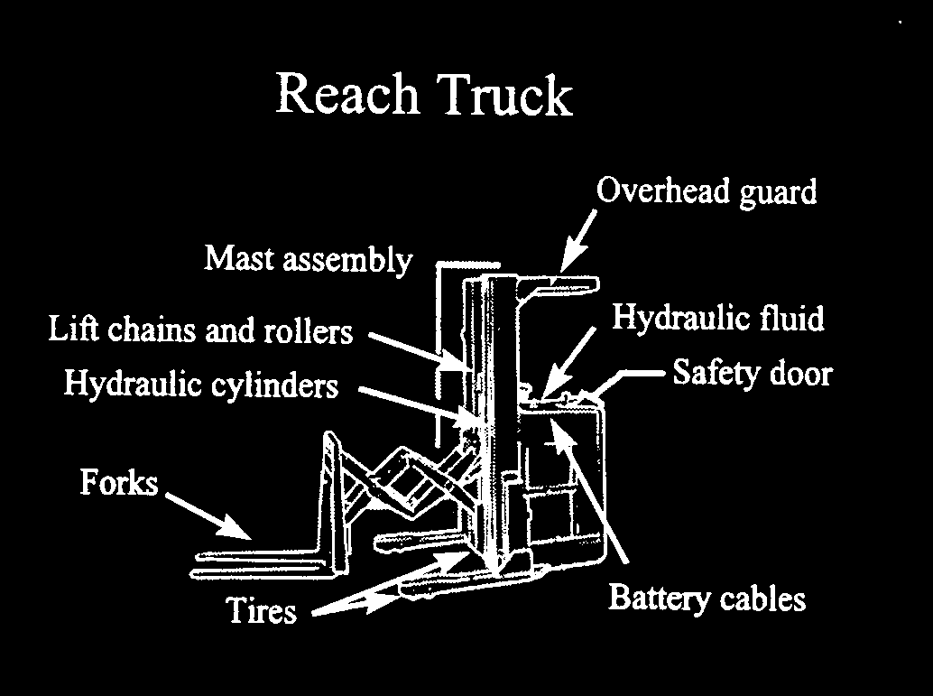
KEY OFF Procedures

- Vehicle inspection
- Overhead guard
- Hydraulic cylinders
- Mast assembly
- Lift chains and rollers
- Tires
- Battery cables
- Safety door
- Hydraulic fluid

KEY ON Procedures

- Check gauges
- Oil and battery lights
- Temperature
- Hour meter
- Test the standard equipment
- Steering
- Front, tail, and brake lights
- Horn

Daily Inspection Checklist  Order Picker | 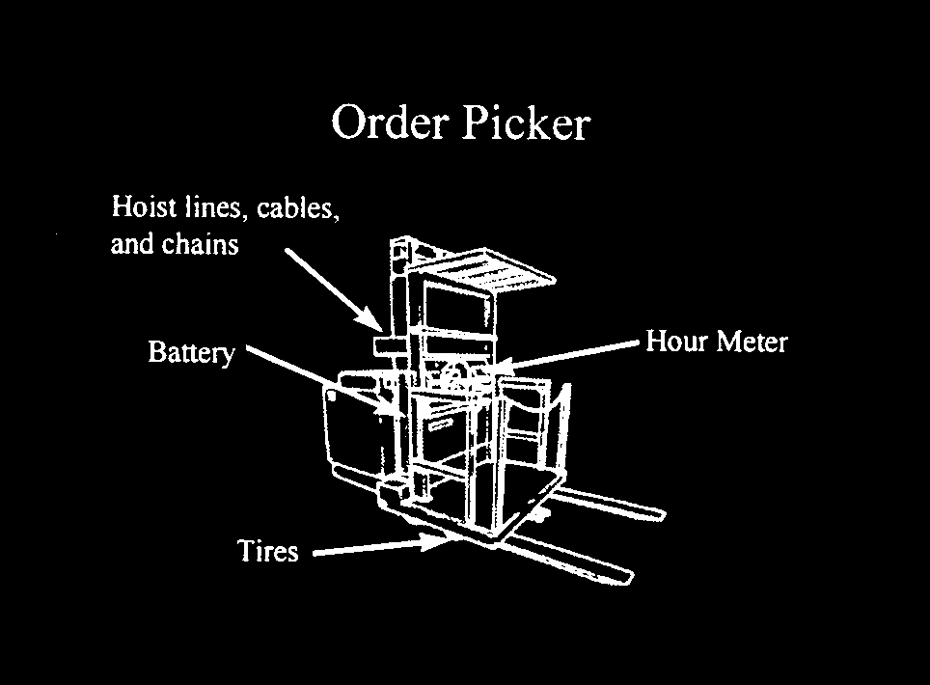
KEY OFF Procedures

- Vehicle inspection
- Hoist lines, cables, and chains
- Hour meter
- Tires
- Battery cables
- Limiting device

KEY ON Procedures

- Check battery discharge indicator
- Test the standard equipment
- Safety interlock
- Steering
- Brakes
- Lights
- Horn
- Check accessories
- Gripper jaws
- Work platform

Sample Generic Checklist
For Powered Industrial Trucks

- Overhead Guard - Are there broken welds, missing bolts, or damaged areas?

- Hydraulic Cylinders - Is there leakage or damage on the lift, tilt, and attachment functions of the cylinders?

- Mast Assembly - Are there broken welds, cracked or bent areas, worn or missing stops?

- Lift Chains and rollers

- Is there wear or damage or kinks, signs of rust, or any sign that lubrication is required?
- Is there squeaking?

- Forks

- Are they cracked or bent, worn, or mismatched?
- Is there excessive oil or water on the forks?

- Tires - What do the tires look like?

- Are there large cuts that go around the circumference of the tire?
- Are there large pieces of rubber missing or separated from the rim?
- Are there missing lugs?
- Is there bond separation that may cause slippage?

- Battery Check

- Are the cell caps and terminal covers in place?
- Are the cables missing insulation?

- Hydraulic Fluid - Check level?

- Gauges - Are they all working properly?
- Steering

- Is there excessive free play?
- If power steering, is the pump working

- Brakes

- If pedal goes all the way to the floor when you apply the service brake, that is the first indicator that the brakes are bad. Brakes should work in reverse, also.
- Does the parking brake work? The truck should not be capable of movement when the parking brake is engaged.

- Lights - If equipped with lights, are they working properly?

- Horn - Does the horn work?

- Safety seat - If the truck is equipped with a safety seat, is it working?

- Load Handling Attachments

- Is there hesitation when hoisting or lowering the forks, when using the forward or backward tilt, or the lateral travel on the side shift?
- Is there excessive oil on the cylinders?

- Propane Tank - Is the tank guard bracket properly positioned and locked down?

- Propane Hose

- Is it damaged? It should not be frayed, pinched, kinked, or bound in any way.
- Is the connector threaded on squarely and tightly?

- Propane Odor - If you detect the presence of propane gas odor, turn off the tank valve and report the problem.

- Engine Oil - Check levels.

- Engine Coolant - Visually check the level. Note: Never remove the radiator cap to check the coolant level when the engine is running or while the engine is hot. Stand to the side and turn your face away. Always use a glove or rag to protect your hand.

- Transmission Fluid - Check levels.

- Windshield Wipers - Do they work properly?

- Seat Belts - Do they work?

- Safety Door - (found on stand up rider models) Is it in place?

- Safety Switch - (found on stand up riding tow tractors) Is it working?

- Hand guards - (found on stand up riding tow tractors, walking pallet trucks, walking transtackers) Are they in place?

- Tow Hook

- Does it engage and release smoothly?
- Does the safety catch work properly?

- Control Lever - Does the lever operate properly?

- Safety Interlock - (found on order pickers) If the gate is open, does the vehicle run?

- Gripper Jaws - (found on order pickers) Do the jaws open and close quickly and smoothly?

- Work Platform - (found on order pickers) Does the platform raise and lower smoothly?

Developing a Training Program for
Powered Industrial Trucks

This handout is intended to be used for training purposes only. It is not a substitute for any provisions of the Occupational Safety and Health Act of 1970, or for any standards issued by the U.S. Department of Labor’s Occupational Safety and Health Administration (OSHA).

HOW DO I DEVELOP A POWERED INDUSTRIAL OPERATOR TRAINING PROGRAM?

Before you begin developing your operator training program you should become familiar with the OSHA standard for powered industrial trucks and any operator’s manual pertinent to the equipment you have in your workplace.

- IDENTIFY YOUR OPERATORS

First, you need to determine the employees that will be required to operate powered industrial trucks in your workplace. If an employee has other duties, but sometimes operates a powered industrial truck, training must be provided.

- IDENTIFY THE TYPES OF POWERED INDUSTRIAL TRUCKS YOU HAVE IN YOUR WORKPLACE AND THOSE EMPLOYEES WHO WILL BE REQUIRED TO OPERATE THE VEHICLES.

There are many different types of powered industrial trucks. Typically, these types of vehicles are known as forklifts or lift trucks. Some types of trucks are not capable of being ridden by the operator. These are also covered by the OSHA standard and training is required. Some trucks are fitted with attachments purchased from the manufacturer. The use of these attachments may affect the manner in which the truck is handled; therefore training on the use of the attachment would also be required. If your employees will be expected to operate several different types of powered industrial trucks, then training is required on the unique handling characteristics of the vehicles.

- METHODS OF TRAINING

Once you have identified your truck operators and types of trucks you have in your workplace, you should determine the methods of training you will use.

Training must consist of a combination of formal instruction and practical training. Using both methods is the only way to ensure that the trainee receives and comprehends the instruction and uses the information to safely operate a powered industrial truck. Note that the formal training need not take place in a classroom. Discussions can consist of the trainer talking to the trainee and explaining the training material, either in the workplace or n another location. The training must, however, include an explanatory element as well as a practical element.

Formal instruction may include lectures, conferences, classroom discussions, demonstrations, and written or oral tests. To enhance the training and make it more understandable to the employee, employers and other trainers may use movies, slides, computers, videotapes and other visual presentations.

Using visual aids has several advantages, including:

  - The employees being trained remain more attentive, thereby increasing the training’s effectiveness;
  - The trainer can use visual presentations to ensure that the necessary information is covered during the training;
  - Graphical presentations make better use of the training time be decreasing the need for the instructor to carry on long discussions about the instructional material; and,
  - Trainees have greater retention of information learned from graphical presentations.

While some employees can learn instructional material while seated in a classroom, other employees may learn best by observing an operation (demonstration) and/or by personally performing an operation (practical exercise). In most cases, a combination of different training methods provides the best training in the least amount of time.

Once you have selected the method of training, then the content of the training program must be considered to include all pertinent training items.

- TRAINING PROGRAM CONTENT

Because each type (make and model) of powered industrial truck has different operating characteristics, limitations, and other unique features, a good employee training program for powered industrial truck operators should be based upon the type of vehicles that the employee will be trained and authorized to operate. The training should also emphasize the workplace’s features that will affect how the vehicle must be operated. Finally, the training should include the general safety rules applicable to operating any powered industrial truck.

The following is an outline of a generic powered industrial truck operator training program:

- Characteristics of the powered industrial truck(s) the employee will be allowed to operate:

  - Differences from the automobile;
  - Controls and instrumentation: location, what they do, and how they work;
  - Engine or motor operation;
  - Steering and maneuvering;
  - Visibility;
  - Fork and/or attachment adaptation, operation, and limitations of their use;
  - Vehicle capacity;
  - Vehicle stability;
  - Vehicle inspection and maintenance the operator will be required to perform;
  - Refueling or charging and recharging batteries;
  - Operating limitations; and
  - Any other operating instruction, warning, or precaution listed in the operator’s manual for the type of vehicle the employee is being trained to operate.

- The operating environment:

  - Floor surfaces and/or ground conditions where the vehicle will be operated;
  - Composition of probable loads and load stability;
  - Load manipulation, stacking, unstacking;
  - Pedestrian traffic;
  - Narrow aisle and restricted place operation;
  - Operating in classified hazardous locations;
  - Operating the truck on ramps and other sloped surfaces that would affect the stability of the vehicle;
  - Other unique or potentially hazardous environmental conditions that exist or may exist in the workplace; and
  - Operating the vehicle in closed environments and other areas where insufficient ventilation and/or poor vehicle maintenance could cause a buildup of carbon monoxide or diesel exhaust.

- The requirements of the OSHA Standard.

After the training program has been completed, the employer must evaluate the trainee’s knowledge and skills and determine that the employee is competent to operate the truck safely.

- EMPLOYEE EVALUATION

When the employee completes the training exercises and prior to operating the truck in the workplace, an evaluation of the employee must be performed. This evaluation will determine the adequacy of training and the ability of the employee to perform truck operations safely in the workplace. The OSHA standard also requires that an evaluation of the operator’s performance be conducted at least once every three years and after refresher training.

The employer should then complete a certification of training record containing the name of the operator, the date of the training, the date of the evaluation, and the identity of the person(s) performing the training or evaluation.

- REFRESHER TRAINING

During the course of truck operation, the supervisor may observe the employee performing an unsafe act, such as riding with the load with the load too high or traveling at an unsafe speed. The person making the correction should point out the incorrect manner of operation of the truck or other unsafe act being conducted, tell the employee how to do the operation correctly, and then ensure the employee does the operation correctly. When there have been multiple on-the-spot corrections, the employer may decide to conduct a more structured retaining program which include the following information:

  - Common unsafe situations encountered in the workplace;
  - Unsafe operating methods observed or known to be used;
  - The need for constant attentiveness to the vehicle, the workplace conditions, and the manner in which the vehicle is operated.

The above subject areas need to be taught so that the trainee receives all the information needed for safe vehicle operation. Specific details of the above subject areas may be found in the vehicle manufacturer’s literature, the national consensus standards [e.g., the ASME B56 series of standards (current revisions)], and the OSHA standards relating to powered industrial truck operator training.

SAMPLE POWERED INDUSTRIAL TRUCK (PIT)

OPERATOR TRAINING PROGRAM OUTLINE

- Introduction
  - Overview of the program.
  - Goal of the program: to provide a training program based on the trainee’s prior knowledge, the types of vehicles used in the workplace, and the hazards of the workplace.
  - Course will utilize video, group discussion and hands-on practice. Each operator must obtain the knowledge and skills needed to do their job correctly and safely.

- Types, Features, and Physics
  - Familiarize each operator with the basic types and functions of powered industrial trucks.
  - Develop an understanding of the information shown on a data plate.
  - Understand the critical truck measurements that affect safety.
  - Understand the forces that cause “tipovers,” and the truck design considerations and safety ratings that help prevent them, including the “stability triangle.”

- Inspecting the vehicle
  - Understanding the purpose and importance of pre-operational checkouts.
  - Provide a basic understanding of areas covered during a pre-operational checkout.
  - Familiarize each operator with a checklist for pre-operational checkouts, and what to do if a problem is discovered.

- Driving the Truck
  - Understand the elements of safe movement of a powered industrial truck.
  - Understand the differences between an automobile and a powered industrial truck.
  - Recognize the safety hazards associated with operating a powered industrial truck.

- Load Handling
  - Understand the elements of load lifting safety.
  - Understand the safe operating procedures for raising and lowering loads in aisles.

- LPG for Lift Trucks
  - Discuss LPG and its properties.
  - Understand the elements and procedures of safely refueling internal combustion vehicles.
  - Describe tank components: service valve, surge valve, relief valve, etc.
  - Discuss related safety issues.

- Battery and Charging
  - Understand the elements and procedures of safely changing and charging batteries.
  - Discuss filling procedures and maintenance.
  - Discuss related safety issues.

- Safety Concerns
  - Review/reinforce potential of serious injury.
  - Review/reinforce safety procedures in your facility.

- Specific Truck and Workplace Training/Hands-On
  - Review features of specific PITs to be operated.
  - Review operating procedures of specific PITs to be operated.
  - Review safety concerns of specific PITs to be operated.
  - Review workplace conditions and safety concerns of areas where PITs will be operated.
  - Learn/Practice actual operation of specific PITs to be operated and specific workplace conditions where PITs will be operated.
  - Demonstrate proficiency performing the powered industrial truck operator duties specific to the trainee’s position and workplace conditions.

- Certification of Completion of the Course

Powered Industrial Truck Operators

Training Questionnaire

Circle the letter which best completes the statement.

1. Repairs to your forklift should be made:
a. Before you use the forklift for work
b. Whenever you get a break from the work you are presently doing
c. When your company has a scheduled maintenance time
d. By someone who has time to look it over

2. Who can operate forklifts?
a. Supervisors
b. Trained and certified workers
c. Friends
d. Anybody

3. Operators are required to inspect their forklifts:
a. Monthly
b. Daily
c. Weekly
d. Before each shift

4. If your vision is obstructed when traveling with a load:
a. Raise the load so you can see under it
b. Lower and tilt the load forward so you can see over it
c. Travel forward
d. Travel in reverse

5. Who has the right-of-way?
a. Your forklift
b. Someone else's forklift
c. Things approaching from the left
d. Pedestrians

6. Riders are allowed on a forklift:
a. If they are strapped in
b. On the forks, within a safety platform
c. Never
d. Towed behind the unit

7. During the pre-operational inspection you should check:
a. Hydraulic system
b. Brakes
c. Tires
d. All of the above

8. Travel down a ramp:
a. Avoid this, if possible
b. Travel with the load upgrade
c. Forward
d. Only without loads

9. How far should forks enter the pallet?
a. Half way
b. Three quarters
c. One fourth
d. All the way

10. It is permissible to push one forklift with another forklift:
a. If it is broken down
b. If it is in your way
c. If the forklift in front is driving too slow
d. Never

- The maximum allowable load should be clearly marked on the nameplate of the forklift truck.
a. True
b. False

12. It is permissible to overload the truck by 25% if additional counterweights are used.
a. True
b. False

13. It is good practice to keep the load back against the forklift mast as much as possible.
a. True
b. False

14. Maintenance personnel may be lifted on the forks to reach their work.
a. True
b. False
15. Smoking is permissible in refueling and recharging areas provided you see no leaking fuel.
a. True
b. False

16. Parking Forklifts in front of fire extinguishes or an exit door is okay for a few minutes.
a. True
b. False

17. It is permissible to let someone else operate your forklift if he says he knows how.
a. True
b. False

18. When traveling with a load, the mast should be tilted back.
a. True
b. False

19. A professional operator checks each load for stability before moving it.
a. True
b. False

- When loading a highway truck or trailer, its wheels should be chocked or blocked even though the driver says he set the brakes.
a. True
b. False

Test Score Instructor Signature

Date

SAMPLE PERFORMANCE TEST
FOR FORKLIFT OPERATORS

EMPLOYEE DATE TIME

- 1. Shows familiarity with truck controls.
- 2. Gave proper signals when turning.
- 3. Slowed down at intersections.
- 4. Sounded horn at intersections.
- 5. Obeyed signs.
- 6. Kept a clear view of direction of travel.
- 7. Turned corners correctly - was aware of rear and swing.
- 8. Yield to pedestrians.
- 9. Drove under control and within proper traffic aisles.
- 10. Approached load properly.
- 11. Lifted load properly.
- 12. Maneuvered properly.
- 13. Traveled with load at proper height.
- 14. Lowered load smoothly/slowly.
- 15. Stops smoothly/completely.
- 16. Load balanced properly.
- 17. Forks under load all the way.
- 18. Carried parts/stock in approved containers.
- 19. Checked bridgeplates/ramps.
- 20. Did place loads within marked area.
- 21. Did stack loads evenly and neatly.
- 22. Did drive backward when required.
- 23. Did check load weights.
- 24. Did place forks on the floor when parked, controls neutralized, brake on set, power off.
- 25. Followed proper instructions for maintenance - checked both at beginning and end.

Total Rating Evaluator

CERTIFICATION OF TRAINING

I attended a training session covering the rules, regulations, and operation of Powered Industrial Trucks (Forklifts) in accordance with 29 CFR 1910.178. I have reviewed a copy of my company's written requirements and agree to comply with the rules of operation. I understand that my failure to comply with the safety rules may result in disciplinary action up to and including termination.

Print Employee Name

Social Security Number

Employee Signature

Date of Training Date of Evaluation

I certify that the above name employee has passed both the powered industrial truck written test and driving test for the following powered industrial trucks:

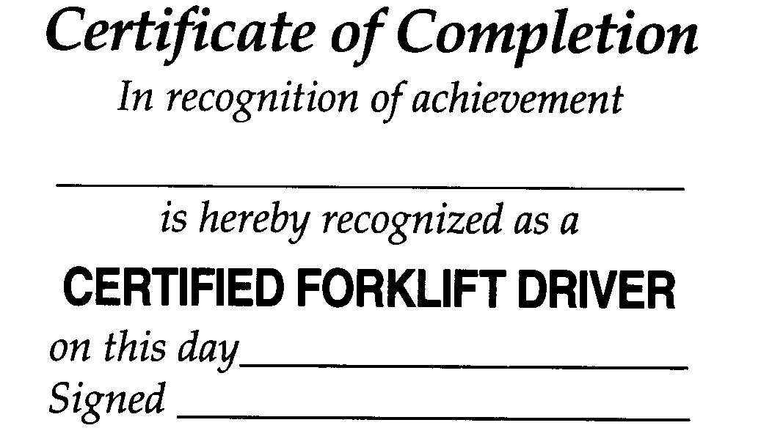

Frequently Asked Questions About Powered

Industrial Truck Operator Training

On December 1, 1998, the Occupational Safety and Health Administration (OSHA) published a standard that revised the existing requirements and issued new requirements to improve the training of powered industrial truck operators. The standard becomes effective on March 1, 1999. This new standard is intended to reduce the number of injuries and deaths that occur as a result of inadequate operator training. The powered industrial truck operator training requirements will apply to all industries where trucks are being used, except agricultural operations.

1. What is the definition of a powered industrial truck?

Any mobile power-propelled truck used to carry, push, pull, lift, stack or tier materials. Powered industrial trucks can be ridden or controlled by a walking operator. Earth moving and over the road haulage trucks are not included in the definition. Equipment that was designed to move earth but has been modified to accept forks are also not included.

2. What does the new standard require?

The new standard requires employers to develop and implement a training program based on the general principles of safe truck operation, the types of vehicle(s) being used in the workplace, the hazards of the workplace created by the use of the vehicle(s), and the general safety requirements of the OSHA standard. Trained operators must know how to do the job properly and do it safely as demonstrated by workplace evaluation. Formal (lecture, video, etc.) and practical (demonstration and practical exercises) training must be provided. Employers must also certify that each operator has received the training and evaluate each operator at least once every three years. Prior to operating the truck in the workplace, the employer must evaluate the operator’s performance and determine the operator to be competent to operate a powered industrial truck safely. Refresher training is needed whenever an operator demonstrates a deficiency in the safe operation of the truck.

3. Does OSHA provide a list of topics to include in my training program?

Yes. The standard provides a list of training topics; however, the employer may exclude those topics which are not relevant to safe operation at the employee’s work location.

4. Who should conduct the training?

All training and evaluation must be conducted by persons with the necessary knowledge, training, and experience to train powered industrial truck operators and evaluate their competence. An example of a qualified trainer would be a person who, by possession of a recognized degree, certificate, or professional standing, or who by extensive knowledge, training, and experience has demonstrated the ability to train and evaluate powered industrial truck operators.

There are many resources available to the employer if he/she choose not to perform the training him/herself. Truck manufactures, local safely and health safety organizations, such as the National Safety Council local chapters, private consultants with expertise in powered industrial trucks, local trade and vocational schools are some available resources.

Various Internet sites are devoted to forklift safety. Private companies who provide forklift safety training services, including videos and written programs, can be located on various Internet websites. Most videos can be either leased or purchased. One some aspect of forklift safety does not meet the full requirements of the OSHA standard. Site specific information must be conveyed as well as a method to evaluate the employee’s acquired knowledge subsequent to the training.

5. If my employees receive training from an outside consultant, how will I know that these employees have be adequately trained?

Outside qualified training organizations can provide evidence that the employee has successfully completed the relevant classroom and practical training. However, each employer must ensure that each powered industrial truck operator is competent to operate a truck safely, as demonstrated by the successful completion of the training and evaluation.

6. My employees receive training from the union on the use of powered industrial trucks. Will I have to provide any additional training?

When a worker reports to work, the employer must evaluate the employee to ensure that he/she is knowledgeable about the operation of the powered industrial trucks he/she will be assigned to operate. This evaluation could be a simple as having a person with the requisite skills, knowledge and experience observe the operator performing several typical operations to ensure that the truck is being operated safely and asking the operator a few questions related to the safe operation of the vehicle. If the operator has operated the same type of equipment before in the same type of environment that he/she will be expected to be working, then duplicative or additional training is not required.

7. Will testing be required?

No. The standard does not specifically require testing; however, some method of evaluation is necessary.

8. Does OSHA require the employer to issue licenses to employees who have received training?

No. The OSHA standard does not require employees to be licensed. An employer may choose to issue licenses to trained operators.

9. What type of records or documentation must I keep?

The OSHA standard requires that the employer certify that each operator has received the training and has been evaluated. The written certification record must include the name of the operator, the date of the training, the date of the evaluation, and the identity of the person(s) performing the training or evaluation.

10. How long must I keep the certification records?

Employers who evaluate the operator’s performance more frequently than every three years may retain the most recent certification record; otherwise, certification records must be maintained for three years.

11. If my employees receive training, but accidents still continue to occur, what should I do?

Refresher training in relevant topics is necessary when the operator has been involved in a accident or near-miss incident.

12. Is annual training required?

No. An evaluation of each powered industrial truck operator’s performance is required to be conducted after initial training, after refresher training, and at least once every three years.

13. How often must refresher training be given?

The standard does not require any specific frequency of refresher training. Refresher training must be provided when:

- The operator has been observed to operate the vehicle in an unsafe manner.
- The operator has been involved in an accident or near-miss incident. The operator has received an evaluation that reveals that the operator is not operating the truck safely.
- The operator is assigned to drive a different type of truck.
- A condition in the workplace changes in a manner that could affect safety operation of the truck.

14. If my employees have already received training, or have been operating trucks for many years, must I retrain them?

No. An employer does not need to retrain an employee in the operation of a powered industrial truck if the employer certifies that the operator has been evaluated and has proven to be competent to operate the truck safely. The operator would need additional training in those elements where his or her performance indicates the need for further training and for new types of equipment and areas of operation.

15. How do I evaluate my employee’s competency to operate a truck safely?

Evaluation of an operator’s performance can be determined by a number of ways, such as:

- a discussion with the employee
- an observation of the employee operating the powered industrial truck
- written documentation of previous training
- a performance test

16. Will OSHA provide training to my truck operators?

No. It is the employer’s responsibility to train the employees.

17. Will I have to train all employees in my workplace?

Any employee that operates a powered industrial truck must be trained.

18. Will I have to ensure that my operator’s are physically capable of driving a powered industry truck?

The new standard does not contain provisions for checking vision, hearing or general medical status of employees operating powered industrial trucks. The Americans With Disabilities Act (ADA) addresses the issue of whether employers may impose physical qualifications upon employees or applicants for employment. The ADA permits that an individual does not pose a “direct threat to the health or safety of other individuals in the workplace” provided all reasonable efforts are made to accommodate otherwise qualified individuals.

19. I have three different types of trucks in my workplace. Can I provide training on just one type of truck?

If an operator will be expected to operate all three types of vehicles, then training must address the unique characteristics of each type of vehicle the employee is expected to operate. When an attachment is used on the truck to move odd-shaped materials, then the operator training must include instruction on the safe conduct of those operations so that the operator knows and understands the restrictions or limitations created by each vehicle’s use.

20. I only have powered hand trucks in my workplace. Do the training requirements cover the operators of this type of vehicle? The operator walks alongside the unit while holding onto the handle to guide it.

Yes. The use of powered hand trucks present numerous hazards to employees who operate them and those working in the area where they are used.

21. I employ drivers from a temporary agency. Who will provide them training - the temporary service or me?

OSHA has issued several letters of interpretations on the subject of training of temporary employees. Basically, there is a shared responsibility for assuring employees are adequately trained. The responsibility for providing training should be spelled out in the contractual agreement between the two parties. The temporary agency or the contracting employer may conduct the training and evaluation of operators from a temporary agency as required by the standard; however, the host employer (or other employer who enters into a contract with the temporary agency) must provide site-specific information and training on the use of the particular types of trucks and workplace-related topics that are present in the workplace.

22. Should my training include the use of operator restraint devices (e.g. seat belts)?

Employers are required to train employees in all operating instructions, warnings, and precautions listed in the operator’s manual for the type of vehicle which the employed is being trained to operate. Therefore, operators must be trained in the use of operator restraint systems when it is addressed in the operating instructions.

23. What does OSHA expect to achieve as a result of improved operator’s training?

OSHA’s goal is to reduce the number of injuries and illnesses that occur to workers in the workplace from unsafe powered industrial truck usage. By providing an effective training program many other benefits will result. Among these are the lower costs of compensation insurance, less property damage, and less product damage.

24. Where can I get additional information about OSHA and new standards?

For more information, contact your local OSHA Area office at (208) 321-2960 or Boise State University Safety and Health Consultation Program at (208) 426-3283. OSHA also has a Home Page on the Internet at http://www.osha.gov/

Forklift Designations

For the purpose of this standard there are eleven different designations of industrial trucks or tractors: D, DS, DY, E, ES, EE, EX, G, GS, LP, and LPS.

- The D designated units are units similar to the G units except that they are diesel engine powered instead of gasoline engine powered.
- The DS designated units are diesel powered units that are provided with additional safeguards to the exhaust, fuel and electrical systems. They may be used in some locations where a D unit may not be considered suitable.
- The DY designated units are diesel powered units that have all the safeguards of the DS units and in addition do not have any electrical equipment including the ignition and are equipped with temperature limitation features.
- The E designated units are electrically powered units that have minimum acceptable safeguards against inherent fire hazards.
- The ES designated units are electrically powered units that, in addition to all of the requirements for the E units, are provided with additional safeguards to the electrical system to prevent emission of hazardous sparks and to limit surface temperatures. They may be used in some locations where the use of an E unit may not be considered suitable.
- The EE designated units are electrically powered units that have, in addition to all of the requirements for the E and ES units, the electric motors and all other electrical equipment completely enclosed. In certain locations the EE unit may be used where the use of an E and ES unit may not be considered suitable.
- The EX designated units are electrically powered units that differ from the E, ES, or EE units in that the electrical fittings and equipment are so designed, constructed and assembled that the units may be used in certain atmospheres containing flammable vapors or dusts.
- The G designated units are gasoline powered units having minimum acceptable safeguards against inherent fire hazards.
- The GS designated units are gasoline powered units that are provided with additional safeguards to the exhaust, fuel, and electrical systems. They may be used in some locations where the use of a G unit may not be considered suitable.
- The LP designated unit is similar to the G unit except that liquefied petroleum gas is used for fuel instead of gasoline.
- The LPS designated units are liquefied petroleum gas powered units that are provided with additional safeguards to the exhaust, fuel, and electrical systems. They may be used in some locations where the use of an LP unit may not be considered suitable.

The atmosphere or location shall have been classified as to whether it is hazardous or non-hazardous prior to the consideration of industrial trucks being used therein and the type of industrial truck required shall be as provided in this section for such location.

The industrial trucks specified below are the minimum types required, but industrial trucks having greater safeguards may be used if desired.

For specific areas of use see Table A. References are to the corresponding classification.

- Power-operated industrial trucks shall not be used in atmospheres containing hazardous concentration of acetylene, butadiene, ethylene oxide, hydrogen (or gases or vapors equivalent in hazard to hydrogen, such as manufactured gas), propylene oxide, acetaldehyde, cyclopropane, diethyl ether, ethylene, isoprene, or unsymmetrical dimethyl hydrazine (UDMH).
- In hazardous atmospheric conditions:

- Power-operated industrial trucks shall not be used in atmospheres containing hazardous concentrations of metal dust, including aluminum, magnesium, and their commercial alloys, other metals of similarly hazardous characteristics, or in atmospheres containing carbon black, coal or coke dust except approved power-operated industrial trucks designated as EX may be used in such atmospheres.
- In atmospheres where dust of magnesium, aluminum or aluminum bronze may be present, fuses, switches, motor controllers, and circuit breakers of trucks shall have enclosures specifically approved for such locations.

- Only approved power-operated industrial trucks designated as EX may be used in atmospheres containing acetone, acrylonitrile, alcohol, ammonia, benzine, benzol, butane, ethylene dichloride, gasoline, hexane, lacquer solvent vapors, naphtha, natural gas, propane, propylene, styrene, vinyl acetate, vinyl chloride, or xylenes in quantities sufficient to produce explosive or ignitable mixtures and where such concentrations of these gases or vapors exist continuously, intermittently or periodically under normal operating conditions or may exist frequently because of repair, maintenance operations, leakage, breakdown or faulty operation of equipment.
- Power-operated industrial trucks designated as DY, EE, or EX may be used in locations where:

- volatile flammable liquids or flammable gases are handled, processed or used, but in which the hazardous liquids, vapors or gases will normally be confined within closed containers or closed systems from which they can escape only in case of accidental rupture or breakdown of such containers or systems, or in the case of abnormal operation of equipment;
- hazardous concentrations of gases or vapors are normally prevented by positive mechanical ventilation but which might become hazardous through failure or abnormal operation of the ventilating equipment; or
- location is adjacent to Class I, Division 1 locations, and to which hazardous concentrations of gases or vapors might occasionally be communicated unless such communication is prevented by adequate positive-pressure ventilation from a source of clear air, and effective safeguards against ventilation failure are provided.

Designated Locations

In locations used for the storage of hazardous liquids in sealed containers or liquefied or compressed gases in containers, approved power-operated industrial trucks designated as DS, ES, GS, or LPS may be used. This classification includes locations where volatile flammable liquids or flammable gases or vapors are used, but which would become hazardous only in case of an accident or of some unusual operating condition. The quantity of hazardous material that might escape in case of accident, the adequacy of ventilating equipment, the total area involved, and the record of the industry or business with respect to explosions or fires are all factors that should receive consideration in determining whether or not the DS or DY, ES, EE, GS, LPS designated truck possesses sufficient safeguards for the location. Piping without valves, checks, meters and similar devices would not ordinarily be deemed to introduce a hazardous condition even though used for hazardous liquids or gases. Locations used for the storage of hazardous liquids or of liquefied or compressed gases in sealed containers would not normally be considered hazardous unless also subject to other hazardous conditions.

Only approved power-operated industrial trucks designated as EX shall be used in atmospheres in which combustible dust is or may be in suspension continuously, intermittently, or periodically under normal operating conditions, sufficient to produce explosive or ignitable mixtures, or where mechanical failure or abnormal operation of machinery or equipment might cause such mixtures to be produced.

The EX classification usually includes the working areas of grain handling and plants, rooms containing grinders or pulverizes, cleaners, graders, scalpers, open conveyors or spouts, open bins or hoppers, mixers, or blenders, automatic or hopper scales, packing machinery, elevator heads and boots, stock distributors, dust and stock collectors (except all-metal collectors vented to the outside), and all similar dust producing machinery and equipment in grain processing plants, starch plants, sugar pulverizing plants, malting plants, hay grinding plants, and other occupancies of similar nature; coal pulverizing plants (except where the pulverizing equipment is essentially dust tight); all working areas where metal dusts and powders are produced, processed, handled, packed, or stored (except in tight containers); and other similar locations where combustible dust may, under normal operating conditions, be present in the air in quantities sufficient to produce explosive or ignitable mixtures.

Only approved power-operated industrial trucks designated as DY, EE, or EX shall be used in atmospheres in which combustible dust will not normally be in suspension in the air or will not be likely to be thrown into suspension by the normal operation of equipment or apparatus in quantities sufficient to produce explosive or ignitable mixtures but where deposits or accumulations of such dust may be ignited by arcs or sparks originating in the forklift.

- Only approved power-operated industrial trucks designated as DY, EE, or EX shall be used in locations which are hazardous because of the presence of easily ignitable fibers or flyings but in which such fibers or flyings are not likely to be in suspension in the air in quantities sufficient to produce ignitable mixtures.
- Only approved power-operated industrial trucks designated as DS, DY, ES, EE, EX, GS, or LPS shall be used in locations where easily ignitable fibers are stored or handled, including outside storage, but are not being processed or manufactured. Powered industrial trucks designated as E, which have been previously used in these locations may be continued in use.
- On piers and wharves handling general cargo, any approved power-operated industrial truck designated as Type D, E, G, or LP may be used, or forklifts which conform to the requirements for these types may be used.
- If storage warehouses and outside storage locations are hazardous only the approved power-operated industrial truck specified for such locations in this paragraph (c) (2) shall be used. If not classified as hazardous, any approved power-operated industrial truck designated as Type D, E, G, or LP may be used, or forklifts which conform to the requirements for these types may be used.
- If general industrial or commercial properties are hazardous, only approved power-operated industrial trucks specified for such locations in this paragraph (c) (2) shall be used. If not classified as hazardous, any approved power-operated industrial truck designated as Type D, E, G, or LP may be used, or forklifts which conform to the requirements of these types may be used.

