Weekly vehicle safety checklist

Periodic Spot Check | Handover/Takeover
Driver
Vehicle type
Registration number
Speedometer reading
Documentation Checked | Comments
Manufacturer’s handbook
Service record book (up to date?)
Driver handbook
Accident report form
Vehicle interior Serviceable | Remarks
Door handles and locks
Alarm
Seats
Seat belts/operational/damage
All instruments/wipers
Lights and indicators-front
Lights and indicators-rear
Interior light
Window operation
Window (glass) condition
Heated rear window and wash wiper
Cleanliness
Boot compartment Serviceable | Remarks
Cleanliness
Boot lid secure & operational
Spare wheel jack & brace
Spare wheel tyre pressure & condition
Engine compartment Serviceable | Remarks
Engine oil level
Coolant level (anti freeze)
Battery electrolyte level
Battery security
Battery terminals secure and clean / greased
Brake fluid level
Clutch fluid level
Washer bottle full and correct frost protection fluid
Compartment clean
Exterior Serviceable | Remarks
Tyre condition (damage)
Tyre thread depth (min 1.6mm)
Tyre pressure correct
Exterior cleanliness

Condition of vehicle-detail all damage
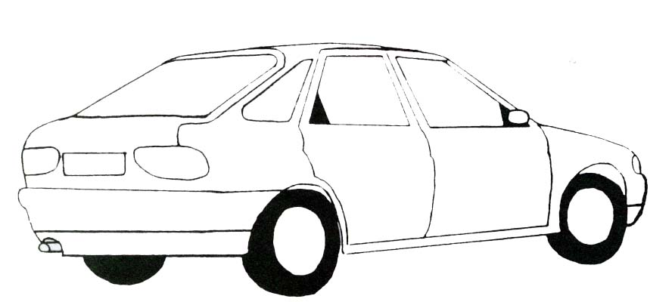

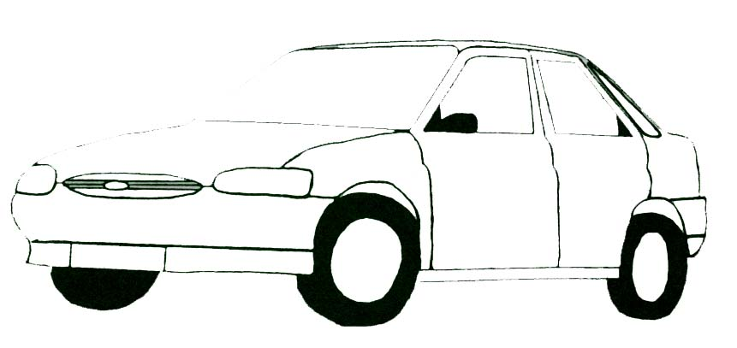

General remarks
Driver’s signature | Date
Manager’s signature | Date

