Caution Zone Checklist Use one sheet for each position evaluated.
Movements or postures that are a regular and foreseeable part of the job, occurring more than one day per week, and more frequently than one week per year. |  | If done in this job position  the box |  | Job Position evaluated:  Date: | No. of employees in these jobs?
Awkward Posture |  |  |  | Comments/Observations
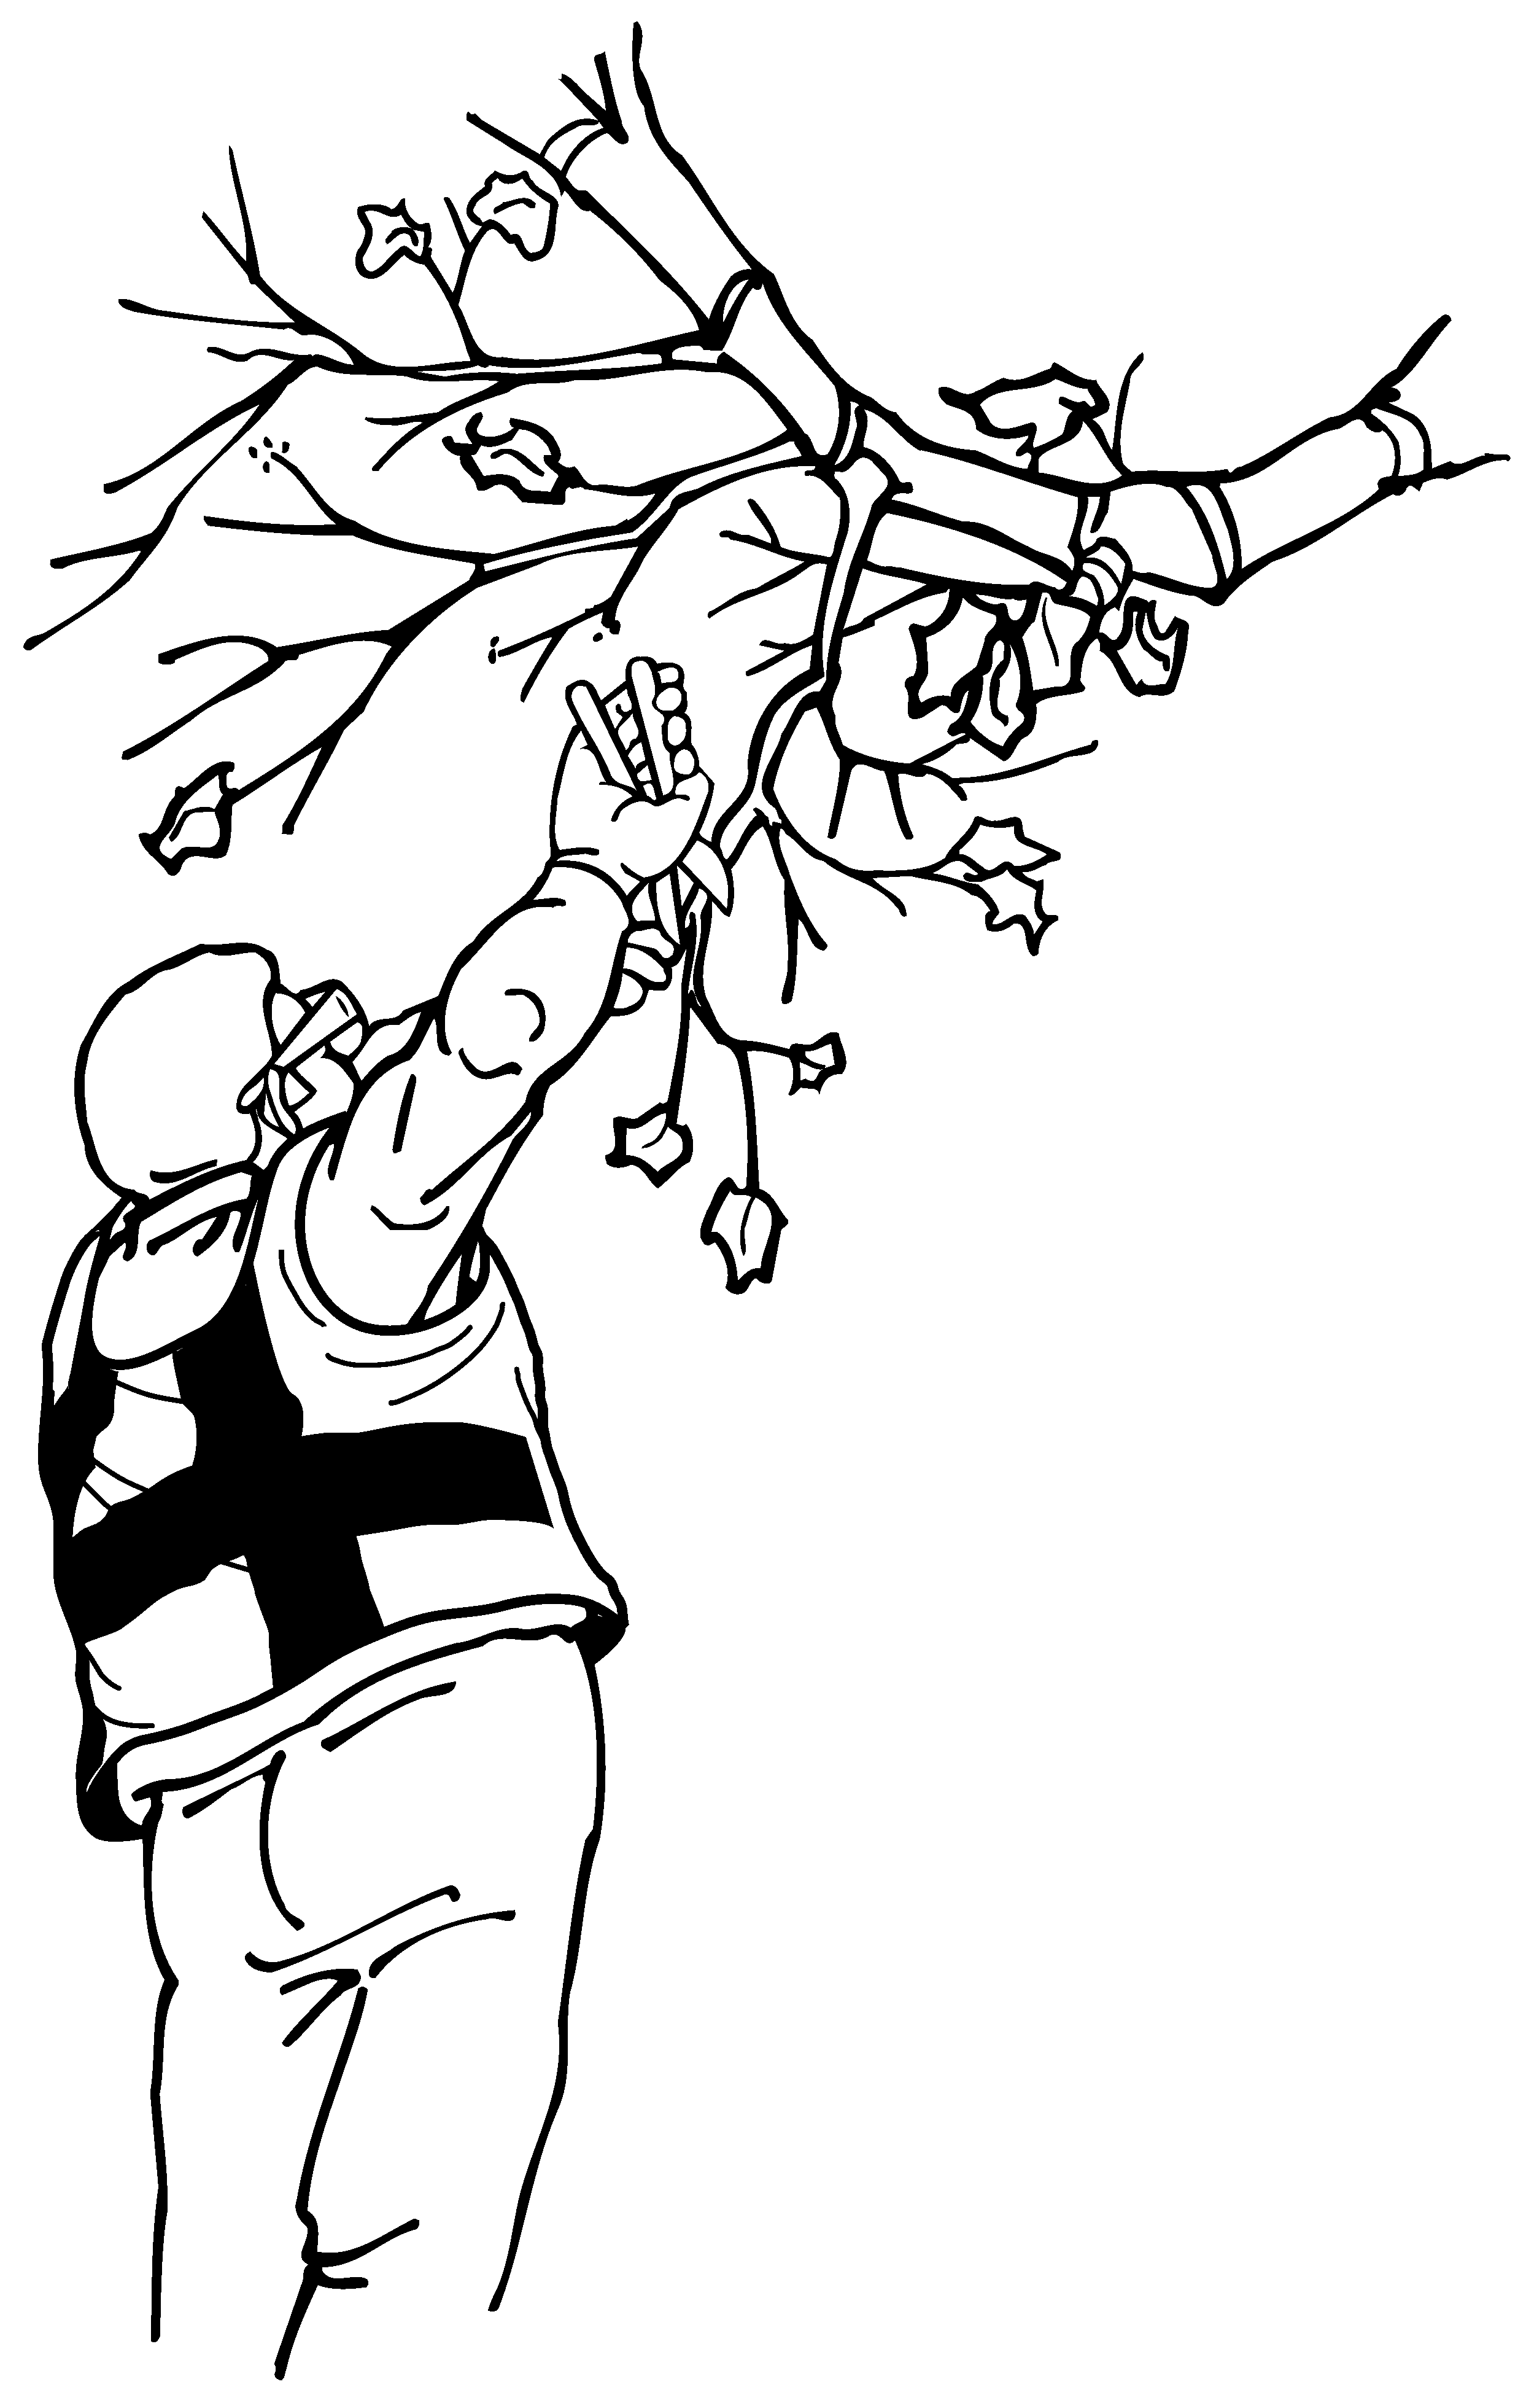 | 1. Working with the hand(s) above the head, or the elbow(s) above the shoulders more than 2 hours total per day. |  | □
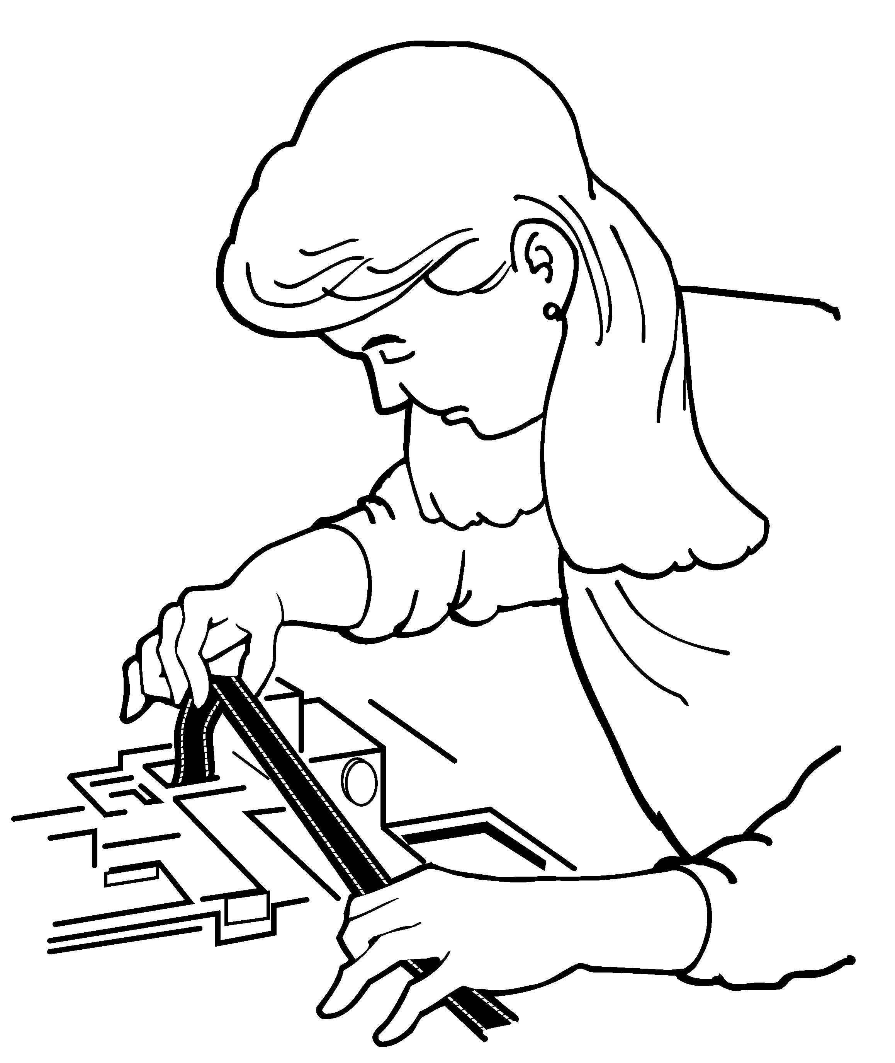 | 2. Working with the neck or back bent more than 30 degrees (without support and without the ability to vary posture) more than 2 hours total per day. |  | □
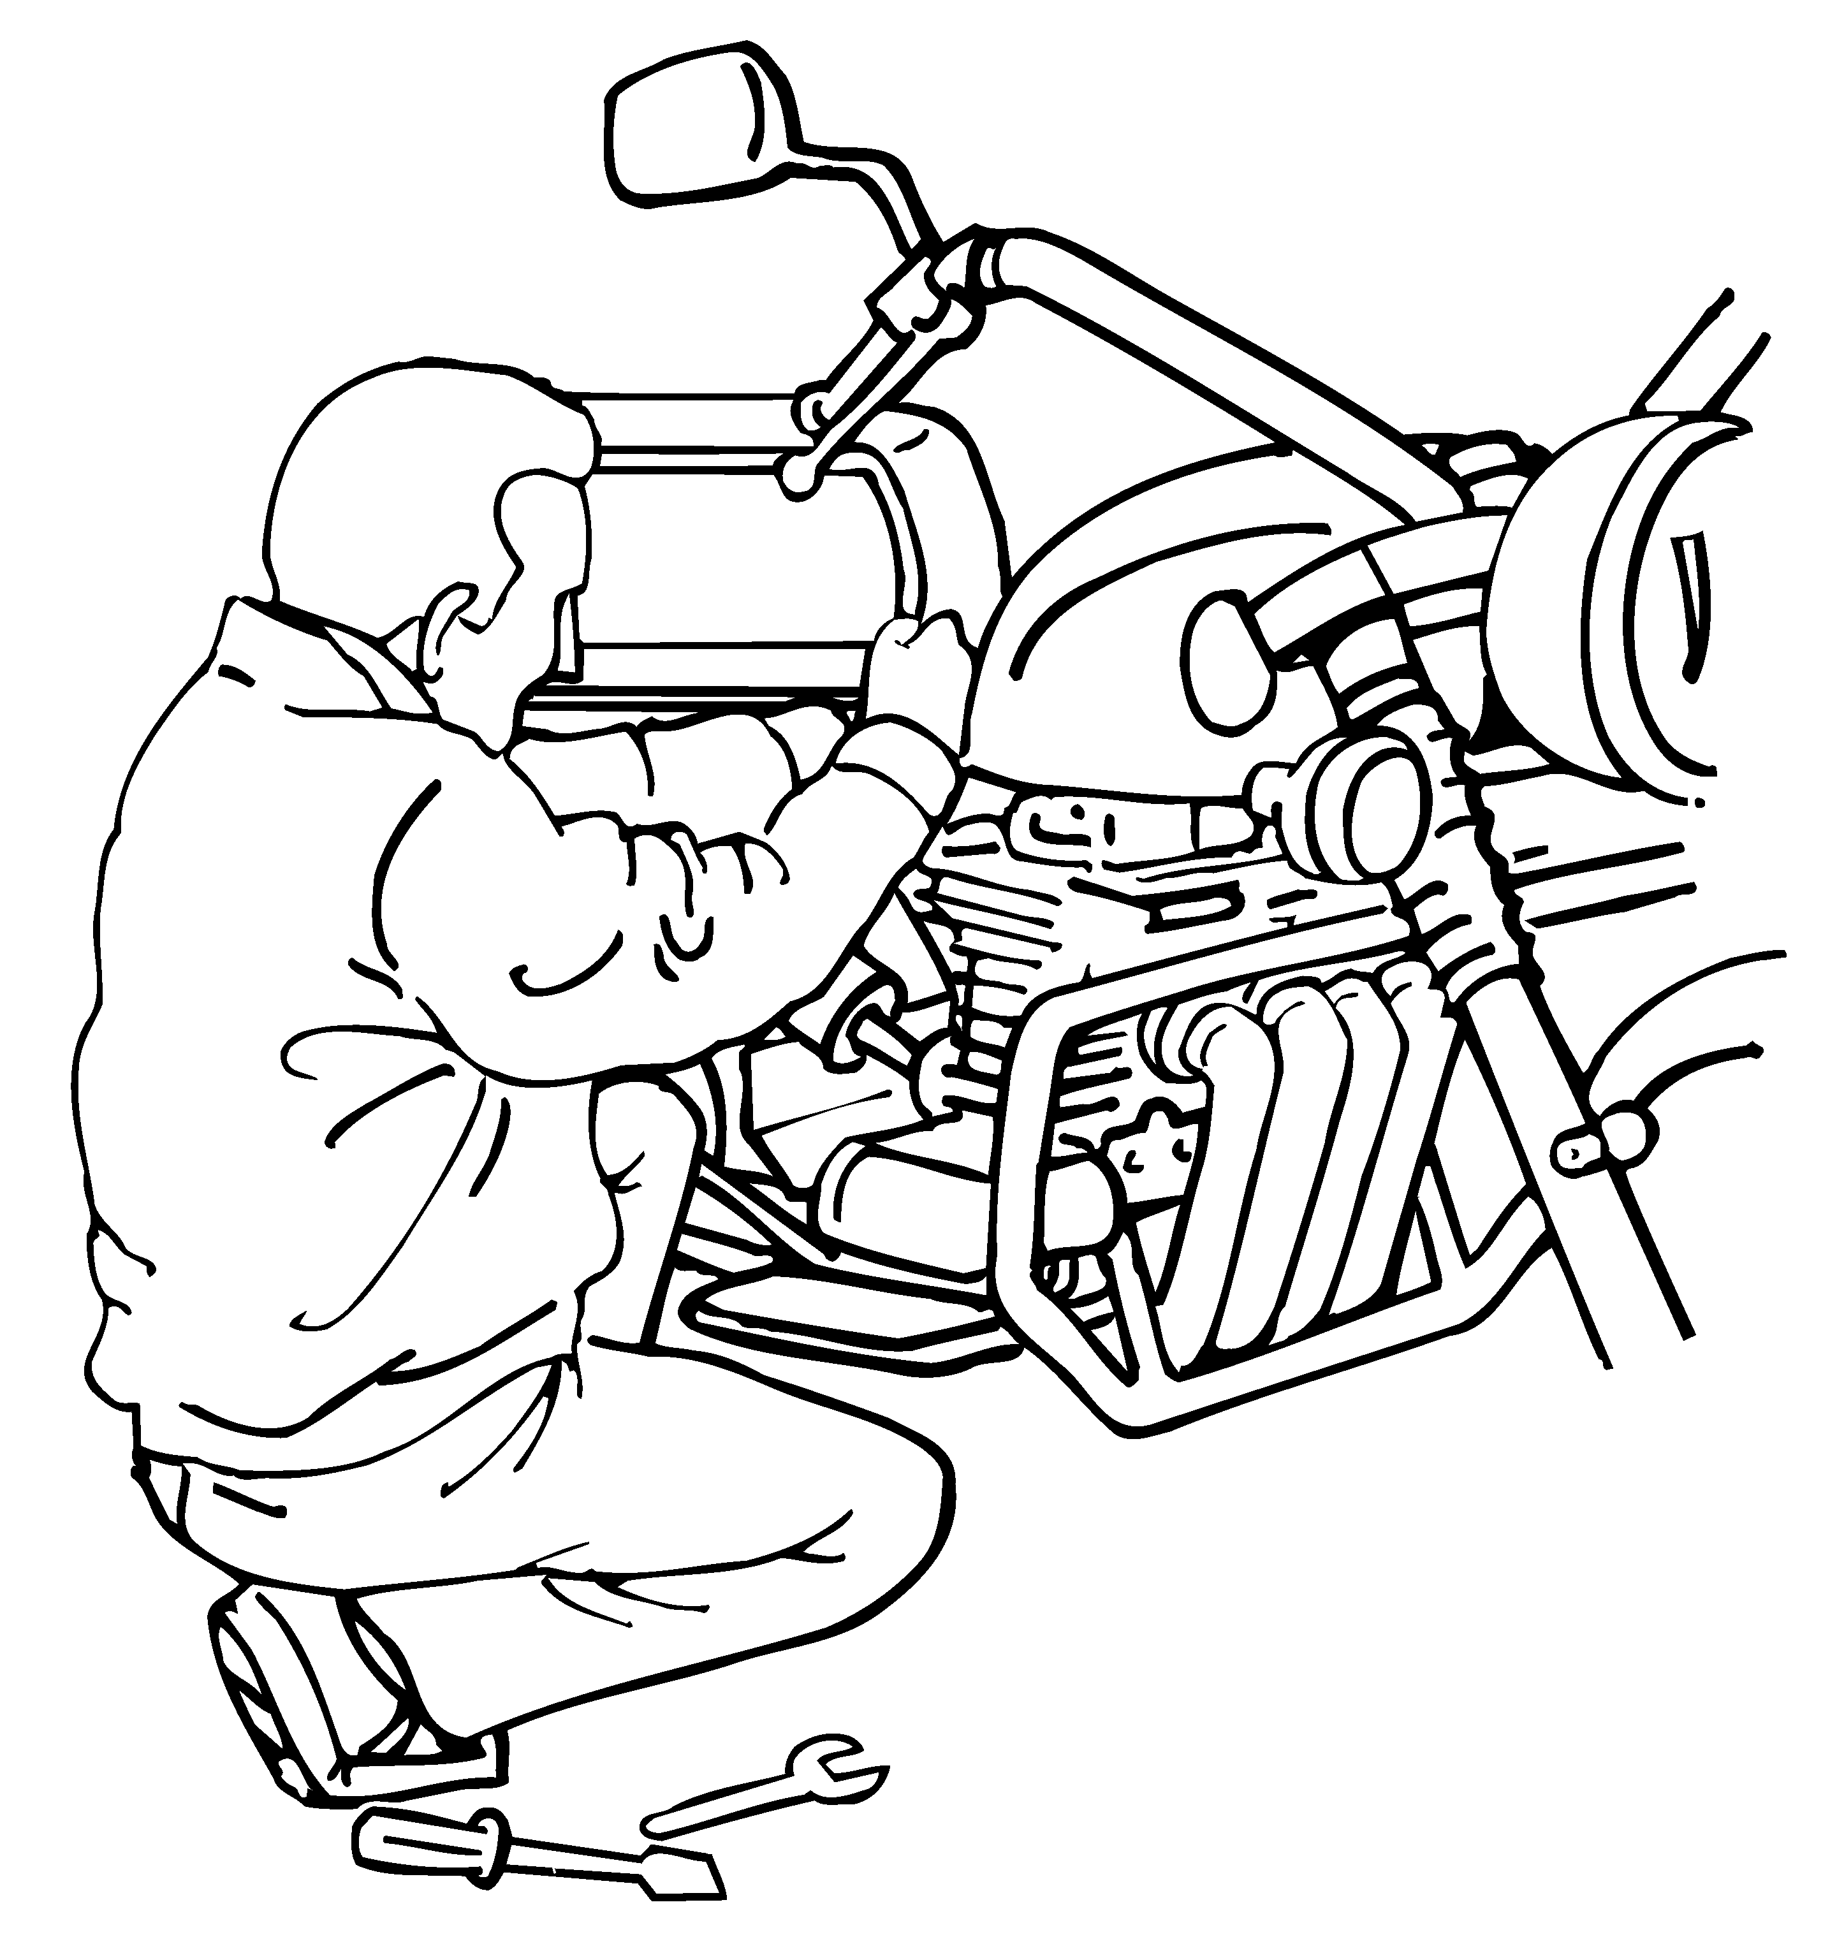 | 3. Squatting more than 2 hours total per day. |  | □
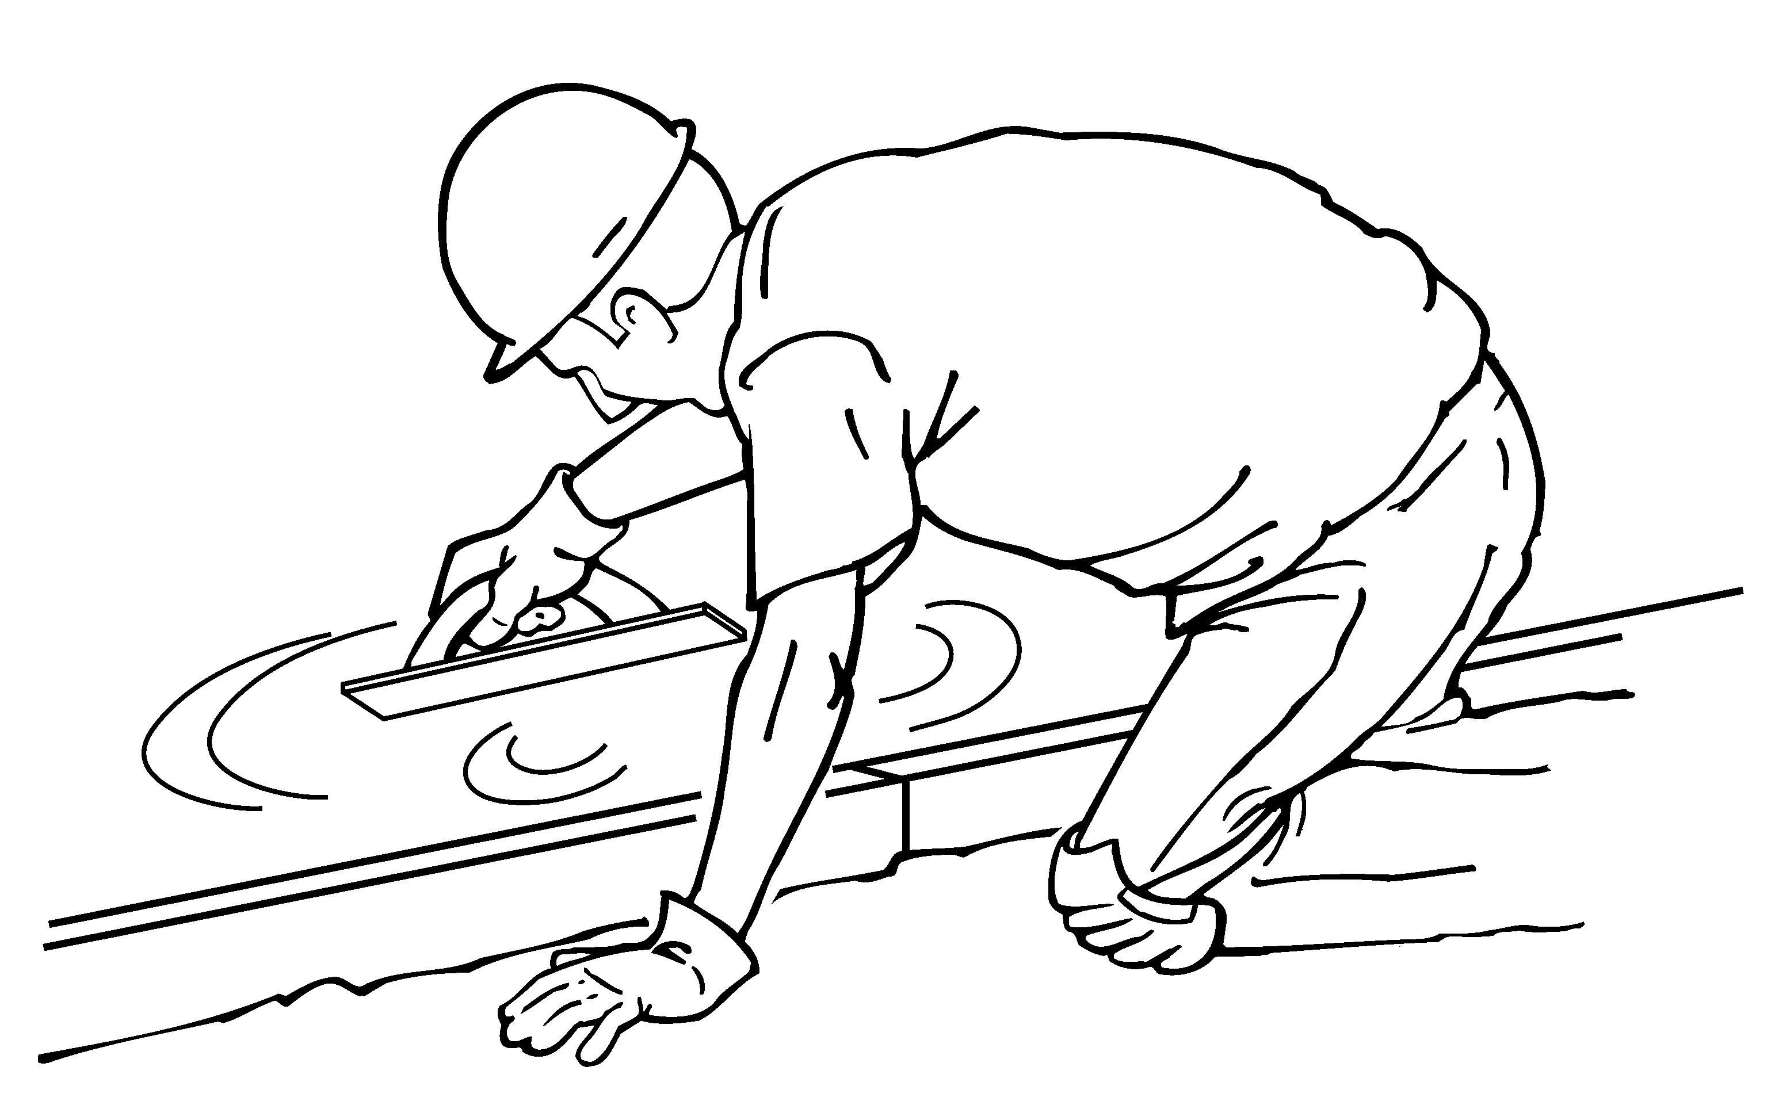 | 4. Kneeling more than 2 hours total per day. |  | □
High Hand Force |  |  |  | Comments/Observations
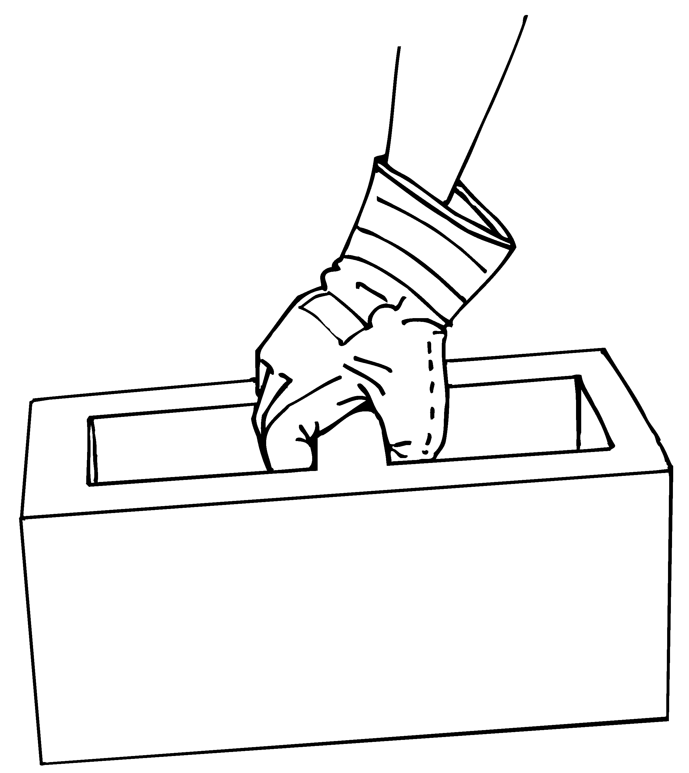 | 5. Pinching an unsupported object(s) weighing 2 or more pounds per hand, or pinching with a force of 4 or more pounds per hand, more than 2 hours total per day (comparable to pinching half a ream of paper). |  | □
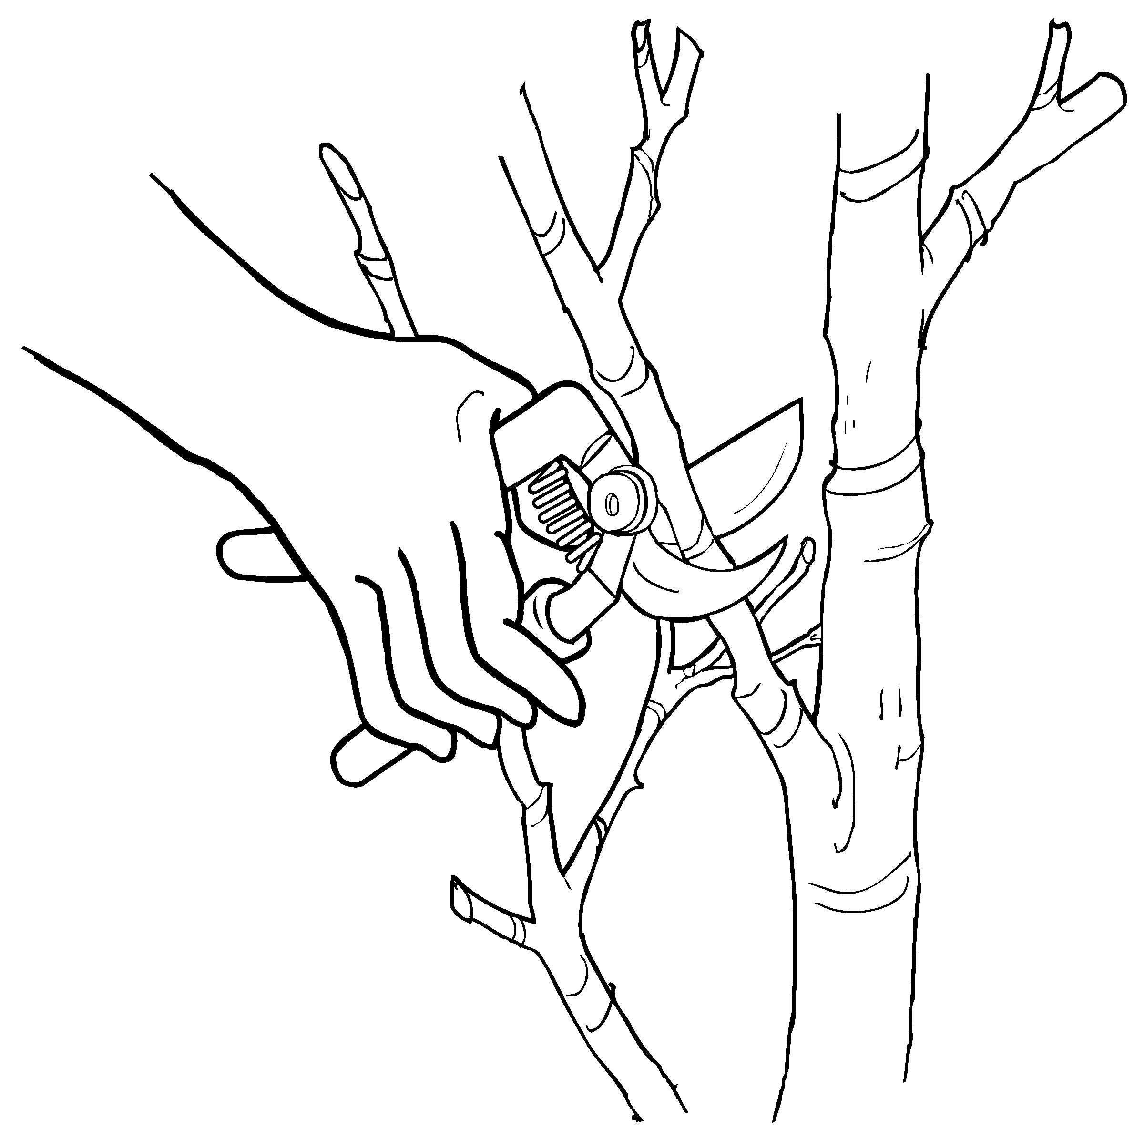 | 6. Gripping an unsupported objects(s) weighing 10 or more pounds per hand, or gripping with a force of 10 or more pounds per hand, more than 2 hours total per day (comparable to clamping light duty automotive jumper cables onto a battery). |  | □

Highly Repetitive Motion |  |  | Comments/Observations
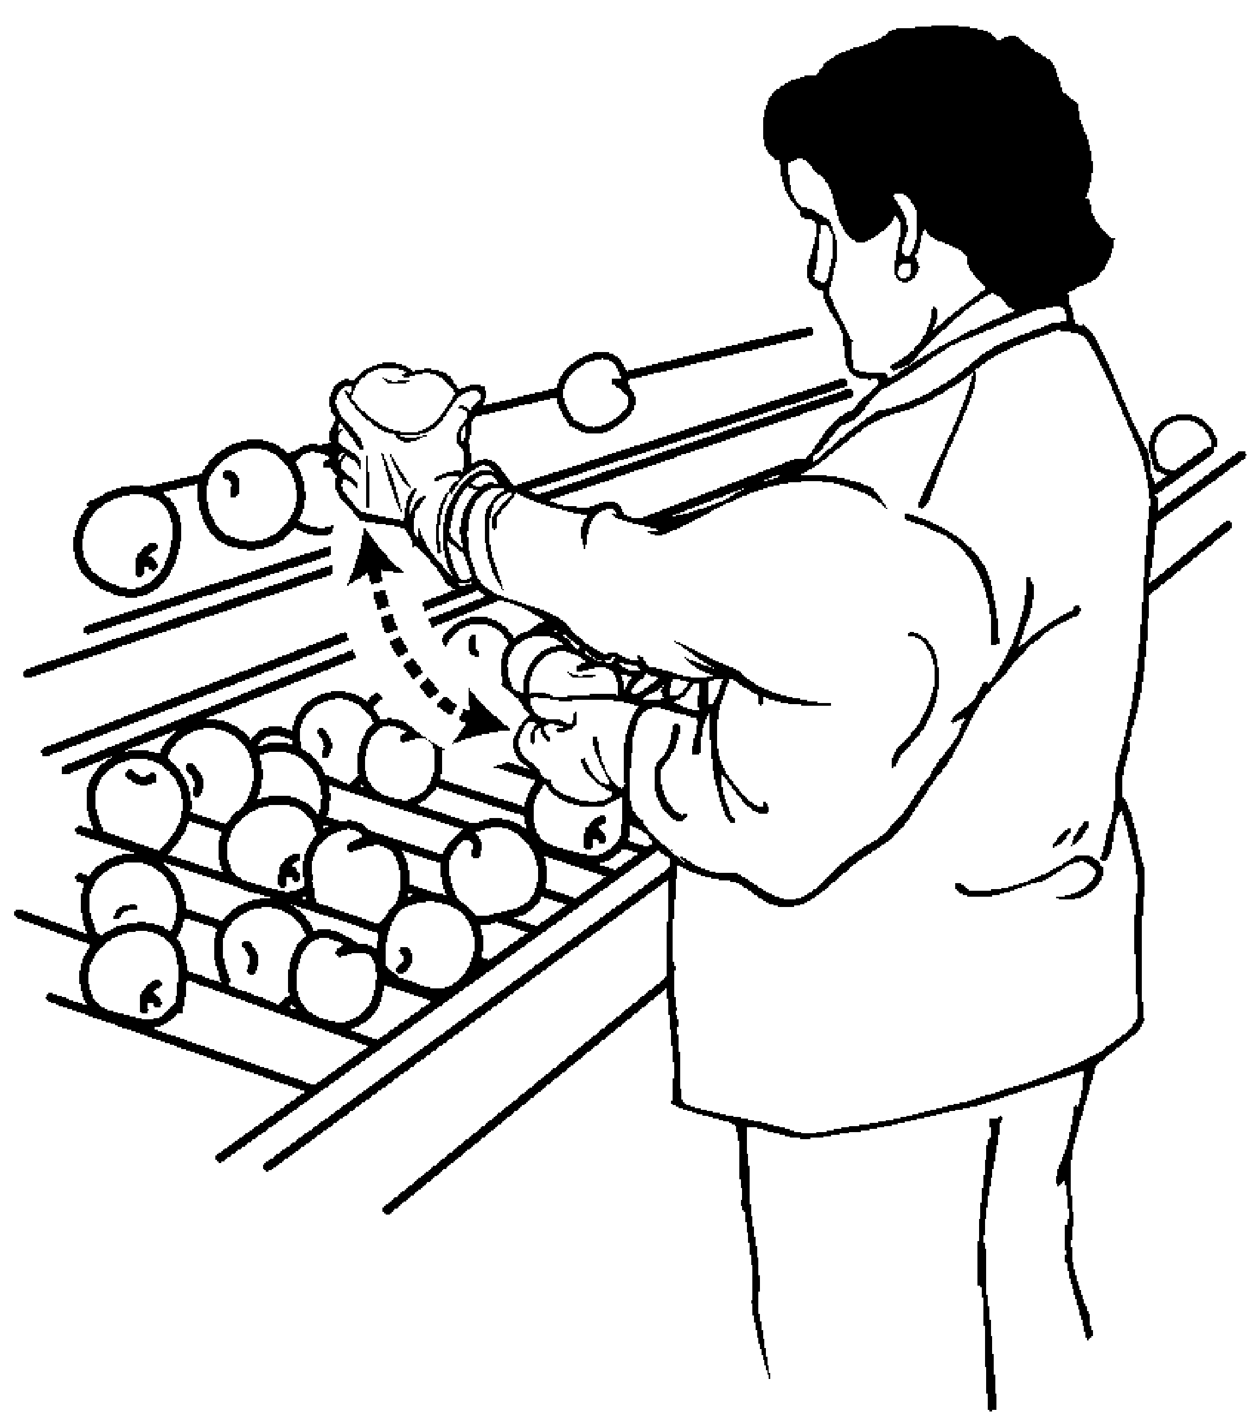 | 7. Repeating the same motion with the neck, shoulders, elbows, wrists, or hands (excluding keying activities) with little or no variation every few seconds, more than 2 hours total per day. | □
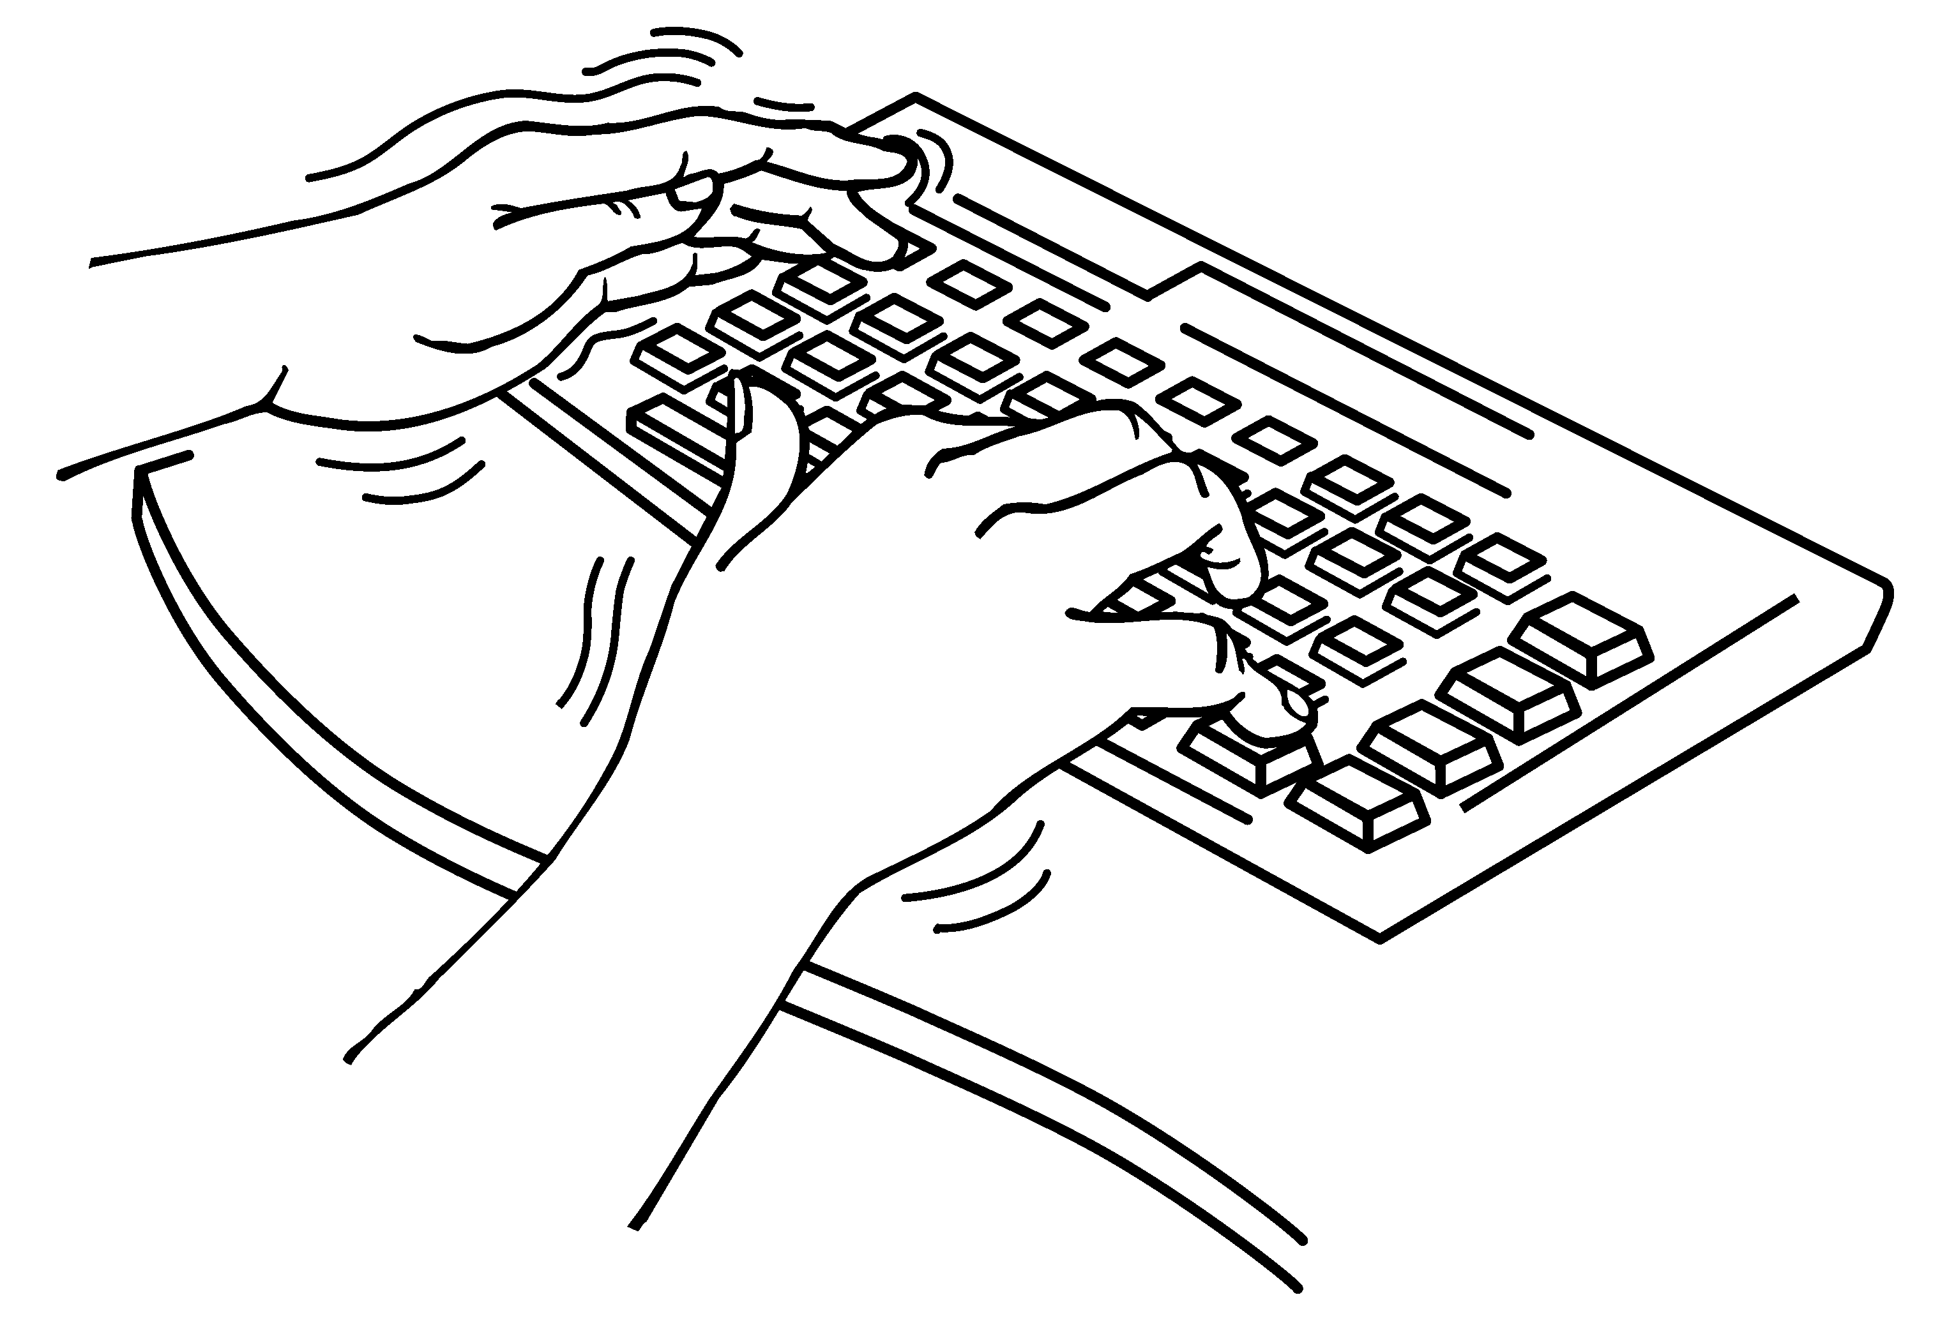 | 8. Performing intensive keying more than 4 hours total per day. | □
Repeated Impact |  |  | Comments/Observations
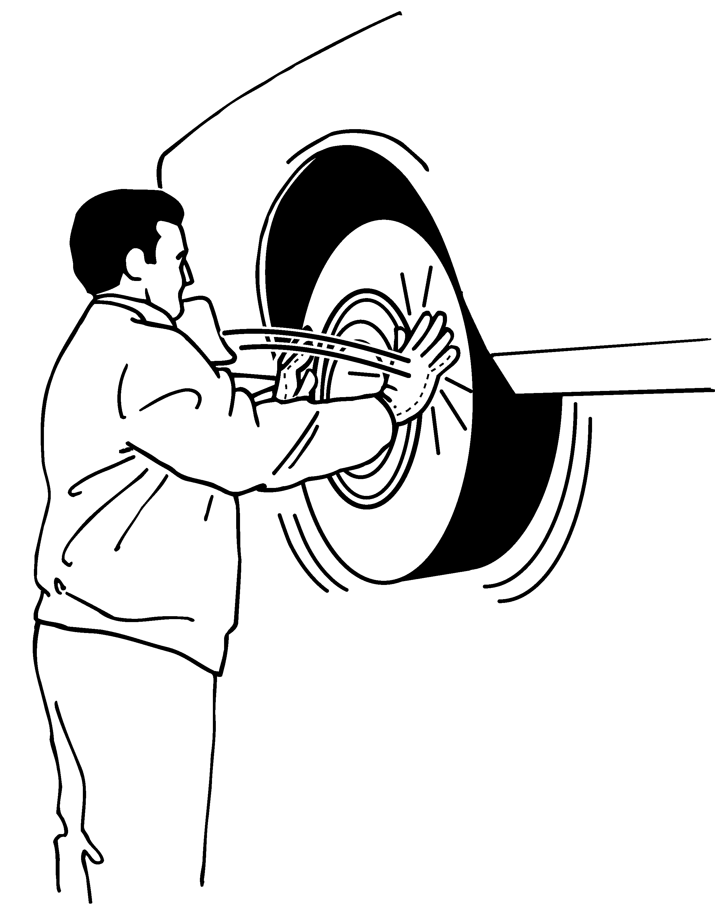 | 9. Using the hand (heel/base of palm) or knee as a hammer more than 10 times per hour, more than 2 hours total per day. | □
Heavy, Frequent or Awkward Lifting (A simple scale can be used to determine the weight of materials) |  |  | Comments/Observations
 | 10. Lifting object weighing more than 75 pounds once per day or more than 55 pounds more than 10 times per day. | □
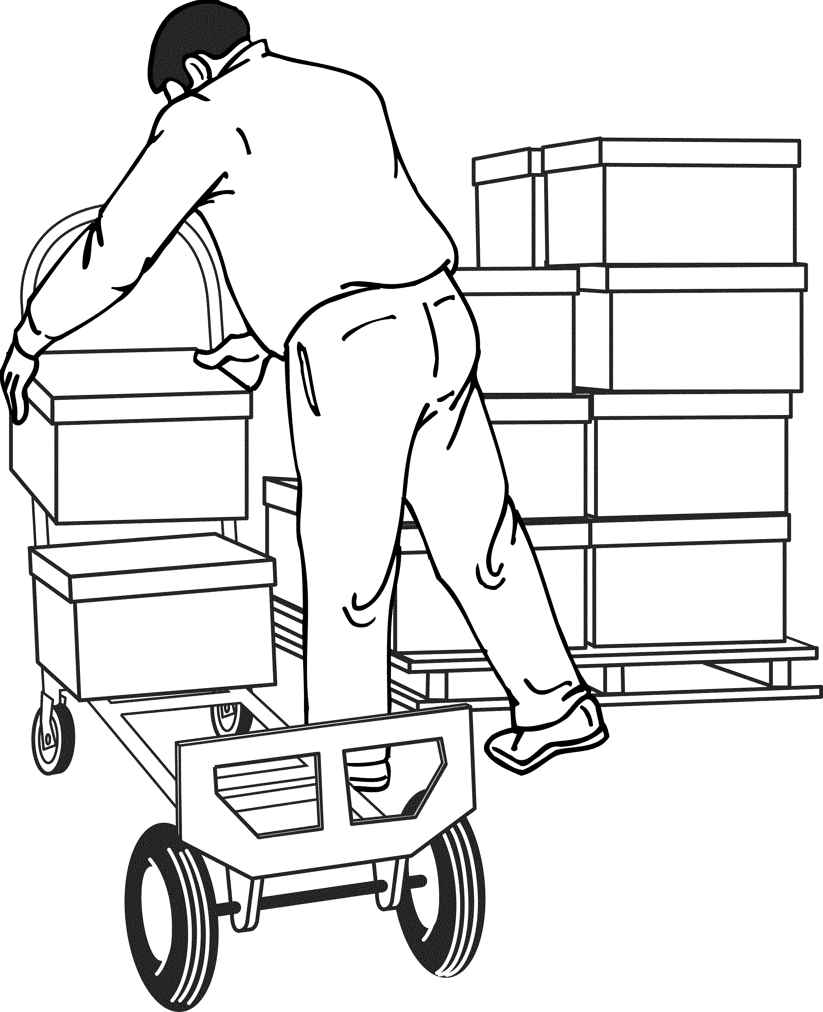 | 11. Lifting objects weighing more than 10 pounds if done more than twice per minute, more than 2 hours total per day. | □
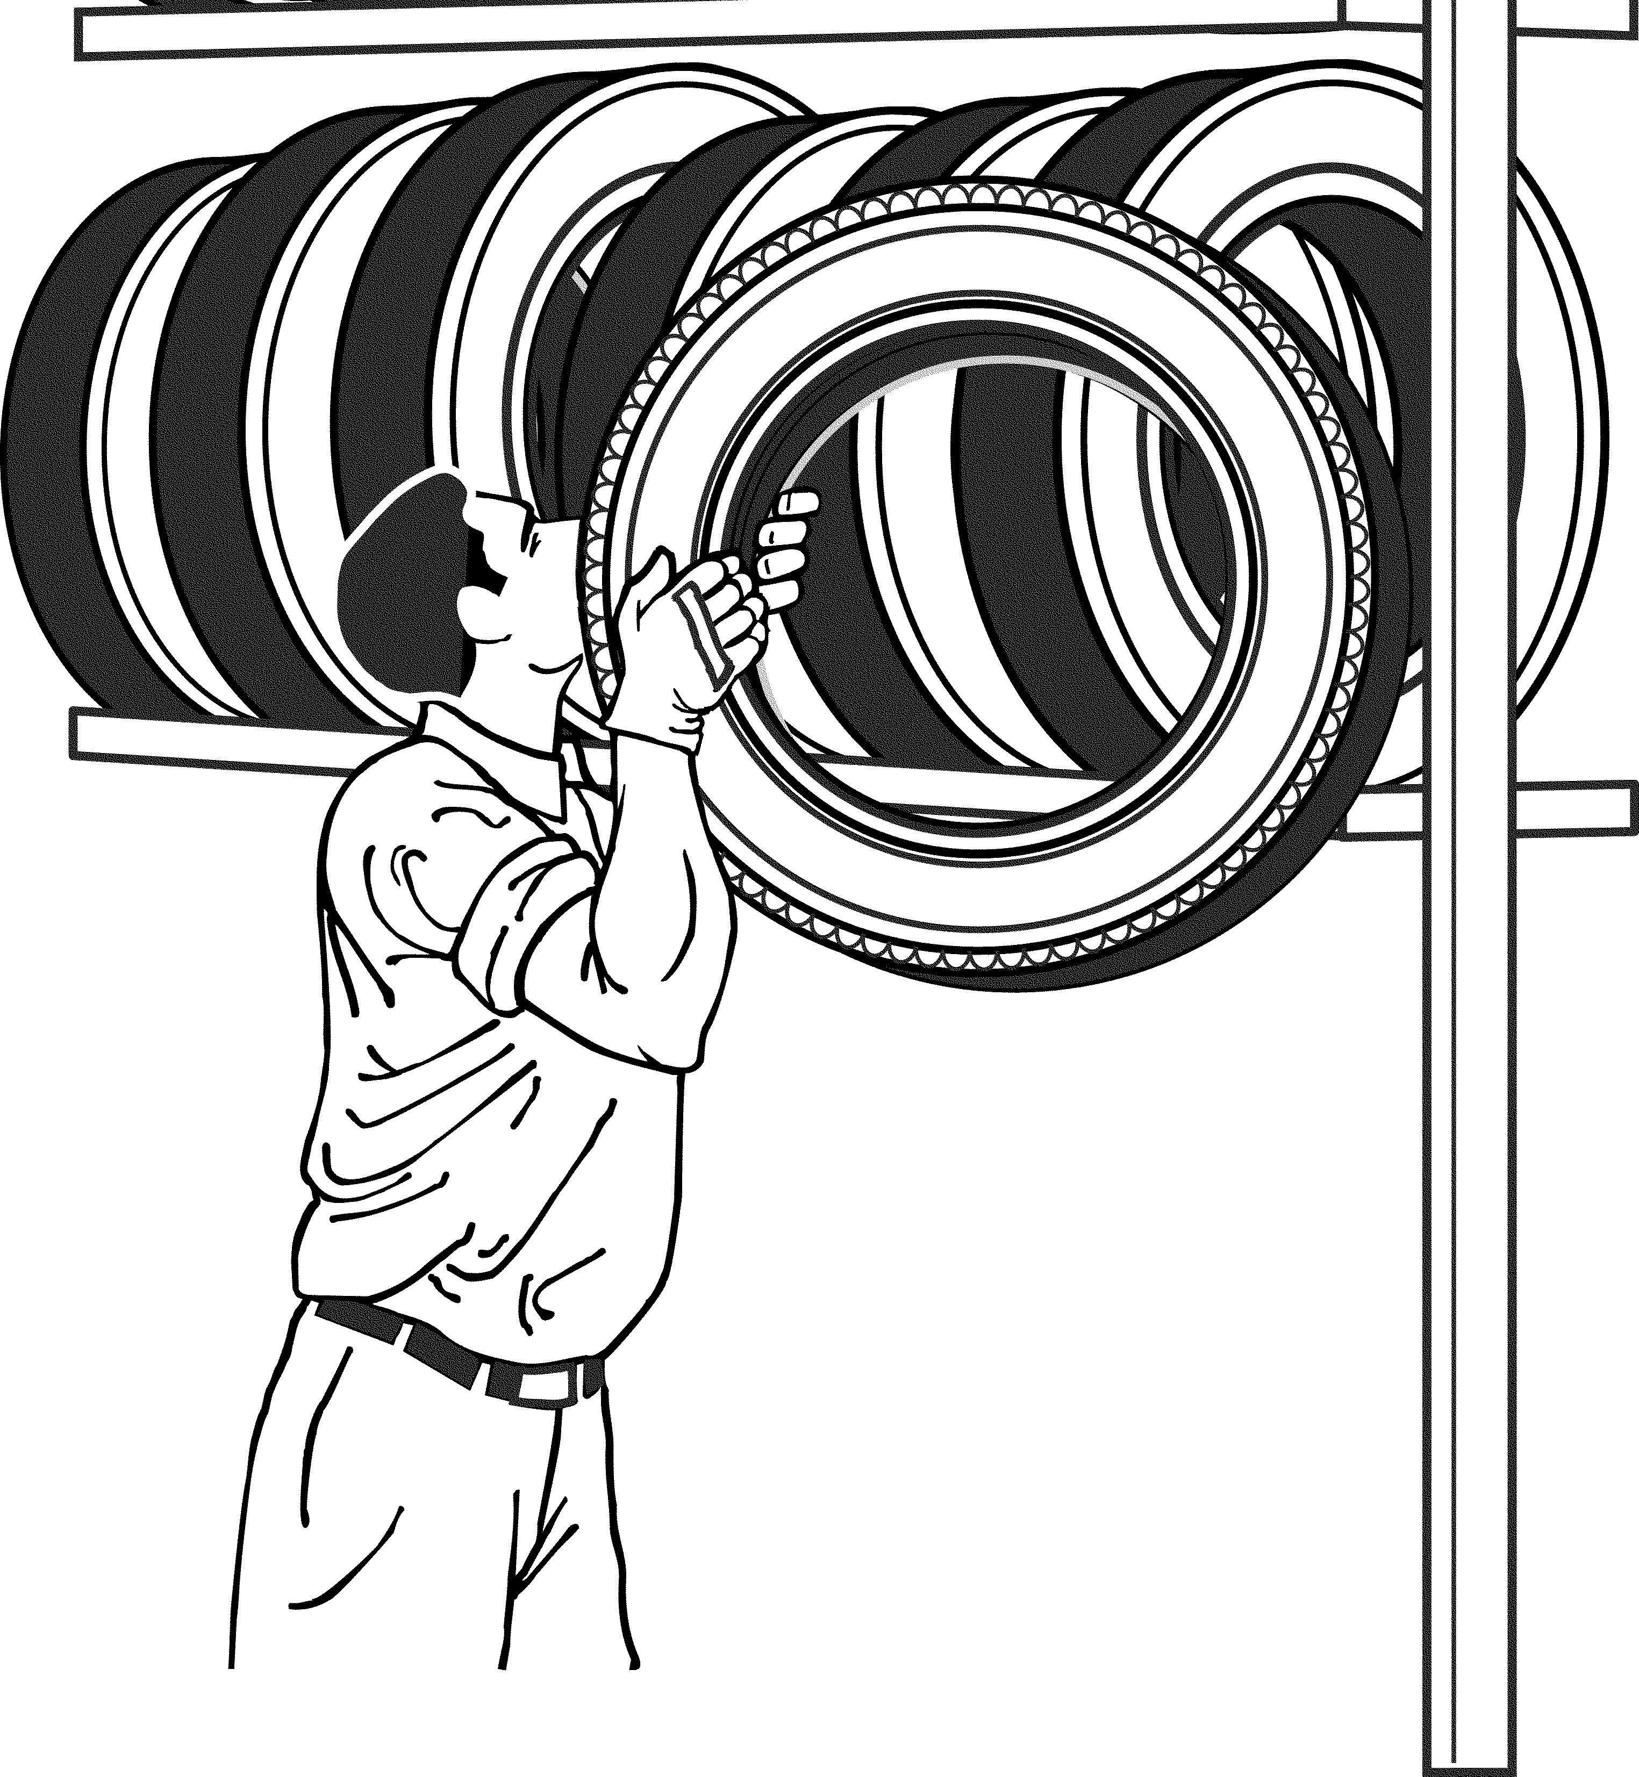 | 12. Lifting objects weighing more than 25 pounds above the shoulders, below the knees or at arms length more than 25 times per day. | □
Moderate to High Hand- Arm Vibration  (Closely estimate or obtain the vibration value of the tool in use) |  |  | Comments/Observations
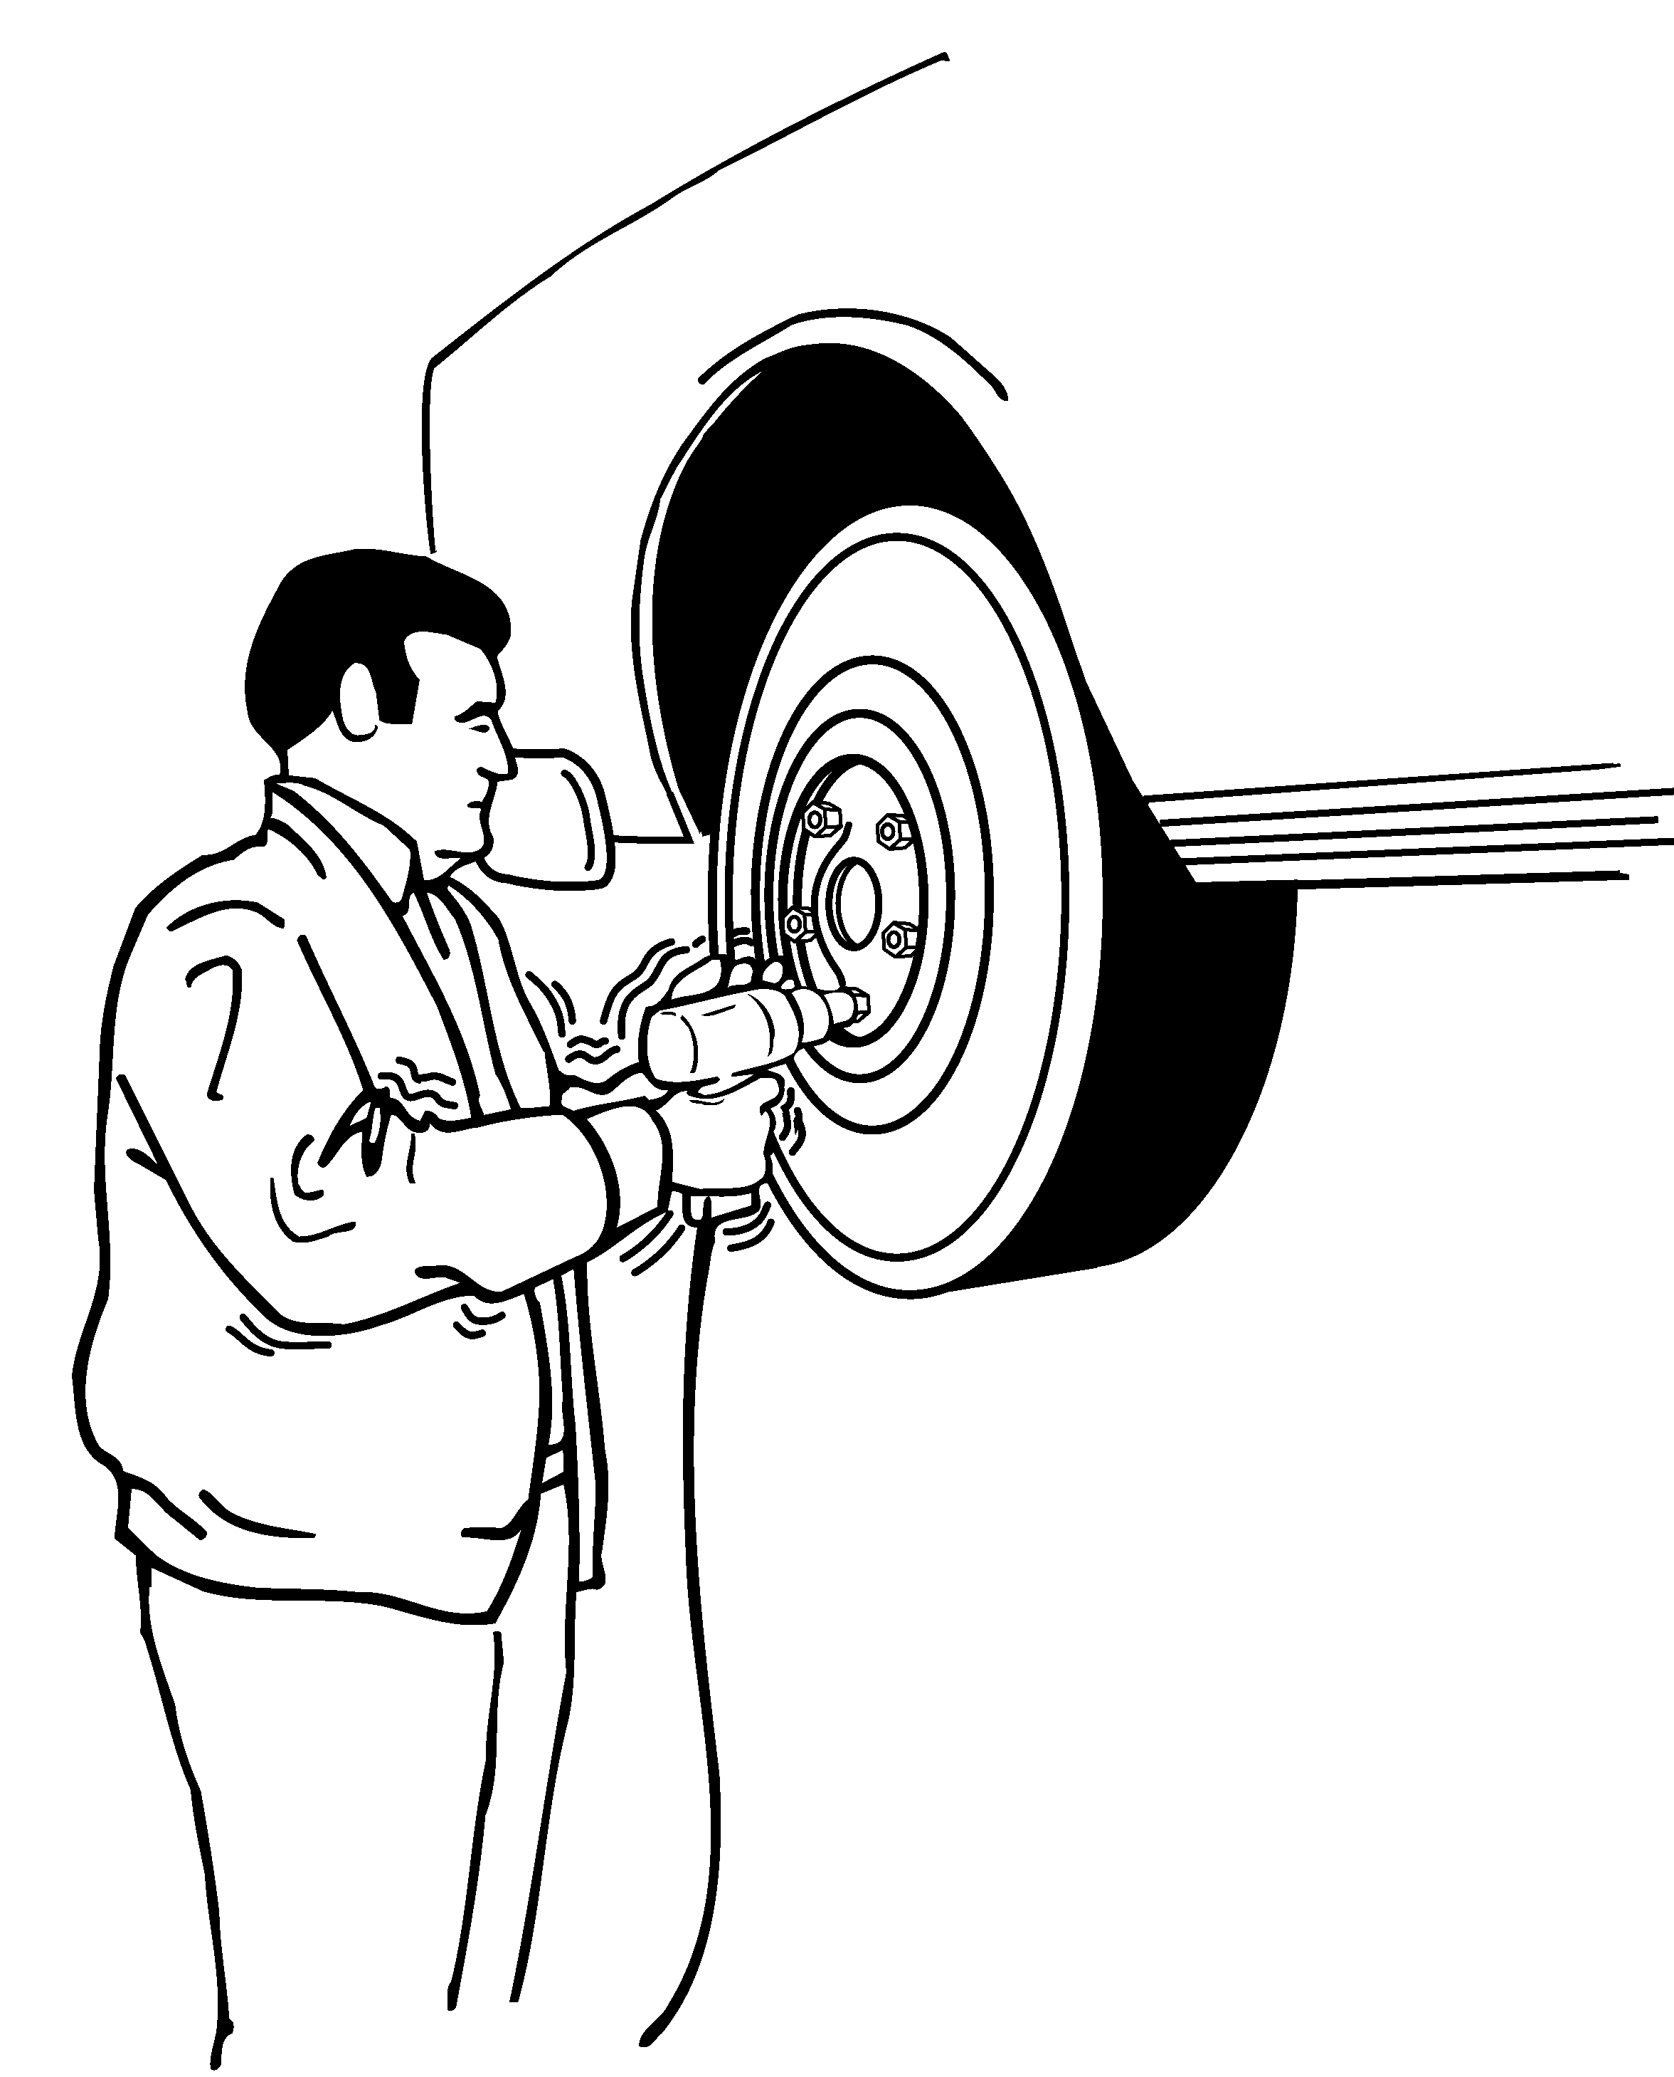 | 13. Using impact wrenches, carpet strippers, chain saws, percussive tools (jack hammers, scalers, riveting or chipping hammers) or other tools that typically have high vibration levels, more than 30 minutes total per day. | □
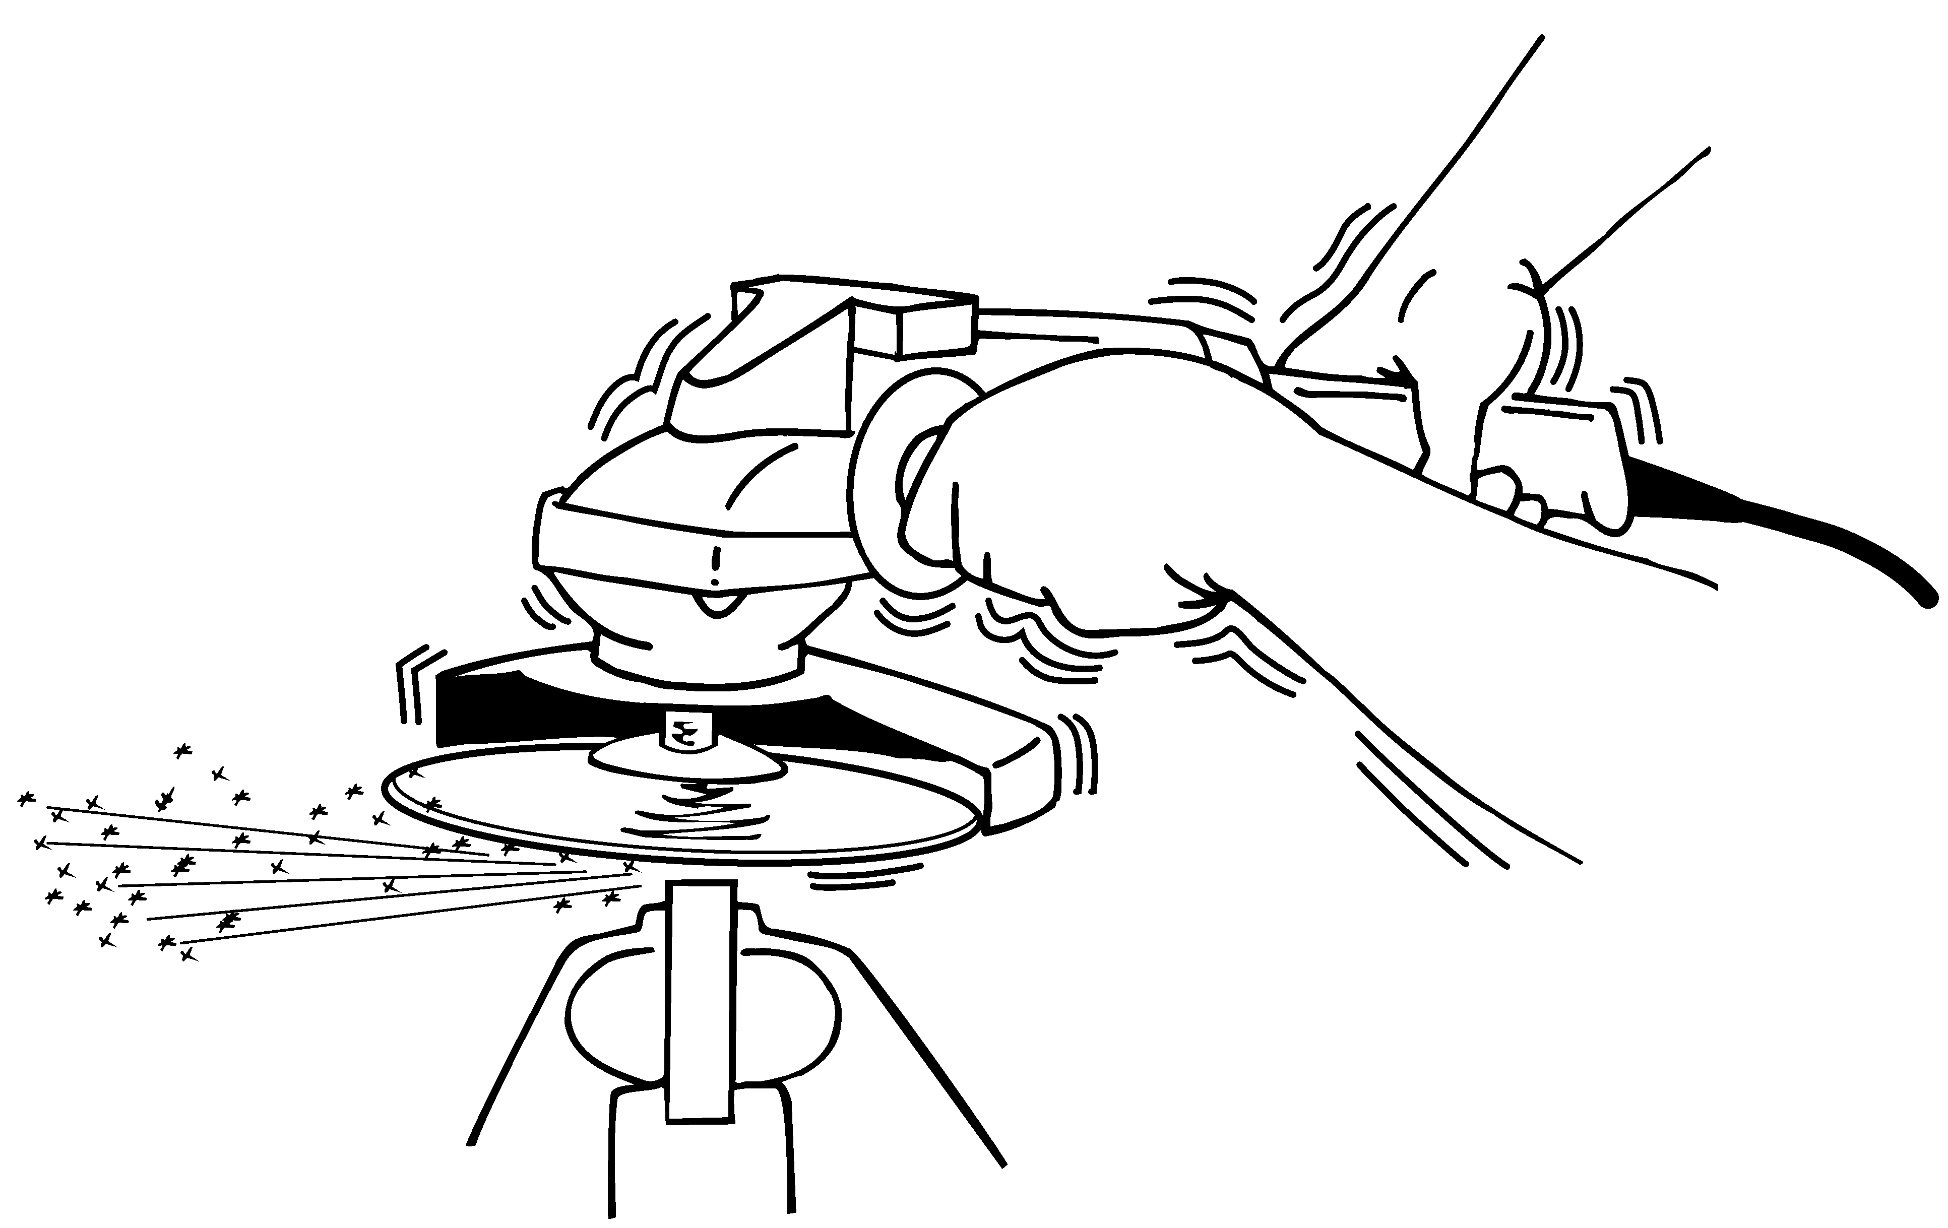 | 14. Using grinders, sanders, jigsaws or other hand tools that typically have moderate vibration levels more than 2 hours total per day. | □

