HAZARD ZONE JOBS CHECKLIST
For each "caution zone job" find any physical risk factors that apply. If a hazard exists, it must be reduced below the hazard level or to the degree technologically and economically feasible.
Movements or postures that are a regular and forseeable part of the job, occurring more than one day per week, and more frequently than one week per year. |  |  | Hazard Exists   | Job Position evaluated:  Date: | No. of employees in these jobs?
Awkward Posture |  |  |  | Comments/Observations
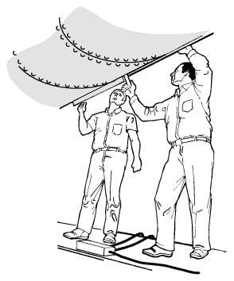 | 1. Working with the hand(s) above the head, or the elbows above the shoulders | More than 4 hours total per day | □
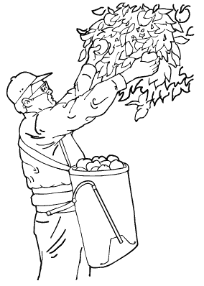 | 2. Repeatedly raising the hand(s) above the head, or the elbow(s) above the shouder(s) more than once per minute | More than 4 hours total per day | □
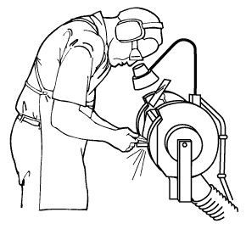 | 3. Working with the neck bent more than 45° (without support or the ability to vary posture) | More than 4 hours total per day | □
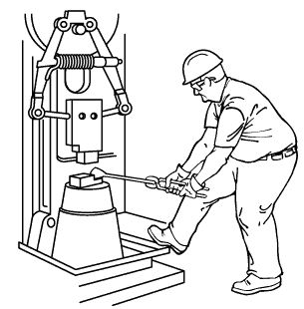 | 4. Working with the back bent forward more than 30° (without support or the ability to vary posture) | More than 4 hours total per day | □
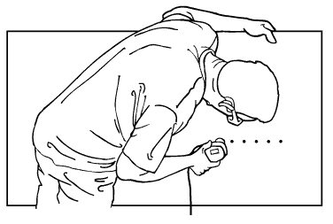 | 5. Working with the back bent forward more than 45° (without support or the ability to vary posture) | More than 2 hours total per day | □
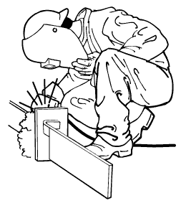 | 6. Squatting | More than 4 hours total per day | □
 | 7. Kneeling | More than 4 hours total per day | □

-1-

High Hand Force |  |  | Hazard Exists | Comments/Observations
Pinching an unsupported object(s) weighing 2 lbs or more per hand, or pinching with a force of 4 lbs or more per hand (comparable to pinching a half a ream of paper)
8.  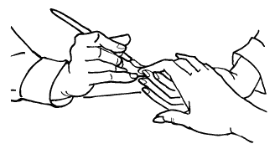 | +  Highly repetitive motion | +  More than 3 hours total per day | □
9.  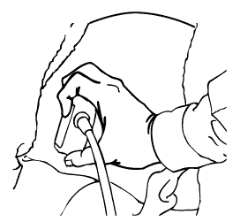 | +  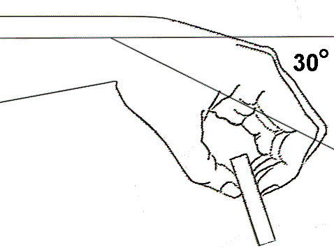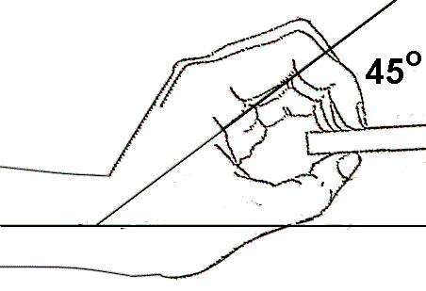  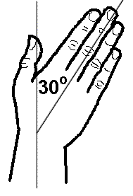 | +  More than 3 hours total per day | □
10.  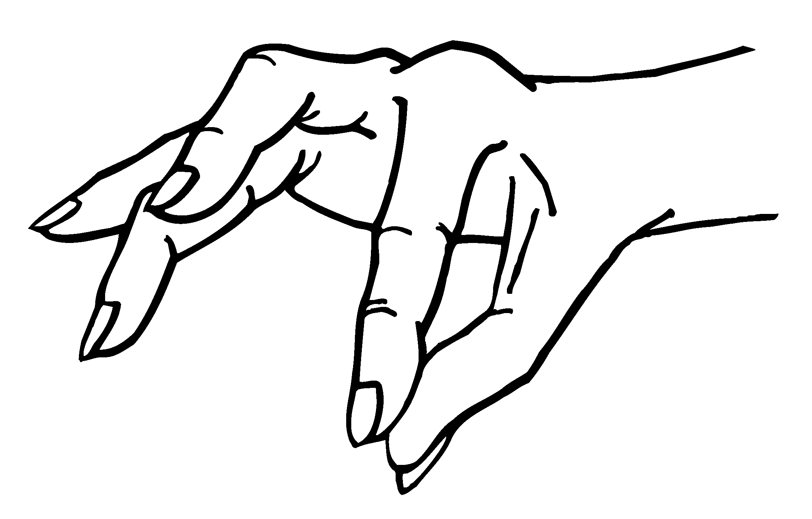 | No other risk factors | +  More than 4 hours total per day | □
Gripping an unsupported object(s) weighing 10 lbs or more per hand, or gripping with a force of 10 lbs or more per hand (comparable to clamping light duty automotive jumper cables onto a battery)
11.  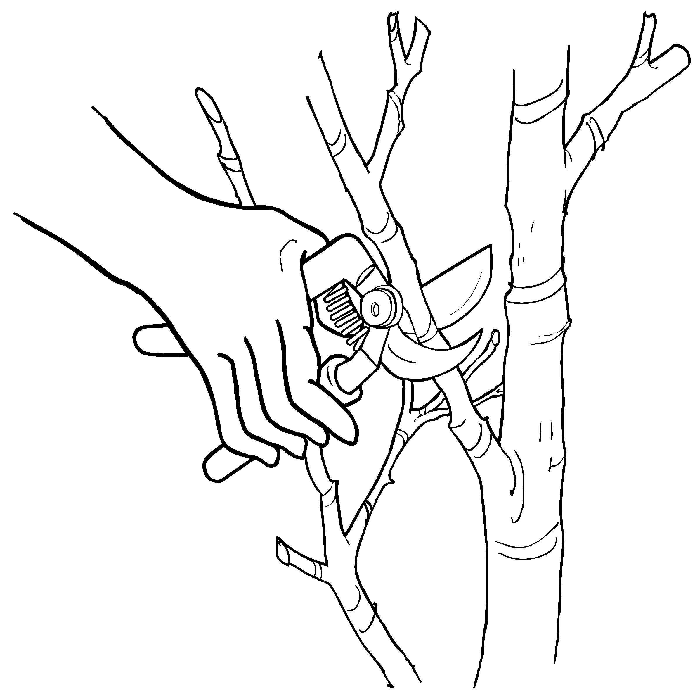 | +  Highly Repetitive motion | +  More than 3 hours total per day | □
12.  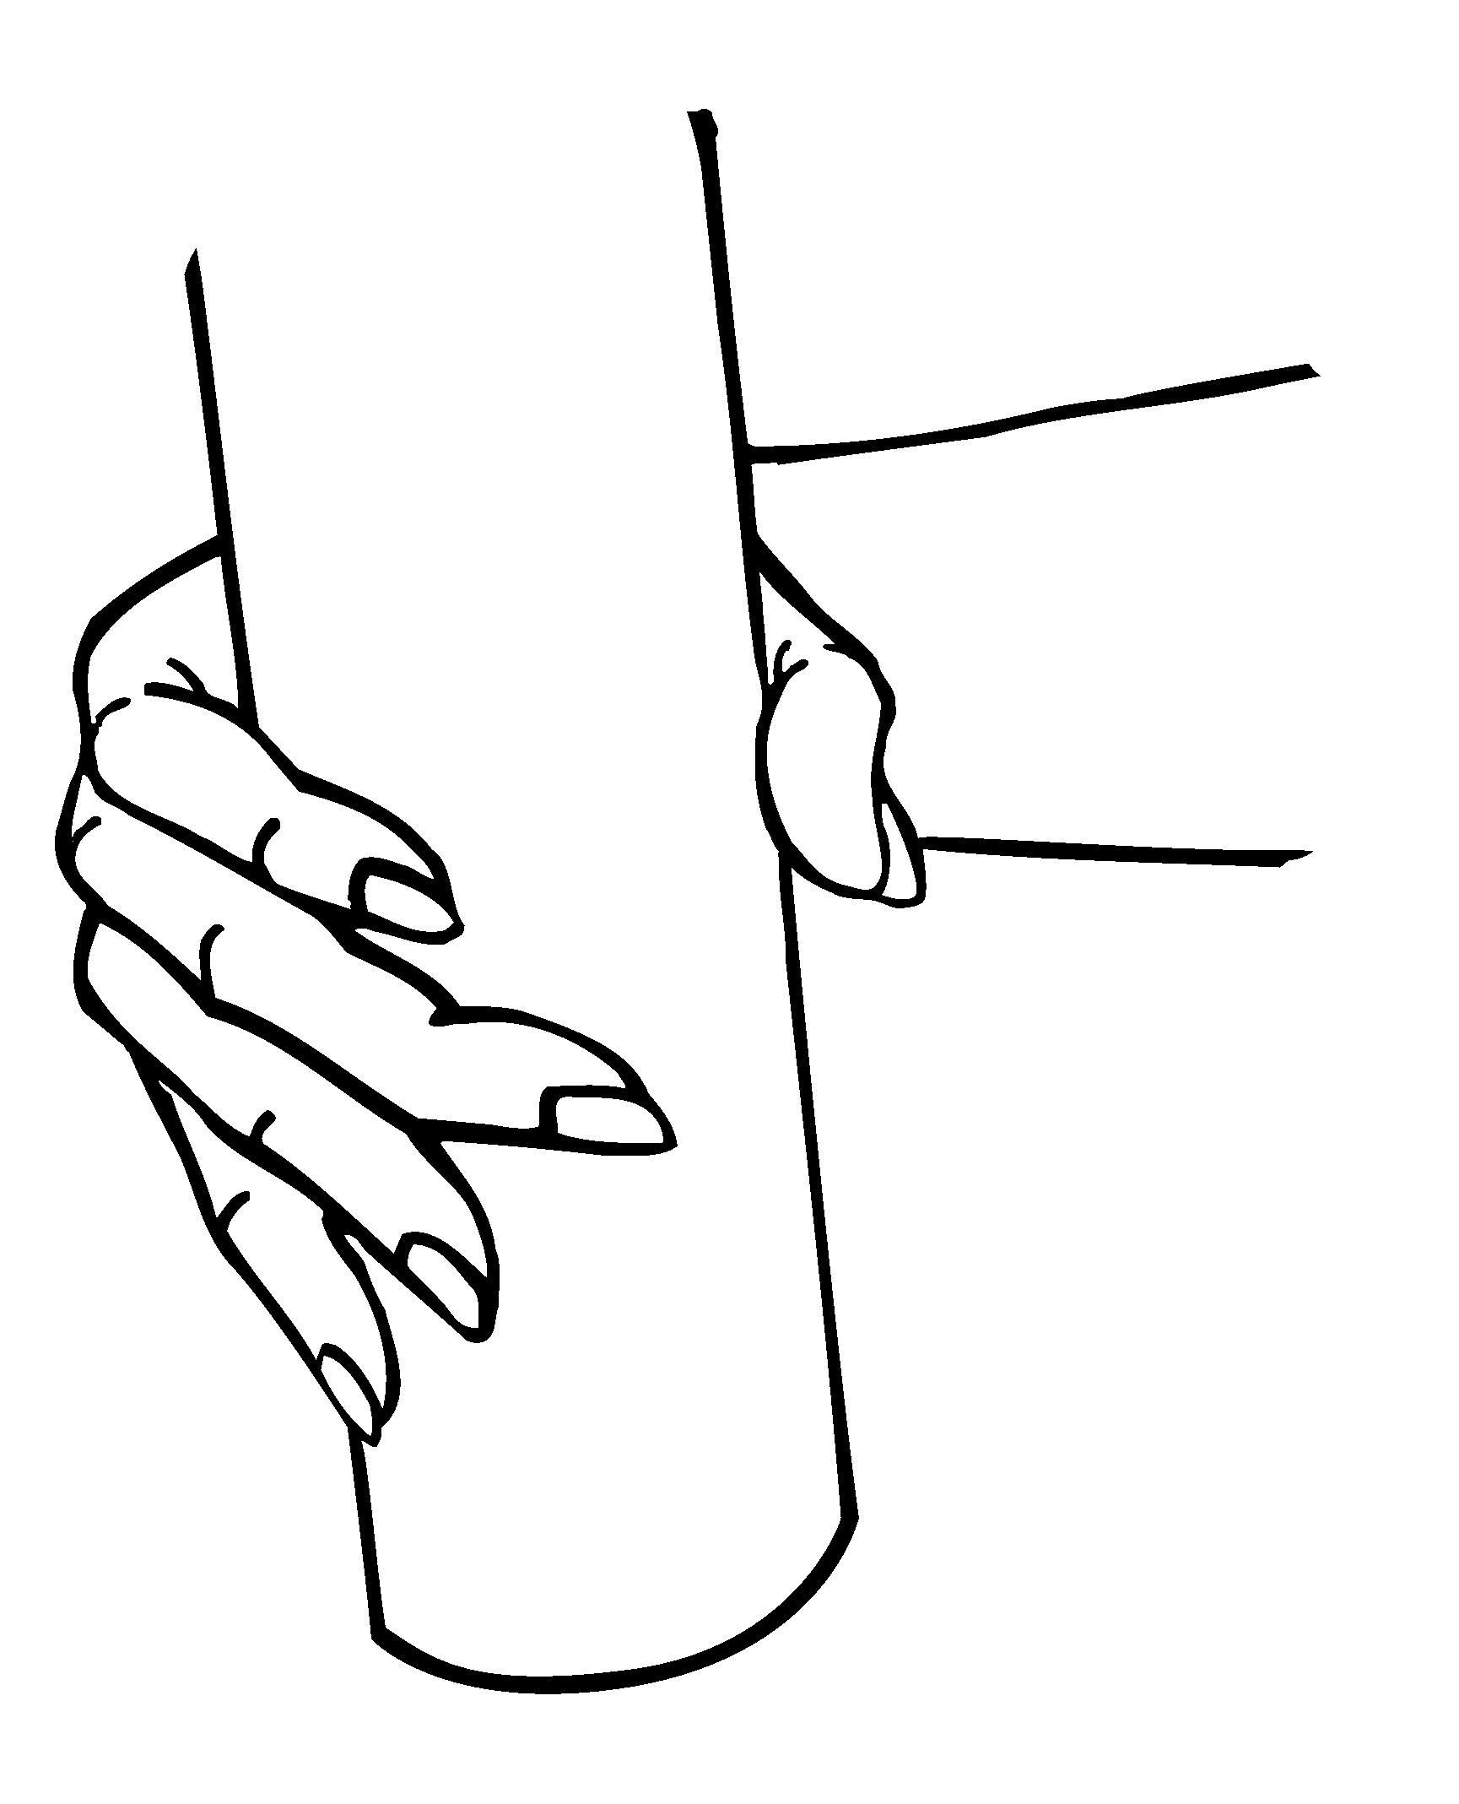 | + | +  More than 3 hours total per day | □
13.  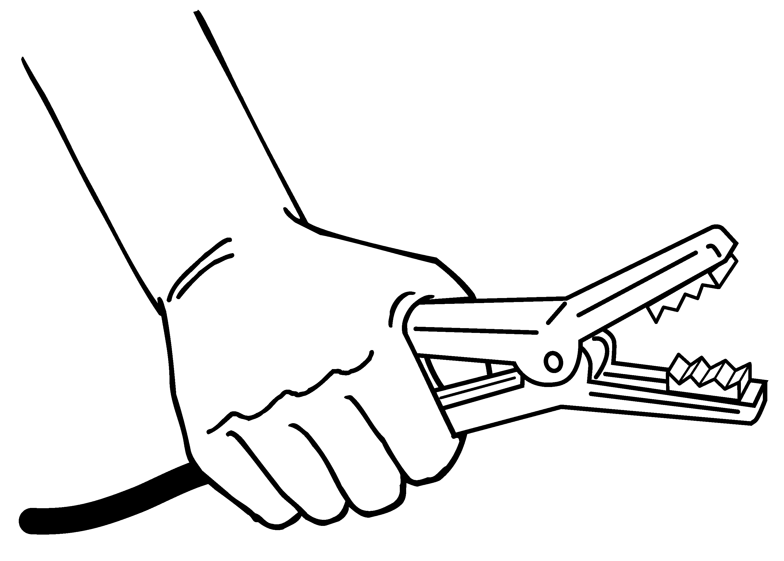 | No other risk factors | +  More than 4 hours total per day | □
- 2 -

Highly Repetitive Motion |  |  |  | Hazard Exists | Comments/  Observations
Using the same motion with little or no variation every few seconds (excluding keying activities)
14.  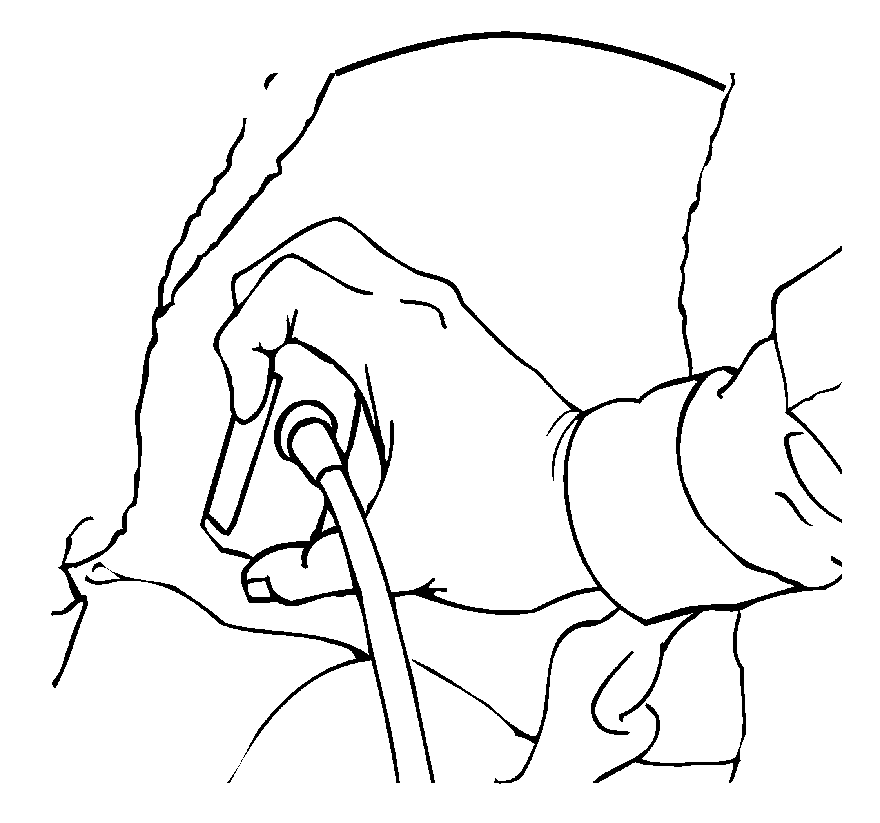 |  | +  +  High, forceful exertions with the hand(s) | +  More than 2 hours total per day | □
15.  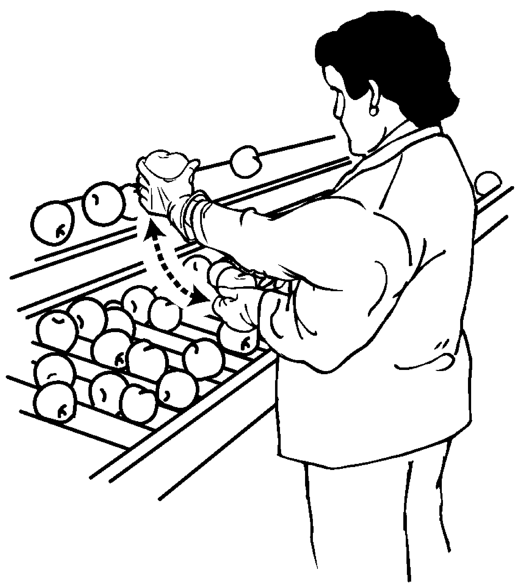 |  | No other risk factors | +  More than 6 hours total per day | □
Intensive keying
16.  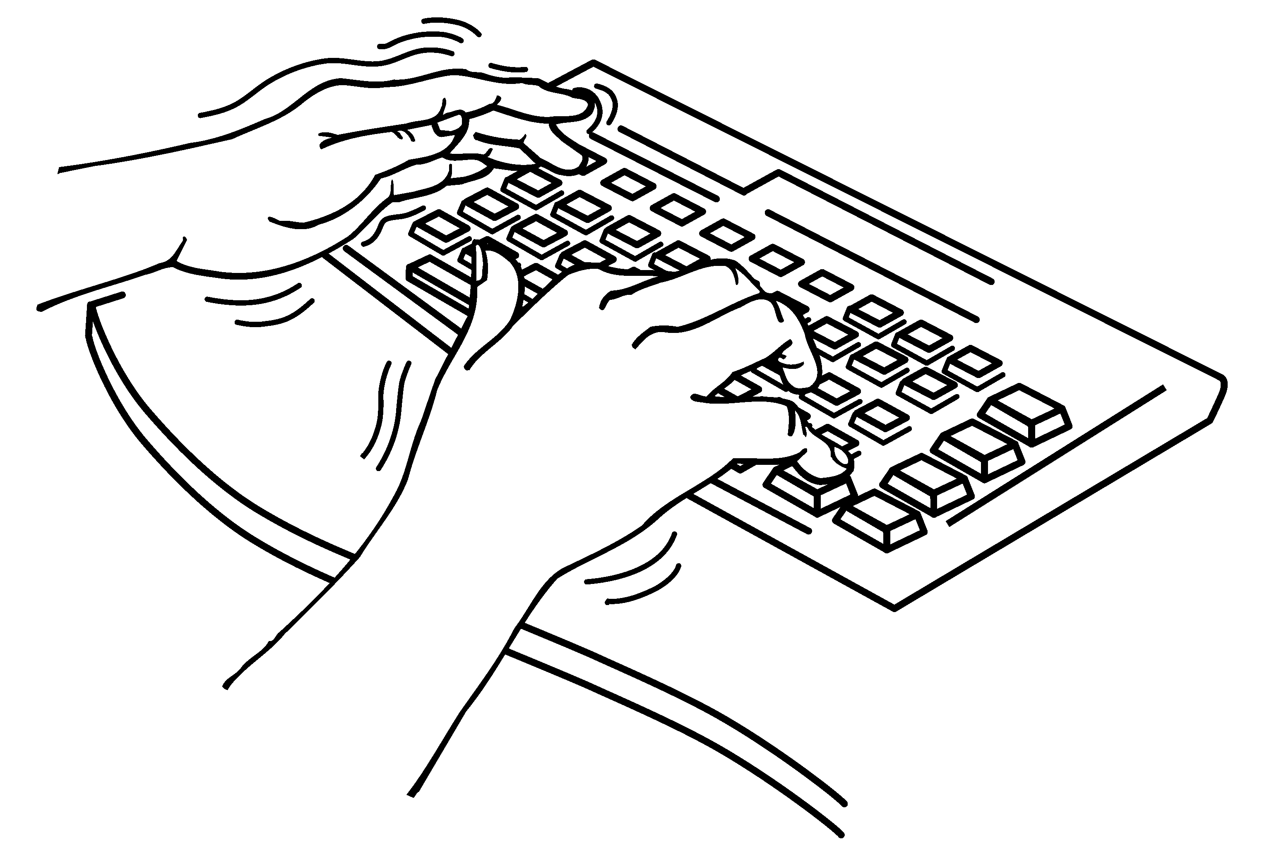 |  | + | +  More than 4 hours total per day | □
17. |  | No other risk factors | +  More than 7 hours total per day | □
Repeated Impact |  |  |  |  | Comments/  Observations
18.  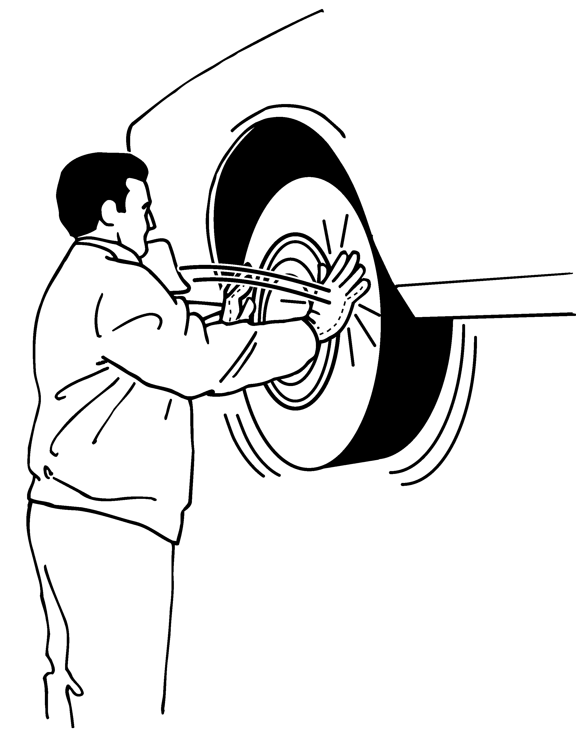 |  | Using the hand (heel/base of palm) as a hammer more than once per minute | +  More than 2 hours total per day | □
19.  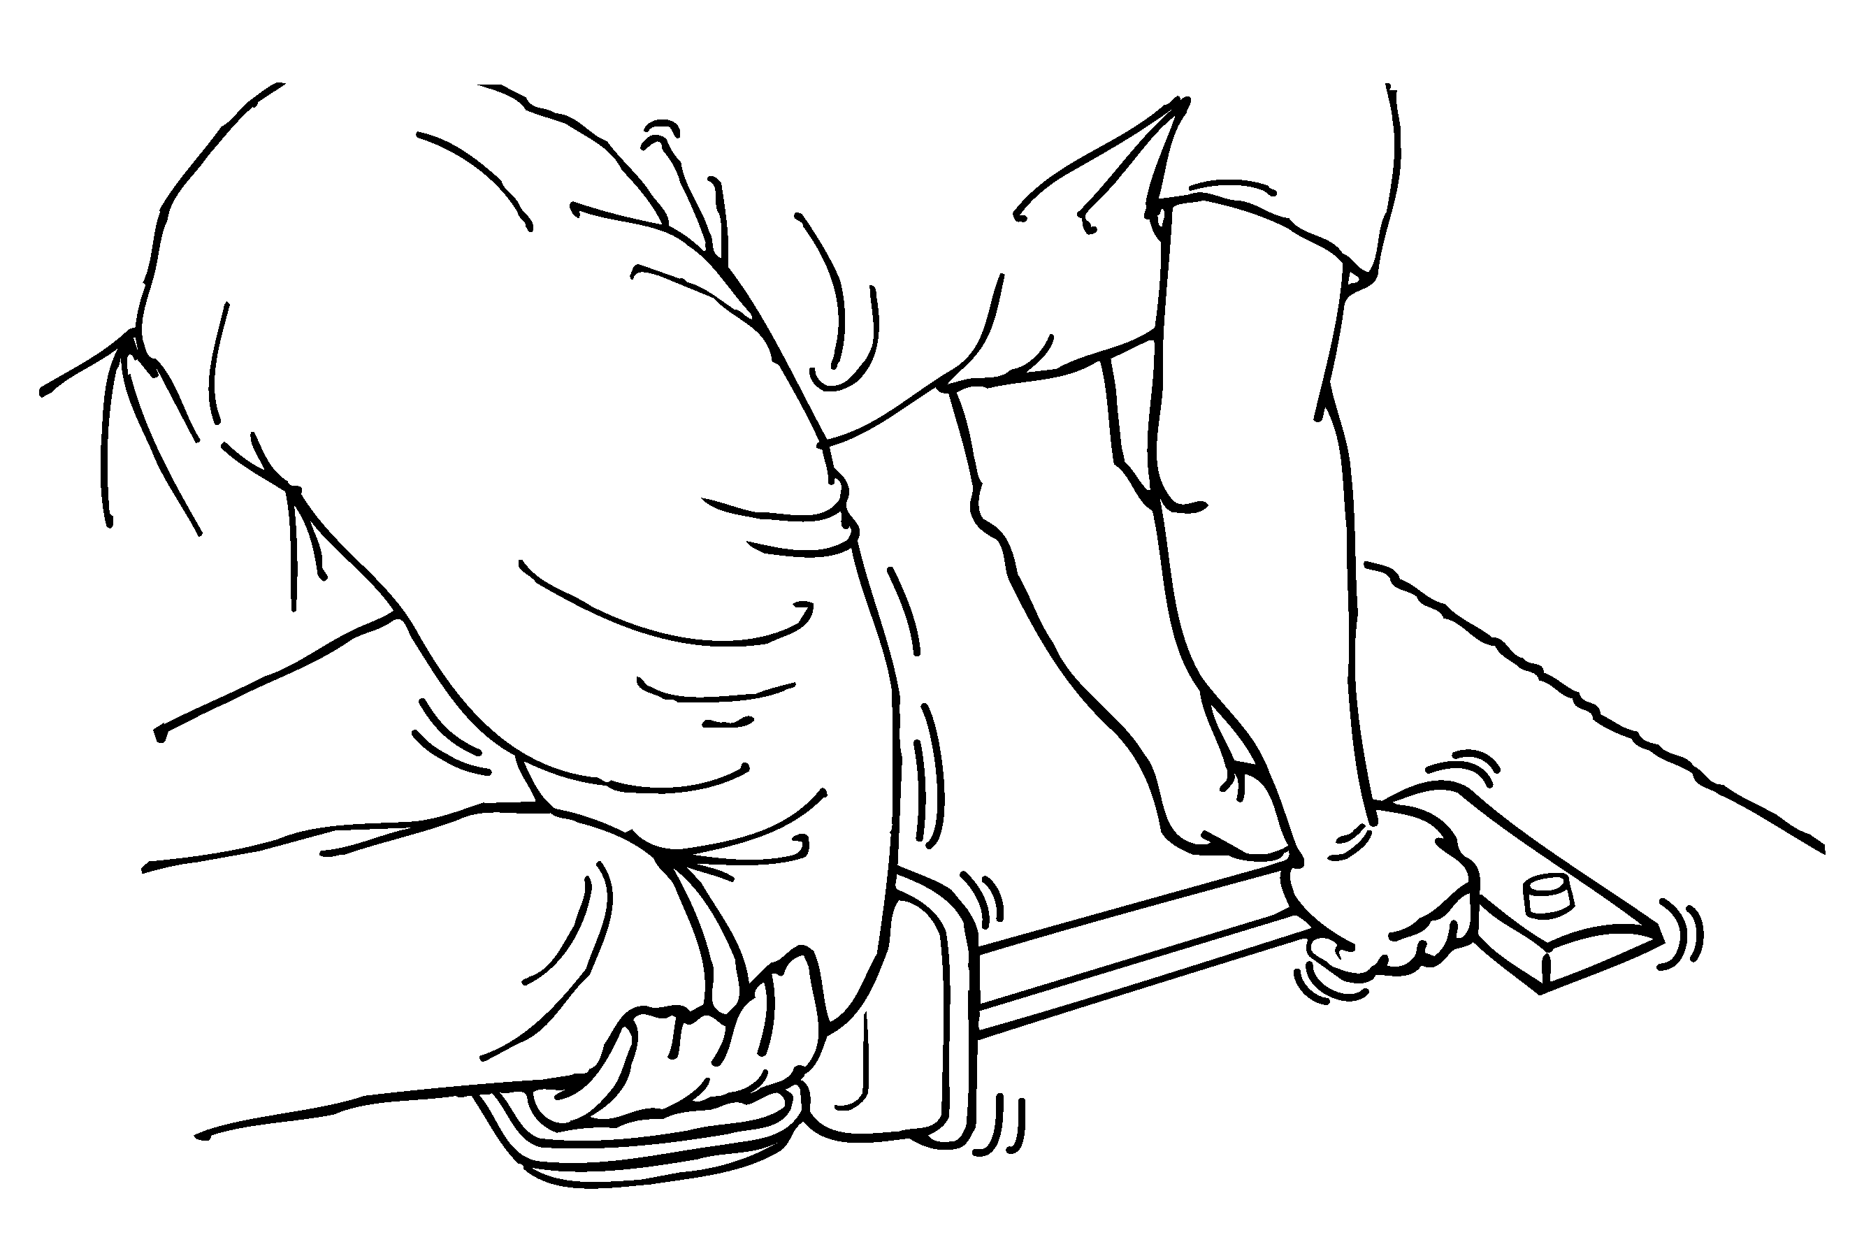 |  | Using the knee as a hammer more than once per minute  - 3 - | +  More than 2 hours total per day | □
 | Calculator for analyzing lifting operations

Company Evaluator

Job Date

1 Enter the weight of

Weight Lifted

lbs.
the object lifted.

2 Circle the number on a rectangle below that corresponds to the position of the person’s hands when they begin to lift or lower the objects.

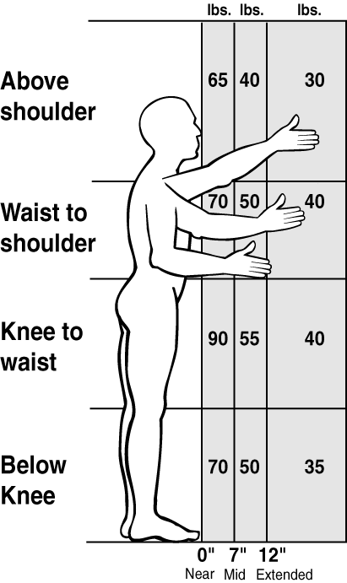

3 Circle the number that corresponds to the times the person lifts per minute and the total number of hours per day spent lifting.

Note: For lifting done less than once every five minutes, use 1.0
How many lifts  per minute? | How many hours per day?
How many lifts  per minute? | 1 hr or less | 1 hr to 2 hrs | 2 hrs or more
1 lift every 2-5 min | 1.0 | 0.95 | 0.85
1 lift every min | 0.95 | 0.9 | 0.75
2-3 lifts every min | 0.9 | 0.85 | 0.65
4-5 lifts every min | 0.85 | 0.7 | 0.45
6-7 lifts every min | 0.75 | 0.5 | 0.25
8-9 lifts every min | 0.6 | 0.35 | 0.15
10+ lifts every min | 0.3 | 0.2 | 0.0

4 Circle 0.85 if the person
0.85
twists 45 degrees or more
while lifting.
1.0

Otherwise circle

5 Copy below the numbers you have circled in steps 2, 3, and 4.

 |  |  |  |  |  | Lifting Limit
lbs. | X |  | X |  | =
Step  2 |  | Step  3 |  | Step  4 |  | lbs.
Yes – OK
No – HAZARD

6 Is the Weight Lifted (1)
less than the Lifting
Limit (5)

Note: If the job involves lifts of objects with a number of different weights and/or from a number of different locations, use Steps 1 through 5 above to:
- Analyze the 2 worst-case lifts—the heaviest object lifted and the lift done in the most awkward posture.
- Analyze the most commonly performed lift. In Step 3, use the frequency and duration for all the lifting done in a typical workday.

4

Calculator for analyzing lifting operations

7 SOLUTIONS PRINCIPLES
To find the most appropriate solution for this job, look for the lowest number you used to do the calculations (2, 3, 4)

HANDS POSITION (2)  - Reduce the horizontal distance from the body  - Remove barriers, obstacles  - Reduce weight of load  - Reduce capacity of the container  - Team lift the object with two or more workers  - Design workstation with the adjustable heights to eliminate trunk bent forward  - Provide handholds  - Store objects at 30 inches off the floor | FREQUENCY (3)  - Increase weight of a load so it requires mechanical assist  - Improve layout to minimize manual material handling  - Use mobile storage racks
DURATION (3)  - Use mechanical assist such as overhead hoist, manipulator, vacuum lift, pneumatic balancer, forklift  - Eliminate the use of deep shelves  - Job rotation to other jobs where no lifting is required | TWISTING (4)  - Redesign workstation layout to eliminate trunk twisting  - Locate lifting operations in front of the body  - Use slides, gravity, chutes to eliminate lifting/twisting

- 5 -

Calculator for Hand-Arm Vibration

- Find the vibration value for the tool. (Get it from the manufacturer look it up
at this website http://umetech.niwl.se/Vibration/action.lasso?-database=HAVbase.fp3&-layout=Normal&-response=HAVSearch.html&-show On the graph below mark the point on the left side shown as Vibration value.
Vibration

m/s2

Duration

Hrs.
- Find out how many total hours per day the employee is using the tool and mark that point on the bottom of the chart below.

3. Trace a line into the graph from each of these two points until they cross.

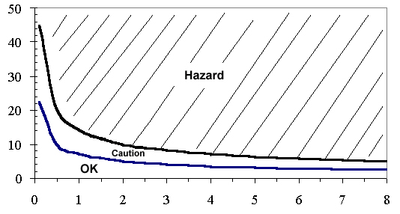
4. Interpretation
- If that point lies in the crosshatched “Hazard” area above the upper curve, then the vibration hazard must be reduced below the hazard level or to the degree technologically and economically feasible.
- If the point lies between the two curves in the “Caution” area, then the job remains as a “Caution Zone Job.”
- If the point falls in the “OK” area below the bottom curve, then no further steps are required.

Note: The caution limit curve (bottom) is based on an 8-hour energy-equivalent frequency- weighted acceleration value of 2.5 m/s2. The hazard limit curve (top) is based on an 8-hour energy-equivalent frequency- weighted acceleration value of 5 m/s2.

- 6 -
- 6 -

