Department/Facility

Minimum Requirements for the Control of Hazardous Energy
(Lockout/Tagout)

for

___________________________________
(Department/Facility)

Minimum Requirements for the Control of Hazardous Energy
(Lockout/Tagout)

Table of Contents

1.0 Scope, Application & Purpose 1

2.0 Definitions 2

3.0 Rules & Responsibilities 3

4.0 Compliance with this Program 4

5.0 Training & Communication 4

6.0 Sequence of Lockout 5

7.0 Lockout/Tagout Devices 8

8.0 Contractor’s Responsibilities 9

9.0 Evaluation of Program Effectiveness 9

Appendix A. Lock/Tagout Procedures

Appendix B. Special Lock & Tag Removal Procedure

Appendix C. Lockout/Tagout Periodic Inspection Record

Appendix D. Training Records

(Department/Facility)
Minimum Requirements for The Control of Hazardous Energy
(Lockout/Tagout)

1.0 Scope, Application & Purpose


The Occupational Safety and Health Administration’s (OSHA) Standard 1910.147, “The Control of Hazardous Energy,” (lockout/tagout) helps safeguard employees from the unexpected startup of machines and equipment or release of hazardous energy while performing repairs, service or maintenance.

The “Lockout/Tagout” Standard identifies the practices and procedures necessary to shut down and lockout or tagout machines and equipment. It requires that a written hazardous energy program be implemented and address the following:

- describes safe work practices,
- establishes formal lockout/tagout procedures,
- trains all employees in the program, and
- enforces the use of the procedures through periodic inspections (including disciplinary action for failure to follow them).

It shall be the duty of each employee covered by this program to become familiar with its contents and ensure compliance with its procedures. Department heads shall ensure that their employees receive the knowledge, skills and ability to safely perform service, repair and maintenance of equipment requiring hazardous energy isolation.

The procedures and practices established in this program are the minimum requirements for the lockout of energy isolating devices whenever maintenance or servicing is performed on machines or equipment. The procedures and safe work practices are to be used to ensure that the machine or equipment is stopped, isolated from all potentially hazardous energy sources and locked out before employees perform any servicing, repairs or maintenance where the unexpected energization or start-up of the machine or equipment or release of stored energy could cause injury.

2.0 Definitions

Affected Employee: An employee whose job requires him/her to operate or use a machine or equipment on which servicing or maintenance is being performed under lockout or tagout, or whose job requires him/her to work in an area in which such servicing or maintenance is being performed.

Authorized Employee: A person who locks out or tags out machines or equipment in order to perform servicing or maintenance on that machine or equipment. An affected employee becomes an authorized employee when that employee’s duties include performing servicing or maintenance covered under this program.

Capable of Being Locked Out: An energy isolating device is capable of being locked out if it has a hasp or other means of attachment to which, or through which, a lock can be affixed, or it has a locking mechanism built into it. Other energy isolating devices are capable of being locked out, if lockout can be achieved without the need to dismantle, rebuild, or replace the energy isolating device or permanently alter its energy control capability.

Energized: Connected to an energy source or containing residual or stored energy.

Energy Isolating Device: A mechanical device that physically prevents the transmission or release of energy, including, but not limited to the following: A manually operated electrical circuit breaker; a disconnect switch; a manually operated switch by which the conductors of a circuit can be disconnected from all ungrounded supply conductors, and in addition, no pole can be operated independently; a line valve; a block or isolate energy. Push buttons, selector switches and other control circuit type devices are not energy isolating devices.

Energy Source: Employees may be exposed to hazardous energy in several forms and combinations during installation, maintenance, service or repair work. Examples include:

- Kinetic (mechanical) energy in the moving parts of mechanical systems
- Potential energy stored in pressure vessels, gas tanks, hydraulic or pneumatic systems, and springs (potential energy can be released as hazardous kinetic energy)
- Electrical energy from generated electrical power, static sources, or electrical storage devices (such as batteries or capacitors)
- Thermal energy (high or low temperature) resulting from mechanical work, radiation, chemical reaction, or electrical resistance
- Potential energy from suspended parts
- Steam and condensate systems under pressure

(Note: Once the energy sources are neutralized, a machine is in a zero mechanical state (ZMS). Zero mechanical state provides the greatest protection against unexpected mechanical movement. Therefore, the objective of good lockout procedures is to achieve zero mechanical state.

Lockout: The placement of a lockout device on an energy isolating device, in accordance with an established procedure, ensuring that the energy isolating device and the equipment being controlled cannot be operated until the lockout device is removed.

Lockout Device: A device that utilizes a positive means such as a lock, either key or combination type, to an energy isolating device in a safe position and prevent the energizing of a machine or equipment. Included are blank flanges and bolted slip blinds. Lockout devices shall indicate the identity of the employee applying the device(s).

Servicing and/or Maintenance: Workplace activities such as constructing, installing, setting up, adjusting, inspecting, modifying, and maintaining and/or servicing machines or equipment. These activities include lubrication, cleaning or unjamming of machines or equipment and making adjustments or tool changes, where the employee may be exposed to the unexpected energization or startup of the equipment or release of hazardous energy. Additional typical situations include:

- When it is necessary to bypass or remove a guard or other safety device
- When it is necessary to place any part of your body where you could be caught by moving machinery
- When it is necessary to place any part of your body near an exposed or uninsulated electrical circuit
- When it is necessary to work on high-pressure systems or on piping which contains hazardous materials

Setting Up: Any work performed to prepare a machine or equipment to perform its normal production operation.

Tagout: The placement of a tagout device on an energy isolating device, in accordance with an established procedure, to indicate that the energy isolating device and the equipment being controlled may not be operated until the tagout device is removed.

Tagout Device: A prominent warning device, such as a tag and a means of attachment, which can be securely fastened to an energy isolating device in accordance with an established procedure, to indicate that the energy isolating device and the equipment being controlled may not be operated until the tagout device is removed. Tagout devices shall indicate the identity of the employee applying the device.

3.0 Rules & Responsibilities

Each department/facility that performs repairs, maintenance or servicing of equipment requiring isolation of hazardous energy shall be responsible for completing Appendix A of this program for every piece of equipment, machine or system covered under the scope of this program. Appendix A requires lockout/tagout procedures to be documented:

- A listing of the equipment requiring lockout and or tagout.
- Energy type and magnitude including stored or residual energy for each listing.
- The hazard associated with the energy.
- The method of control (sequence of lockout), including types and locations of energy isolation.
- The method of verifying isolation of the equipment, machine or system, etc.

Heads of departments/facilities will implement this program and ensure that the employees under their supervision are trained in accordance with the procedures established herein.

4.0 Compliance with this Program

All employees are required to comply with the restrictions and limitations imposed upon them during the use of lockout. The authorized employees are required to perform lockout/tagout in accordance with this procedure. All employees, upon observing a machine or piece of equipment which is locked out to perform servicing or maintenance shall not attempt to start, energize, or use that machine or equipment.

Optional Statement
((Department/Facility) requires that any employee in violation of any provisions of this policy will be subject to disciplinary action, including possible termination. Each situation involving a violation will be thoroughly investigated and action taken on a case-by-case basis.)

5.0 Training & Communication
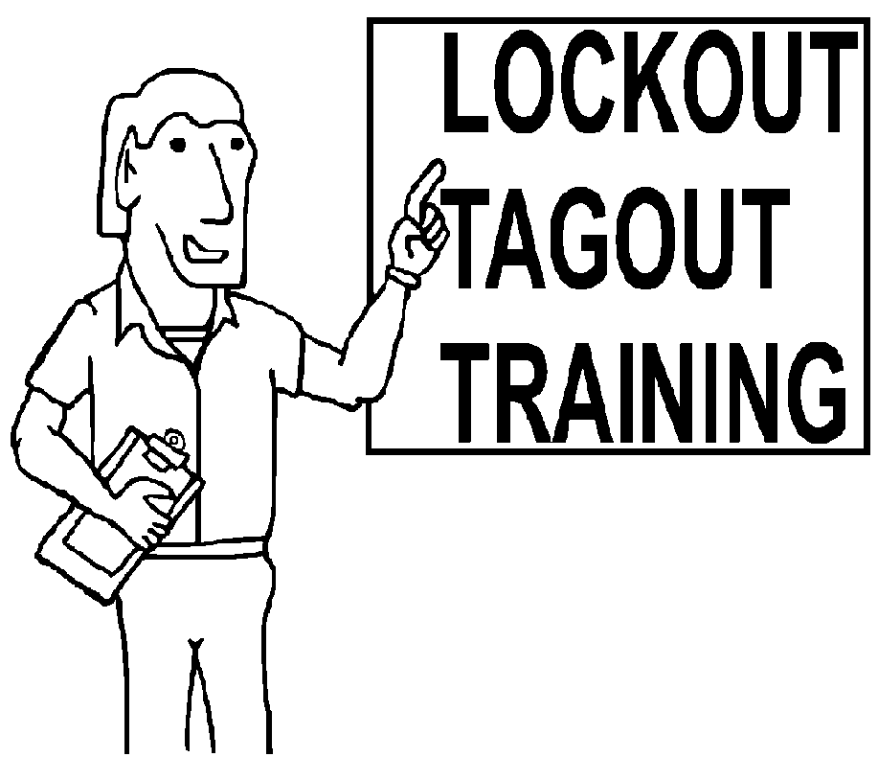

Each department/facility that has employees that perform work or are otherwise affected by the scope and application of this program are required to provide training to ensure that the purpose and function of this hazardous energy control program is understood by their employees. Through training, authorized employees will be required to possess the knowledge, skills and abilities for safe application, usage and removal of energy controls. (See Training Record/Appendix D) Training shall include the following:

- An overview of the OSHA Standard, 1910.147, “The Control of Hazardous Energy,” and the contents of this program.
- Recognition of applicable hazardous energy sources, the type and magnitude of the energy employees are exposed to in the workplace and the methods and means necessary for energy isolation and control.
- Each affected employee shall be instructed in the purpose and use of the energy control procedure.
- All other employees whose work operations are or may be in an area where energy control procedures may be utilized, shall be instructed about the procedure and about the prohibition relating to attempts to restart or reenergize machines or equipment which are locked or tagged out.
- Retraining shall be provided for all authorized and affected employees whenever there is a change in their job assignments, a change in machines, equipment or processes that present a new hazard or when there is a change in energy control procedures.
- Retraining shall also be conducted whenever a periodic inspection reveals, or whenever there is reason to believe, that there are deviations from or inadequacies in the employee’s knowledge or use of the energy control procedures.
- Retraining shall reestablish employee proficiency and introduce new or revised control methods and procedures, as necessary.

6.0 Sequence of Lockout
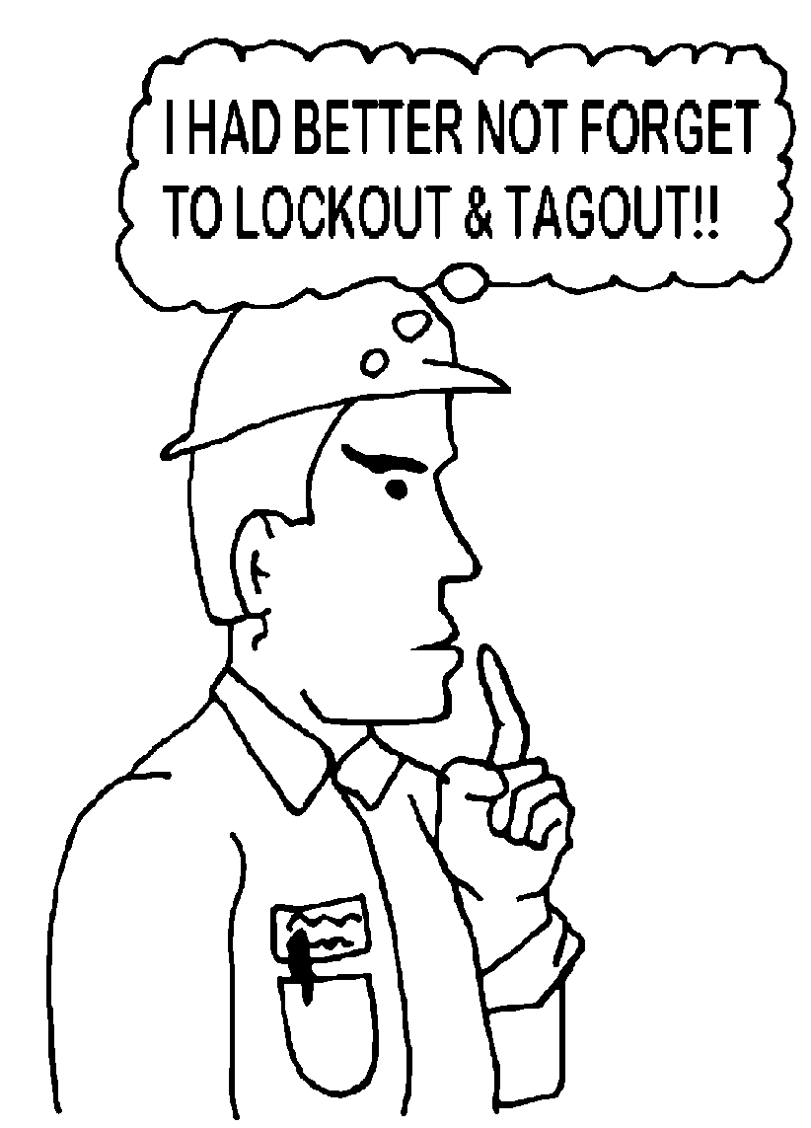
Step 1: Preparation for Lockout/Tagout

- Authorized employees shall locate appropriate lockout/tagout procedures for the type of equipment or machine that will be involved in the lockout. (See Appendix A)

- Authorized employees shall locate all isolating devices that apply to the equipment, machine, etc., that will be involved in the lockout/tagout procedures.

- Authorized employees shall notify all affected employees that a lockout/tagout system is going to be used and the reason e.g., necessary repairs, preventative maintenance, servicing or adjustments.

Step 2: Isolate Energy Sources

  - If the machine or equipment is operating, shut it down by normal stopping procedure (e.g., depress stop button, open switch, secure valve).

  - De-energize all sources of hazardous energy:

    - Disconnect or shut down engines or motors.
    - De-energize electrical circuits.
    - Block fluid (gas or liquid) flow in hydraulic or pneumatic systems.
    - Block machine parts against motion.

  - Block or dissipate stored energy:

- Discharge capacitors.
- Release or block springs that are under compression or tension.
- Vent fluids from pressure vessels, tanks, accumulators.
- Block raised dies, gears, or equipment that could descend or move when the energy is removed. Lower suspended loads to the floor or secure them independently.

  - Secure the equipment, apply all appropriate energy-isolating/lockout devices with danger tags in a safe state. The tag, at a minimum, should have the name of the authorized employee, department, time, and date. Fill out tags completely and place them in such a way as to be immediately apparent to anyone who might attempt to operate the device. Tags must be attached by a durable means, e.g., nylon cable tie. String and tape are prohibited.

  - If more than one person is required to lockout/tagout a piece of equipment, etc., each authorized employee shall place his/her own personal lockout/tagout device on the energy-isolating device(s). When an energy-isolating device cannot accept multiple locks or tags, a multiple lockout/tagout device (hasp) can be used.

Step 3: Methods of Verifying Isolation of Equipment

  - After ensuring that no personnel are exposed, verify by test and/or observation that all energy sources are de-energized.

- Review methods of verifying isolation of equipment for the specific type of equipment. (See Appendix A)
- Operate the push button or other normal operating controls to make certain the equipment will not operate. CAUTION: Return operating control(s) to “Neutral” or “OFF” position after the test.
- When practical, have a second authorized employee familiar with the equipment verify the integrity of your lockout.

Step 4: Perform the Necessary Work

  - Remember to re-check the integrity of the lockout/tagout frequently, especially in tasks that last from several hours to several days.

Step 5: Prepare for Re-Energizing/Restoring Equipment to Service

  - When the servicing or maintenance is completed and the machine or equipment is ready to return to normal operating condition, the following steps shall be taken:

- Check the machine or equipment and the immediate area around the machine to ensure that nonessential items have been removed (tools, work aids and spare parts) and that the machine or equipment components are operationally intact (close cabinets and panels).
- Check the work area to ensure that all employees have been safely positioned or removed from the area.
- Verify that the controls are in neutral.
- Remove the lockout devices and re-energize the machine or equipment. Note: The removal of some forms of blocking may require re-energization of the machine before safe removal.
- Notify affected employees that the servicing or maintenance is completed and the machine or equipment is ready for use.

Step 6: Remove Locks and Tags

  - When all affected employees are ready (clear of danger points), each authorized employee may now remove his/her own locks and tags. No lock or tag shall be removed by anyone other than the employee who signed the tag except by means of the Special Lock and Tag Removal Procedure. (See Appendix B)

Step 7: Shift or Personnel Changes

  - The department/facility shall develop procedures to be utilized during shift or personnel changes to ensure the continuity of lockout or tagout protection, including provision for the orderly transfer of lockout or tagout device protection between off-going and oncoming employees, to minimize exposure of hazards from the unexpected start-up of the machine or equipment or the release of stored energy.

7.0 Lockout/Tagout Devices
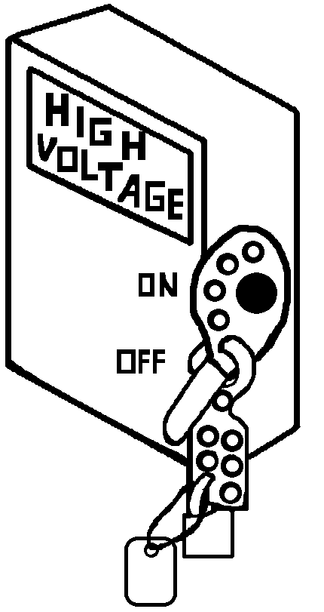
Locks, tags, chains, wedges, key blocks, adapter pins, self-locking fasteners, or other hardware shall be bought and supplied by departments/facilities for isolating, securing or blocking of machines or equipment from energy sources. These devices and materials are to be provided to authorized (trained) employees.

Both lockout and tagout devices shall meet the following requirements:

- singularly identified;
- be the only device(s) used for controlling energy;
- not be used for other purposes;
- capable of withstanding the environment to which they are exposed for the maximum period of time that exposure is expected;
- indicate the identity of the employee applying the device(s);
- standardized within the facility in at least one of the following criteria: (color, shape, or size).

Tagout devices shall meet the following requirements:
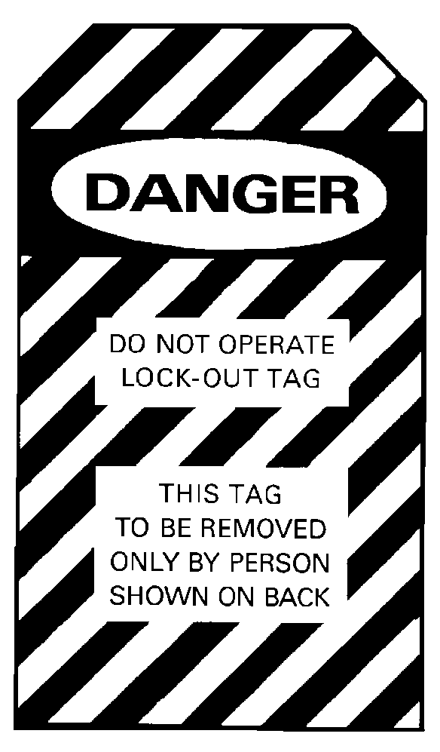
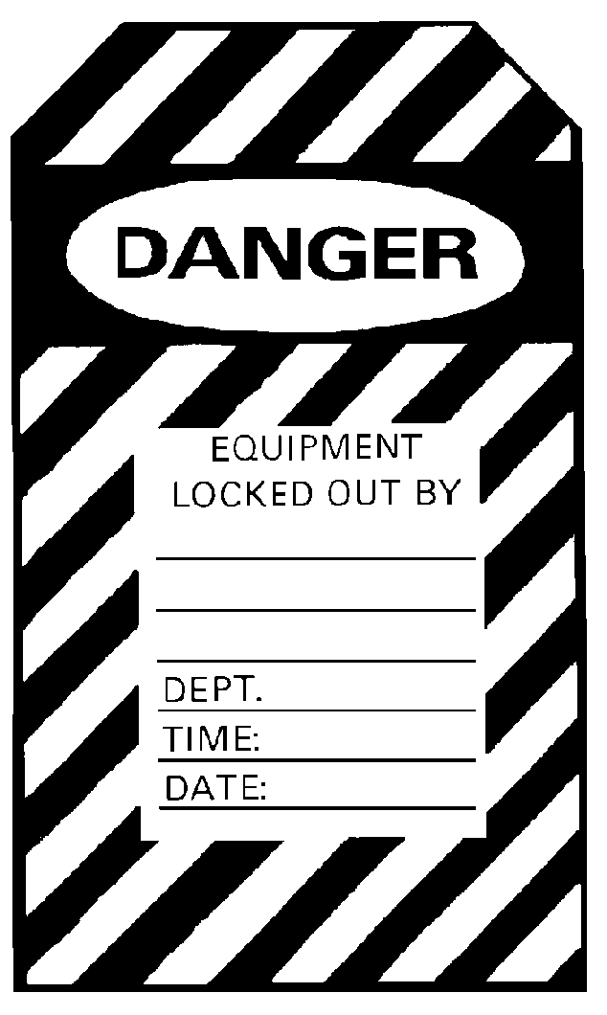

- constructed and printed so that exposure to weather conditions or wet and damp locations will not cause the tag to deteriorate or the message on the tag to become illegible;
- not deteriorate when used in corrosive environments such as areas where acid and alkali chemicals are handled and stored;
- and their means of attachment be substantial enough to prevent inadvertent or accidental removal;
- attachment means shall be of a non-reusable type, attachable by hand, self-locking and non-releasable with a minimum unlocking strength of no less than 50 pounds and having the general design and basic characteristics of being at least equivalent to a one-piece all-environment tolerant nylon cable tie;
- warn against hazardous conditions if the machine or equipment is energized and shall include a legend such as the following: Do Not Start, Do Not Open, Do Not Close, Do Not Energize, Do Not Operate.

Lockout devices shall meet the following requirements:

- be substantial enough to prevent removal without the use of excessive force or unusual techniques, such as with the use of bolt cutters or other metal cutting tools.

8.0 Contractor’s Responsibilities
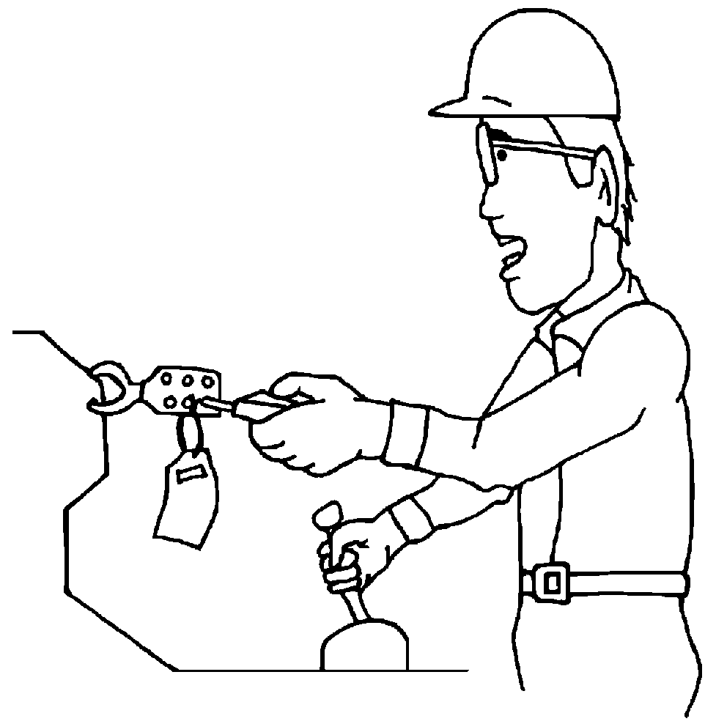

Whenever outside personnel (contractors) are engaged in activities covered by the scope and application of this program, the supervisor of the department/facility responsible for overseeing the contractor will be responsible for the following:

- Determine whether the outside contractor has energy control procedures and devices for the type of service the outside contractor will be conducting. If the outside contractor has no lockout/tagout procedures, then they shall comply with the procedures established in this program.
- Communicate with the outside contractor that the contractor will be responsible for performing the same lockout/tagout procedures while conducting maintenance, servicing, repairing, etc., on any department/facility equipment, machines, systems, etc., that have been locked and/or tagged out by authorized department/facility employees.
- Ensure that each authorized department/facility employee assisting the outside contractor has performed the same energy control (lockout/tagout) procedures.
- Notify affected employees of the contractor’s services.

9.0 Evaluation of Program Effectiveness

Annually, an authorized supervisor(s) of employees that has been authorized to perform energy isolating procedures (lockout/tagout) shall conduct an audit to ensure that the procedures outlined in this program and the requirements of the OSHA Standard 1910.147, The Control of Hazardous Energy (Lockout/Tagout) Standard are being followed.

The audit shall consist of three phases:

Phase One: Review of Lockout/Tagout Procedures

  - The first phase shall consist of reviewing the lockout/tagout procedures found in Appendix A of this program. Appendix A consists of the specific equipment, machines, etc., and the procedures that have been developed by individual departments/facilities.
  - The review will concentrate on ensuring that the procedures are accurate for sequence of lockout/tagout and verification of isolation.
  - It shall also involve determination on whether changes in equipment or operations have occurred that would require a change (additions or subtractions) in the written procedures found in Appendix A.
  - Finally, a review that determines that all authorized and affected employees have been trained and documentation of that training is on file.

Phase Two: Periodic Inspection

- The lockout/tagout periodic inspection record found in Appendix C, will be conducted to correct any deviations or inadequacies.
- This inspection will be conducted by an authorized supervisor (inspector) to evaluate each authorized employee’s responsibilities under the energy control procedure being inspected.
- Once the evaluation has been recorded on the Lockout/Tagout Periodic Inspection Record (Appendix C), a copy shall be forwarded to the Employee Safety & Development Division.

Phase Three: Retention of Records and of Inspection/Audit Procedures

- The department/facility shall maintain records documenting that procedures in Phase One have been conducted.
- The department/facility shall maintain records of Periodic Inspections (Appendix C) and completed/documented Special Lock and Tag Removal forms (Appendix B) for 3 years.
- The department/facility shall maintain training and retraining records. (Appendix D)
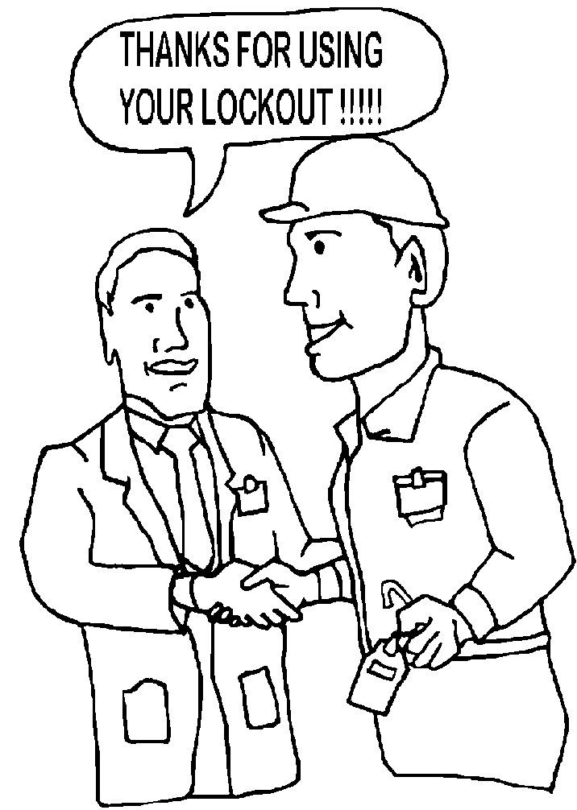

APPENDIX A – LOCKOUT/TAGOUT PROCEDURES

Department/Facility

FACILITY/DEPT. NAME: | _______________________________________________________________________________________________________
AUTHORIZED EMPLOYEES: | _______________________________________________________________________________________________________
AUTHORIZED EMPLOYEES: | _______________________________________________________________________________________________________
AFFECTED EMPLOYEES: | _______________________________________________________________________________________________________
LOCKOUT DEVICES: | _______________________________________________________________________________________________________

LOCKOUT/TAGOUT PROCEDURES
TYPE(S) AND MAGNITUDE OF ENERGY AND HAZARDS
EQUIPMENT REQUIRING LOCKOUT AND/OR TAGOUT | ENERGY TYPE & MAGNITUDE INCLUDING STORED OR RESIDUAL ENERGY | HAZARD | METHOD OF CONTROL (SEQUENCE OF LOCKOUT)  INCLUDE TYPE(S) & LOCATION(S) OF ENERGY ISOLATION | METHOD VERIFYING ISOLATION OF EQUIPMENT

APPENDIX B – SPECIAL LOCK AND TAG REMOVAL PROCEDURES

Department/Facility
Lockout/Tagout

This form is to be utilized when an authorized employee has applied a personal energy isolating (lockout/tagout) device(s) and is not available to remove it. An authorized supervisor and a witness must, at a minimum, ensure the following procedures have been completed prior to any lock/tag removal:

- Verification that the authorized employee who applied the device is not at the facility and worksite has been achieved; and
- Reasonable efforts have been made to contact/locate the authorized employee to inform him/her that his/her lockout or tagout device has been removed; and
- The authorized employee has been notified prior to resuming work, that his/her lockout/tagout device(s) has been removed.

For Lock Assigned to:
(Name of Authorized Employee)

Reason For Lock Removal:

Please Circle the Appropriate Check Marks:

✓ 1. Employee has been personally contacted. How &When:

Was the employee informed that his/her lockout/tagout device(s) has been removed?
Please check: ___ Yes ___ No

✓ 2. Unable to contact the employee.

If Number “2" Is Circled, Complete The Following:

✓ a. Checked time sheet.
✓ b. Called employee’s home. Spoke to:
Call witnessed by:
(Name & Signature of Witness)
✓ c. Asked co-workers: (Name:)
(Name:)
✓ d. Other attempts:
✓ e. A standby person will be stationed by the work location or point of exposure until the equipment is running.

BY VIRTUE OF OUR SIGNATURE BELOW, WE ATTEST TO THE FACT THAT, TO THE BEST OF OUR KNOWLEDGE, THE OWNER OF THIS LOCK AND TAG IS NOT AT THE FACILITY AND WORKSITE.

____________________________________________ ________________________________
(Supervisor’s Signature) (Date)

____________________________________________ ________________________________
(Witness Signature) (Date)

(Note: Prior to removal of any locks or tags, this form shall be signed by both the authorized supervisor and witness. Once completed, a copy shall be retained and kept on file with the Lockout/Tagout Periodic Inspection Record for 3 years.)
APPENDIX C - LOCKOUT/TAGOUT PERIODIC INSPECTION RECORD
Department/Facility

Inspector: _________________________________ Title: _____________________________ Date: _____________

Authorized Employees Inspected:

______________________________ ______________________________ ______________________________
______________________________ ______________________________ ______________________________
______________________________ ______________________________ ______________________________

Equipment Locked Out: _____________________________________ Location: _______________________________

Procedures Requirements

Preparation for Shutdown
Yes No The employees have demonstrated knowledge of the type and magnitude of the energy, the hazards of the energy to be controlled, and the method or means to control the energy.

Yes No The employees have conducted an orderly shutdown of the equipment utilizing the established procedures for this piece of equipment.

Yes No All energy isolating devices for this piece of equipment have been located and physically operated in a manner so as to isolate the equipment from the energy source(s).

Yes No Lockout or tagout devices have been effectively affixed to all energy isolating devices.

Yes No All potentially hazardous stored or residual energy was relieved, disconnected, restrained, or otherwise rendered safe.

Yes No Verification of isolation and deenergization of the equipment was performed.

Procedures for Lockout/Tagout Release & Restoration of Energy
Yes No The work area was inspected to ensure that nonessential items had been removed and that the equipment components were operationally intact.

Yes No All employees were safely positioned or removed from the area.

Yes No The employees understood the concept that before the equipment is started, all affected employees must be informed of the removal of the Lockout/Tagout devices.

Yes No Each Lockout/Tagout device was removed by each employee if the equipment required more than one employee to lock out the equipment.

Procedures for Lockout/Tagout Removal by the Employer
Yes No The employer-assigned employee responsible for Lockout or Tagout device removal in the event that the individual who applied the device is not available to remove it understands the following procedures that are outlined in the written plan:
- Verify that the employee who applied the device(s) is not at the facility.
- Make all reasonable efforts to contact the employee who applied the device in order to inform them that the Lockout/Tagout device has been removed.
- Ensure that the employee has this knowledge prior to resuming work at the facility.

Yes No This inspection has included a review with each authorized employee, of that employee’s responsibilities under the energy control procedure being inspected.

(The authorized inspector shall correct any inadequacies or deviations from procedures with the employee prior to this form being completed. Authorized inspector shall note in comment section if retraining of employee is required.)
_____ CHECK IF INSPECTION IS COMPLETE

COMMENTS:
A copy of the completed form should be forwarded to Employee Safety & Development.
Appendix D - Lockout/Tagout Training Record
(Department/Facility)

Name of Person Conducting Training:____________________________________ Date:_____________

Check one: _____ Required Annual Training _____ Retraining Due to Changes
_____ Retraining as a Result of Periodic Inspection

Contents of Training: At a minimum, the following information must be communicated to each employee:

- An overview of the OSHA Standard, 1910.147, “The Control of Hazardous Energy,” and the contents of this program.
- Recognition of applicable hazardous energy sources, the type and magnitude of the energy employees are exposed to in the workplace and the methods and means necessary for energy isolation and control.
- Each affected employee shall be instructed in the purpose and use of the energy control procedure.
- All other employees whose work operations are or may be in an area where energy control procedures may be utilized, shall be instructed about the procedure and about the prohibition relating to attempts to restart or reenergize machines or equipment which are locked or tagged out.
- Tags are essentially warning devices affixed to energy isolating devices, and do not provide the physical restraint on those devices that is provided by a lock.
- When a tag is attached to an energy isolating means, it is not to be removed without authorization of the authorized person responsible for it, and it is never to be bypassed, ignored, or otherwise defeated.
- Tags must be legible and understandable by all authorized employees, affected employees, and all other employees whose work operations are or may be in the area, in order to be effective.
- Tags and their means of attachment must be made of materials which will withstand the environmental conditions encountered in the workplace.
- Tags may evoke a false sense of security, and their meaning needs to be understood as part of the overall energy control program.
- Tags must be securely attached to energy isolating devices so that they cannot be inadvertently or accidentally detached during use.
- Other additional training: __________________________________________________

 |  | Please Check
Name of Employee | Job/Department | Affected* | Authorized** | Other***

* Affected Employee: An employee whose job requires him/her to operate or use a machine or equipment on which servicing or maintenance is being performed under lockout or tagout, or whose job requires him/her to work in an area in which such servicing or maintenance is being performed.
** Authorized Employee: A person who locks out or tags out machines or equipment in order to perform servicing or maintenance on that machine or equipment. An affected employee becomes an authorized employee when that employee’s duties include performing servicing or maintenance covered under this program.
*** Other Employee: Employees who work operations are or maybe in an area where energy control procedures may be utilized.

