SAFETY OPERATING PROCEDURES

 Drill Press

DO NOT use this machine unless a teacher has instructed
you in its safe use and operation and has given permission.

Safety glasses must be worn at all times in work areas. |   Long and loose hair must be contained.
  Appropriate footwear with substantial uppers must be worn. | 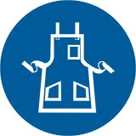  Close fitting/protective clothing must be worn.
  Rings and jewellery must not be worn. | 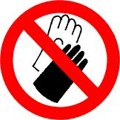  Gloves must not be worn when using this machine.

PRE-OPERATIONAL SAFETY CHECKS
- Check workspace and walkways to ensure no slip-hazards are present.
- Check that the drill chuck guard is in position.
- Ensure the chuck key (if used) has been removed from the drill chuck.
- Locate and ensure you are familiar with the operation of the ON/OFF starter and E-Stop (if fitted).
- Follow correct clamping procedures to ensure work is secure.
- If the job obstructs the walkway erect a barricade.
- Adjust spindle speed to suit drill or cutter diameter.
- Faulty equipment must not be used. Immediately report suspect equipment.

OPERATIONAL SAFETY CHECKS
- Never leave the Drill Press while it is running.
- Before making adjustments or before cleaning swarf accumulations switch off and bring the machine to a complete standstill.
- Feed downwards at a sufficient rate to keep the drill cutting.
- Feed with care as the drill breaks through the underside of the work.
- Use a safe working posture (beware of hair catching).

HOUSEKEEPING
- Switch off the machine.
- Leave the machine in a safe, clean and tidy state.

POTENTIAL HAZARDS
- Hair/clothing entanglement - rotating spindle/drill
■ Eye injuries
- Flying swarf/chips
■ Sharp edges & burrs

