SAFETY OPERATING PROCEDURES

 Metal Lathe

DO NOT use this machine unless a teacher has instructed
you in its safe use and operation and has given permission.

Safety glasses must be worn at all times in work areas. |   Long and loose hair must be contained.
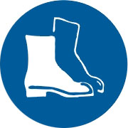  Appropriate footwear with substantial uppers must be worn. | 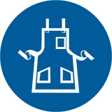  Close fitting/protective clothing must be worn.
  Rings and jewellery must not be worn. | 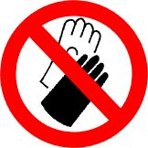  Gloves must not be worn when using this machine.

PRE-OPERATIONAL SAFETY CHECKS
- Check workspaces and walkways to ensure no slip/trip hazards are present.
- Locate and ensure you are familiar with the operation of the ON/OFF starter and E-Stop (if fitted).
- Ensure all guards are in place.
- Check that the job is clamped tight in the chuck.
- Remove all tools from the bed and slides of the machine.
- Ensure correct speed for machining process is selected.
- Remove the chuck key before starting the lathe.
- Do not try to lift chucks or face plates that are too heavy for you.
- Faulty equipment must not be used. Immediately report suspect machinery.

OPERATIONAL SAFETY CHECKS
- Never leave the lathe running unattended.
- Before making adjustments or measurements switch off and bring the machine to a complete standstill.
- Do not attempt to slow/stop the chuck or revolving work by hand.
- Avoid letting swarf build up on the tool or job. Stop the machine and remove it.
- Always remove the chuck key from the chuck.
- Do not store tools and parts on top of the machine.

HOUSEKEEPING
- Switch off the machine and reset all guards to a fully closed position.
- Leave the machine in a safe, clean and tidy state.

POTENTIAL HAZARDS
■ Flying objects - chuck key left in chuck
■ Cutting tool injury when cleaning, filing or polishing
■ Rotating machine parts - entanglement
■ Metal splinters/swarf
■ Eye injuries

