SAFETY OPERATING PROCEDURES

 Pan Brake

DO NOT use this machine unless a teacher has instructed
you in its safe use and operation and has given permission.

Safety glasses must be worn at all times in work areas. |   Long and loose hair must be contained.
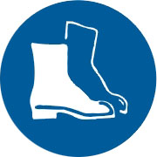  Appropriate footwear with substantial uppers must be worn. | 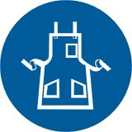  Close fitting/protective clothing must be worn.
  Rings and jewellery must not be worn. | 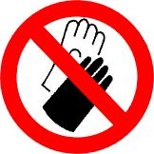  Gloves must not be worn when using this machine.

PRE-OPERATIONAL SAFETY CHECKS
- Guards or safety devices shall never be removed or adjusted, except by an authorized person for maintenance purposes.
- Working parts should be well lubricated and the jaws and fingers free of rust and dirt.
- Ensure no slip/trip hazards are present in workspaces and walkways.
- Be aware of other personnel in the immediate vicinity and ensure the area is clear before using equipment.
- Familiarise yourself with and check all machine operations and controls.
- Faulty equipment must not be used. Immediately report suspect machinery.

OPERATIONAL SAFETY CHECKS
- Never use pan brakes for bending metal that is beyond the machine’s capacity with respect to thickness, shape, or type.
- Never attempt to bend rod, wire, strap, or spring steel sheets in a pan brake.
- Remove the pan brake fingers that are in the way - use only the pan brake fingers required to make the bend.
- Ensure the pan brake fingers that are not removed for an operation are securely seated and firmly tightened before the machine is used.
- Ensure fingers and limbs are clear before operating the pan brake.
- Lower finger clamps to work - do not drop.
- Check workpiece is secure.
- Keep clear of moving counterweight (where fitted).

HOUSEKEEPING
- Lower finger clamps to a safe position.
- Return all accessories to storage racks.
- Leave the work area in a safe, clean and tidy state.

POTENTIAL HAZARDS
- Sharp edges and burrs
- Squash/crush and pinch points
- Impact from counterweight

