SAFETY OPERATING PROCEDURES

 Cold Saw

DO NOT use this machine unless a teacher has instructed
you in its safe use and operation and has given permission.

Safety glasses must be worn at all times in work areas. |   Long and loose hair must be contained.
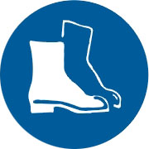  Appropriate footwear with substantial uppers must be worn. | 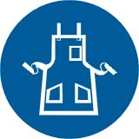  Close fitting/protective clothing must be worn.
  Rings and jewellery must not be worn. |   Hearing protection must be worn when using this machine.

PRE-OPERATIONAL SAFETY CHECKS
- Check workspaces and walkways to ensure that no slip/trip hazards are present.
- Ensure saw blade is in good condition.
- Locate and check the operation of the ON/OFF starter.
- Check that all safety guards are in working order.
- Check the operation of the work vice.
- Check coolant delivery system to allow for sufficient flow of coolant.
- Faulty equipment must not be used. Immediately report suspect equipment.

OPERATIONAL SAFETY CHECKS
- Ensure that the work piece is securely held in the work vice.
- Support overhanging work and signpost if it presents a hazard.
- Never leave the machine running unattended.
- Attention must be paid to unusual noises during the sawing process.
- Never force the saw into the workpiece. Use a slow and even feed rate.
- Before making adjustments or before cleaning swarf accumulations switch off and bring the machine to a complete standstill.
- Immediately absorb any coolant spills.

HOUSEKEEPING
- Switch off the machine.
2. Leave the machine in a safe, clean and tidy state.

POTENTIAL HAZARDS
■ Possible skin irritation from coolants
■ Eye injuries
■ Sharp edges and burrs - metal splinters
■ Noise

FORBIDDEN
- Attempting to cut very small items
- Attempting to cut materials other than metal

