SAFETY OPERATING PROCEDURES

 Manual Bending Rolls

DO NOT use this machine unless a teacher has instructed
you in its safe use and operation and has given permission.

Safety glasses must be worn at all times in work areas. |   Long and loose hair must be contained.
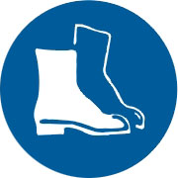  Appropriate footwear with substantial uppers must be worn. |   Close fitting/protective clothing must be worn.
  Rings and jewellery must not be worn. | 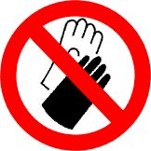  Gloves must not be worn when using this machine.

Only one person may operate this machine at any one time.

PRE-OPERATIONAL SAFETY CHECKS
- Ensure all guards are in place, properly secured and functional.
- Guards or safety devices must never be removed or adjusted, except by an authorized person for maintenance purposes.
- Working parts should be well lubricated and the rolls free of rust and dirt.
- The area around the machine must be adequately lit and kept free of materials, which might cause slips or trips.
- Be aware of other personnel in the immediate vicinity and ensure the area is clear before using equipment.
- Familiarise yourself with and check all machine operations and controls.
- Faulty equipment must not be used. Immediately report suspect machinery.

OPERATIONAL SAFETY CHECKS
- Do not attempt to roll material beyond the capacity of the machine.
- Never attempt to bend rod or wire in bending rolls unless the rolls are grooved for this purpose.
- Adjust both ends of the rollers evenly.
- Take extreme care during the initial feeding of the workpiece into the rolls.
- The workpiece should always be held sufficiently far back from the edge being fed into the rolls to allow for the infeed speed of the machine.
- Wind handle at a slow even rate. Be aware of rotating rollers.

HOUSEKEEPING
- Ensure the handle is left in a safe position after use.
2. Leave the work area in a safe, clean and tidy state.

POTENTIAL HAZARDS
○ Sharp edges and burrs  Crush and pinch points  Entanglement
○ Operator’s hands may be caught and drawn into the counter-rotating rollers

