SAFETY OPERATING PROCEDURES

 Metal Cutting Guillotine

DO NOT use this machine unless a teacher has instructed
you in its safe use and operation and has given permission.

Safety glasses must be worn at all times in work areas. |   Long and loose hair must be contained.
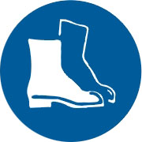  Appropriate footwear with substantial uppers must be worn. | 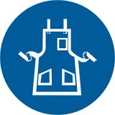  Close fitting/protective clothing must be worn.
  Rings and jewellery must not be worn. | 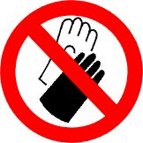  Gloves must not be worn when using this machine.

Only one person may operate this machine at any one time.

PRE-OPERATIONAL SAFETY CHECKS
- Ensure fixed guards are in place to prevent hands or other parts of the body from entering the trapping space.
- Guards or safety devices must never be removed or adjusted, except by an authorized person for maintenance purposes.
- Working parts should be well lubricated and free of rust and dirt.
- The area around the machine must be adequately lit and kept free of materials, which might cause slips or trips.
- Be aware of other personnel in the immediate vicinity and ensure the area is clear before using equipment.
- Familiarise yourself with and check all machine operations and controls.
- Ensure cutting table is clear of scrap and tools.
- Faulty equipment must not be used. Immediately report suspect machinery.

OPERATIONAL SAFETY CHECKS
- Do not attempt to cut material beyond the capacity of the machine.
- Never attempt to cut rod, strap or wire with this machine.
- Use correct lifting procedures when handling large sheets of material.
- Take extreme care during the initial feeding of the workpiece into the machine.
- The workpiece should always be held sufficiently far back from the edge being fed into the guillotine.
- Ensure fingers and limbs are clear before actuating the guillotine.
- Hold material firmly to prevent inaccurate cutting due to creep.
- When cutting ensure feet are positioned to avoid contact with the foot operated lever.

HOUSEKEEPING
- Remove all off cuts and place them in either in the storage rack or waste bin.
- Leave the work area in a safe, clean and tidy state.

POTENTIAL HAZARDS
○ Sharp edges and burrs  Crush and pinch points  Handling metal sheets

