SAFETY OPERATING PROCEDURES

 Circular Bench Saw

DO NOT use this machine unless a teacher has instructed
you in its safe use and operation and has given permission.

Safety glasses must be worn at all times in work areas. |   Long and loose hair must be contained.
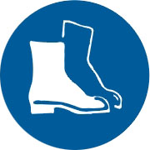  Appropriate footwear with substantial uppers must be worn. | 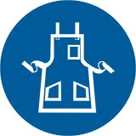  Close fitting/protective clothing must be worn.
  Rings and jewellery must not be worn. |   Hearing protection must be worn when using this machine.

PRE-OPERATIONAL SAFETY CHECKS
- Check workspaces and walkways to ensure that no slip/trip-hazards are present.
- Check that all safety guards are in position and are set to the minimum clearance from the workpiece being cut.
- Locate and ensure you are familiar with the operation of the ON/OFF starter and E-Stop (if fitted).
- Ensure all locks are securely tightened.
- Ensure table and work area is clear of all tools, off-cut timber and sawdust.
- Start the dust extraction unit before using the machine.
- Faulty equipment must not be used. Immediately report suspect equipment.

OPERATIONAL SAFETY CHECKS
- Do not cut freehand.
- Allow the saw blade to obtain maximum speed before making a cut.
- Use push stick (at least 400 mm long) to guide timber through saw.
- Always stand to one side of the line of cut.
- Never remove off cuts or sawdust from the saw table while the saw is running.
- Before making adjustments switch off and bring the machine to a complete standstill.
- Never leave the machine running unattended.
- Remove the rip fence when using the mitre gauge.
- Make sure someone “tails out” when cutting long material.

HOUSEKEEPING

Switch off the machine.

Leave the machine in a safe, clean and tidy state.

POTENTIAL HAZARDS
■ Kickback - wood may catch or jam and be flung back violently

■ Airborne dust  Eye injuries  Contact with blade at point of operation

FORBIDDEN
■ Cutting irregular stock, branches or wood with embedded nails or screws

