SAFETY OPERATING PROCEDURES

 Belt Disc Sander

DO NOT use this machine unless a teacher has instructed
you in its safe use and operation and has given permission.

Safety glasses must be worn at all times in work areas. |   Long and loose hair must be contained.
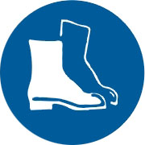  Appropriate footwear with substantial uppers must be worn. | 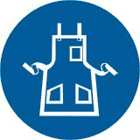  Close fitting/protective clothing must be worn.
  Rings and jewellery must not be worn. | 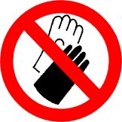  Gloves must not be worn when using this machine.

Only one person may operate this machine at any one time.

PRE-OPERATIONAL SAFETY CHECKS
- Check workspaces and walkways to ensure no slip/trip hazards are present.
- Ensure you are familiar with the operation of the ON/OFF starter and E-Stop (if fitted).
- Check the table is set not more than 2mm from disc.
- Check belts and discs are in a serviceable condition.
- Operator must be positioned out of direct line of abrasive belt at all times.
- Ensure dust extraction is on before operating machine.
- Faulty equipment must not be used. Immediately report suspect machinery.

OPERATIONAL SAFETY CHECKS
- Allow machine to reach maximum revolutions before operating to avoid overloading.
- Always place material on the table on the downward side of the disc travel to hold it down on the table surface.
- Hold material firmly against stops or table before applying pressure on abrasive.
- Keep fingers clear of disc or belt while sanding.
- Never leave the machine while it is running.
- Before making adjustments switch off and bring the machine to a complete standstill.

HOUSEKEEPING
- Switch off the machine.
- Leave the machine in a safe, clean and tidy state.

POTENTIAL HAZARDS

■ Abrasions  Burns to skin  Eye injuries
■ Excessive dust  Unsecured material being flung around

FORBIDDEN:
- Attempting to sand very small items
- Attempting to sharpen tools
- Attempting to sand metal

