SAFETY OPERATING PROCEDURES

 Shaping Machine

DO NOT use this machine unless a teacher has instructed
you in its safe use and operation and has given permission.

Safety glasses must be worn at all times in work areas. |   Long and loose hair must be contained.
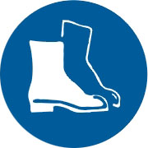  Appropriate footwear with substantial uppers must be worn. | 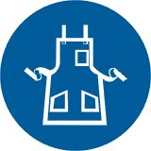  Close fitting/protective clothing must be worn.
  Rings and jewellery must not be worn. |   Hearing protection must be worn when using this machine.

PRE-OPERATIONAL SAFETY CHECKS
- Ensure no slip/trip hazards are present in workspaces and walkways.
- Check that machine guards are in position.
- Do not leave equipment on top of the machine.
- Ensure cutter is in good condition and securely mounted.
- Locate and ensure you are familiar with the operation of the ON/OFF starter and E-Stop (if fitted).
- Faulty equipment must not be used. Immediately report suspect machinery.

OPERATIONAL SAFETY CHECKS
- Keep clear of moving machine parts.
- Never leave the machine running unattended.
- Do not leave equipment on top of the machine.
- Follow correct clamping procedures- keep overhangs as small as possible and check work piece is secure.
- Ensure you have selected correct speed and rate.
- Ensure you have set the correct depth of cut.
- Before making adjustments and measurements or before cleaning swarf accumulations switch off and bring the machine to a complete standstill.

HOUSEKEEPING
- Switch off the machine.
- Leave the machine and work area in a safe, clean and tidy state.

POTENTIAL HAZARDS
■ Sharp cutters
■ Skin irritation
■ Moving machine parts
■ Eye injuries
■ Metal splinters and burrs
■ Loose clothing entanglement

