SAFETY OPERATING PROCEDURES

 Surface Planer

DO NOT use this machine unless a teacher has instructed
you in its safe use and operation and has given permission.

Safety glasses must be worn at all times in work areas. |   Long and loose hair must be contained.
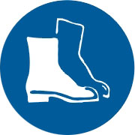  Appropriate footwear with substantial uppers must be worn. | 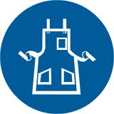  Close fitting/protective clothing must be worn.
  Rings and jewellery must not be worn. |   Hearing protection must be worn when using this machine.

PRE-OPERATIONAL SAFETY CHECKS
- Check workspaces are clear and no slip/trip-hazards are present.
- Check safety guards are adjusted and operate to give maximum protection.
- Where a bridge guard is fitted adjust the guard to ensure a maximum of 2mm clearance between guard and the timber.
- Do not plane stock with structural defects.
- Locate and ensure you are familiar with the operation of the ON/OFF starter and E-Stop (if fitted).
- Set depth of cut and lock table. Never make a single cut greater than 2mm.
- Check and lock fence in position.
- Start the dust extraction unit before using the machine.
- Faulty equipment must not be used. Immediately report suspect equipment.

OPERATIONAL SAFETY CHECKS
- Hands must not be closer than 100mm from the cutter head when it is rotating.
- Use push blocks wherever possible.
- Never leave the machine while it is running.
- Place cupped boards with the concave side against the table.
- Plane with the grain. Hold the workpiece firmly and apply even feed rate.
- Operator should stand to side of infeed table to avoid possible kickbacks.
- Before making any adjustments switch off and wait for the cutter head to completely stop.

HOUSEKEEPING
- Switch off and reset all guards to a fully closed position after use.
- Reset the depth of cut to zero after use.
- Leave the machine in a safe, clean and tidy state.

FORBIDDEN
- Do not surface stock less than 300mm long x 20mm wide x 15mm thick
- Rebating at the end of the cutter-block
■ Planing end grain

