SAFETY OPERATING PROCEDURES

 Manual Metal Arc Welder

DO NOT use this machine unless a teacher has instructed
you in its safe use and operation and has given permission.

Safety glasses must be worn at all times in addition to welding mask. |   Long and loose hair must be contained.
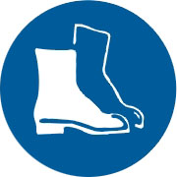  Appropriate footwear with substantial uppers must be worn. |   Close fitting/protective clothing to cover arms and legs must be worn.
Respiratory protection devices may be required for some operations. |   Oil free leather gloves and spats must be worn when welding.
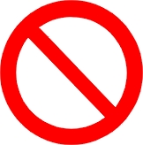  Rings and jewellery must not be worn. | A welding mask with correct grade lens for MMAW must be worn.  

PRE-OPERATIONAL SAFETY CHECKS
- Ensure no slip/trip hazards are present in workspaces and walkways.
- Ensure the work area is clean and clear of grease, oil, and any flammable materials.
- Keep the welding equipment and work area dry to avoid electric shocks.
- Ensure the gloves are dry and free from holes to avoid electric shocks.
- Ensure electrode holder and work leads are in good condition.
- Ensure fume extraction unit is on before beginning welding operation.
- Ensure other people are protected from flashes by closing curtain to welding bay or by erecting screens.
- Faulty equipment must not be used. Immediately report suspect equipment.

OPERATIONAL SAFETY CHECKS
- Keep welding leads as short as possible and coil them to minimise inductance.
- Ensure the electrode holder has no electrode in it before turning on the welding machine.
- Ensure current is correctly set according to electrode selection.
- Do not use bare hands and never wrap electrode leads around yourself.
- When welding is finished or interrupted, remove electrode stub from holder and switch off power source.

HOUSEKEEPING
- Switch off the machine and fume extraction.
- Hang up electrode holder and welding cables and leave the work area in a safe, clean and tidy state.

POTENTIAL HAZARDS
■ Electric shock  Fume  Radiation burns to eyes or body
■ Body burns due to hot or molten materials  Flying sparks  Fire

