SAFETY OPERATING PROCEDURES

 Gas Metal Arc Welder

DO NOT use this machine unless a teacher has instructed
you in its safe use and operation and has given permission.

Safety glasses must be worn at all times in addition to welding mask. |   Long and loose hair must be contained.
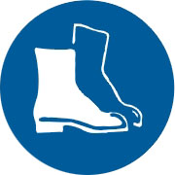  Appropriate footwear with substantial uppers must be worn. | 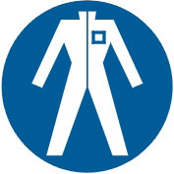  Close fitting/protective clothing to cover arms and legs must be worn.
Respiratory protection devices may be required for some operations. |   Oil free leather gloves and spats must be worn when welding.
  Rings and jewellery must not be worn. | A welding mask with correct grade lens for GMAW must be worn.  

PRE-OPERATIONAL SAFETY CHECKS
- Ensure no slip/trip hazards are present in workspaces and walkways.
- Ensure the work area is clean and clear of grease, oil, and any flammable materials.
- Keep the welding equipment, work area and gloves dry to avoid electric shocks.
- Ensure the gloves, welding gun and work leads are in good condition.
- Ensure other people are protected from flashes by closing curtain to welding bay or erecting screens.
- Ensure fume extraction unit is on before beginning welding operation.
- Ensure the work leads do not create a tripping hazard.

OPERATIONAL SAFETY CHECKS
- Ensure machine is correctly set up for current, voltage, wire feed and gas flow.
- Ensure work return cables make firm contact to provide a good electrical connection.
- Never leave the welder running unattended.
- Take care to avoid flashes.

HOUSEKEEPING
- Switch off the machine and fume extraction.
- Close gas cylinder valve.
- Hang up welding gun and welding cables.
- Leave the work area in a safe, clean and tidy state.

POTENTIAL HAZARDS
■ Electric shock
■ Fume
■ Radiation burns to eyes or body
■ Body burns due to hot or molten materials
■ Flying sparks

