SAFETY OPERATING PROCEDURES

 Oxy-Fuel Gas Welding

DO NOT use this equipment unless a teacher has instructed
you in its safe use and operation and has given permission.

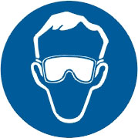  Welding goggles must be worn at all times in work areas. |   Long and loose hair must be contained.
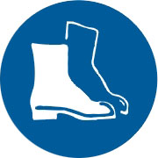  Appropriate footwear with substantial uppers must be worn. | 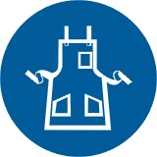  Close fitting/protective clothing must be worn.
  Rings and jewellery must not be worn. | 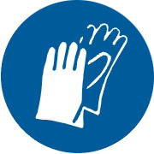  Oil free leather gloves must be worn when welding.

PRE-OPERATIONAL SAFETY CHECKS
- Ensure no slip/trip hazards are present in workspaces and walkways.
- Keep area clean and free of grease, oil and other flammable material.
- Gas hoses must be in good condition and not create a tripping hazard.
- Before lighting up make a visual inspection of all equipment for damage.
- Check that the area is well ventilated and fume extraction unit is on.
- Faulty equipment must not be used. Immediately report suspect equipment.

PRESSURE SETTING
- Check that the oxygen and acetylene regulator adjusting knobs are loose.
- Check that both blowpipe valves are closed.
- Slowly open the cylinder valves on each cylinder for half a turn only.
- Screw in the regulator adjusting knobs slowly until the delivery pressure gauges register 70kPa.
- Purge and check for constant oxygen gas flow.
■ Open the oxygen blowpipe for 2 seconds valve and check the delivery gauge.
■ If necessary re-adjust the oxygen regulator to achieve a 70kPa pressure.
■ Close the oxygen blowpipe valve.
- Purge and check for constant acetylene gas flow.
■ Open the acetylene blowpipe valve for 2 seconds and check the delivery gauge.
■ If necessary re-adjust the acetylene regulator to achieve a 70kPa pressure.
■ Close the acetylene blowpipe valve.

LIGHTING UP
- Open the acetylene blowpipe valve slightly and light the blowpipe with a flint lighter.
- Continue to slowly open the acetylene valve until the flame no longer produces soot.
- Slowly open the oxygen blowpipe valve until a neutral flame is produced.

SAFETY OPERATING PROCEDURES

 Oxy-Fuel Gas Welding

DO NOT use this machine unless a teacher has instructed
you in its safe use and operation and has given permission.

Welding goggles must be worn at all times in work areas. | Long and loose hair must be contained.
Sturdy footwear must be worn at all times in work areas. | Close fitting/protective clothing must be worn.
Rings and jewellery must not be worn. | Oil free leather gloves must be worn when welding.

SHUTTING OFF BLOWPIPE
- Close the acetylene blowpipe valve first.
- Then close the oxygen blowpipe valve.

CLOSING DOWN
- Close down both cylinder valves.
- Open oxygen blowpipe valve to allow the gas to drain out.
- When oxygen gauges read zero, unscrew regulator-adjusting knob.
- Close oxygen blowpipe valve.
- Turn off acetylene cylinder valve.
- Open acetylene blowpipe valve and release gas.
- When acetylene gauges read zero, release regulator adjusting knob.
- Close acetylene blowpipe valve.

HOUSEKEEPING
- Hang up welding blowpipe and hoses.
- Turn off fume extraction.
- Leave the work area in a safe, clean and tidy state.

POTENTIAL HAZARDS

■ Burns

■ Flying sparks

■ Fumes

■ Flashbacks
■ Radiation damage to eyes
■ Explosion by gas leakage

FORBIDDEN

■ Lighting blowpipe with matches or lighters
■ Using oil, grease or other hydrocarbons
  - Using oxygen as a substitute for compressed air

